June is the Month of the Sacred Heart of Jesus!

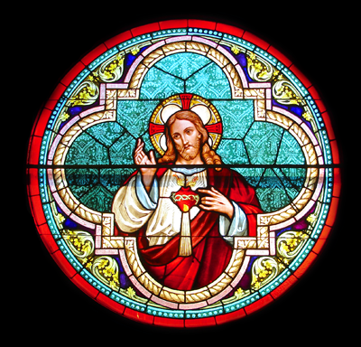

We often take for granted that God loves us. In June we focus specifically on the Heart of Jesus. Jesus is the one who loved us even to the point of dying for us.
In most cultures the heart is the symbol of love; it is what is deep inside us. We speak of a person having a kind heart or a hard heart.
When the Church was gripped with fear of God’s anger, a French sister, St. Margaret Mary Alacoque, was given visions of the Sacred Heart of Jesus in 1673 which assured us that God loves us and that we are to serve without excessive fear. At the same time, we must be careful about sin and pray for those who sin.

Dear friends, let us love one another because love comes from God. Whoever loves is a child of God and knows god. Whoever does not love, does not know God, for God is love. God showed his love for us by sending his only Son into the world, so that we might have life through him. No one has ever seen God, but if we love one another God lives in us and his love is made perfect in us. (1 John 4:7-9, 11-12)

Love is a word that is much used and often badly used. Love is not just a feeling but it is rather the fact that we do good things for other people, such as forgiving them, helping them, showing them kindness. If we love others, then we can get a better idea of how God loves us. We think of this great love.
The Bible is God’s love-letter to his people.
The cross shows us God’s immense love for us.

The chalice reminds us of Jesus’ love for us in the Mass and Holy Communion.
May the love of Jesus surround us.
May the love of Jesus forgive us.
May the love of Jesus help us to love one another.

Prayer to the Sacred Heart of Jesus
Ask and you shall receive
Seek and you shall find
Knock and it shall be opened unto you
O Sacred Heart of Jesus I place all my trust in you.

