‘Baptised and Sent’ Autumn 2019

The Diocese of Westminster gives priority to the support and promotion of small faith-sharing groups. Such groups meet to share the Bible, share their experience and discuss their meaning for the wider community, often undertaking common projects in response to local needs.
The Agency for Evangelisation works to support existing communities through the production of the exploring faith resources and provision of pastoral support and training throughout the year. The Agency also seeks to aid parishes who wish to form new groups seeking to make them a regular part of parish life.

Autumn 2019
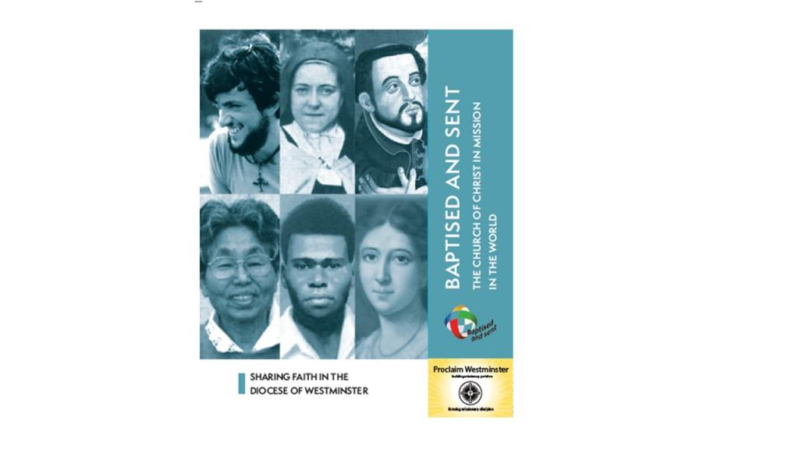
baptised and sent.pdf

