ST MARY’S CATHOLIC PRIMARY SCHOOL

Design and Technology Policy

October 2014

Design and Technology Policy

Contents
- Curriculum Statement

- Teaching and Learning
- Assessment
- Planning and Resources
- Organisation
- Equal Opportunities / Inclusion
- Role of the Subject Leader / Monitoring

Mission Statement
St Mary’s school community follows the teachings of Jesus Christ, working together to develop the whole child, in a spiritual, moral, academic, physical, social and emotional way, within a caring and supportive environment.

Curriculum Statement

Intent
St Mary’s Catholic Primary School uses Kapow Primary's Design and technology scheme of work which aims to inspire pupils to be innovative and creative thinkers who have an appreciation for the product design cycle through ideation, creation, and evaluation. We want pupils to develop the confidence to take risks, through drafting design concepts, modelling, and testing and to be reflective learners who evaluate their work and the work of others. Through our scheme of work, we aim to build an awareness of the impact of design and technology on our lives and encourage pupils to become resourceful, enterprising citizens who will have the skills to contribute to future design advancements.
Kapow Primary's Design and technology scheme of work enables pupils to meet the end of key stage attainment targets in the national curriculum and the aims also align with those in the national curriculum.

Implementation
The Design and technology national curriculum outlines the three main stages of the design process: design, make and evaluate. Each stage of the design process is underpinned by technical knowledge which encompasses the contextual, historical, and technical understanding required for each strand. Cooking and nutrition* has a separate section, with a focus on specific principles, skills and techniques in food, including where food comes from, diet and seasonality.
The National curriculum organises the Design and technology attainment targets under five subheadings or strands:
- Design
- Make
- Evaluate
- Technical knowledge
- Cooking and nutrition*
Kapow Primary's Design and technology scheme has a clear progression of skills and knowledge within these five strands across each year group.
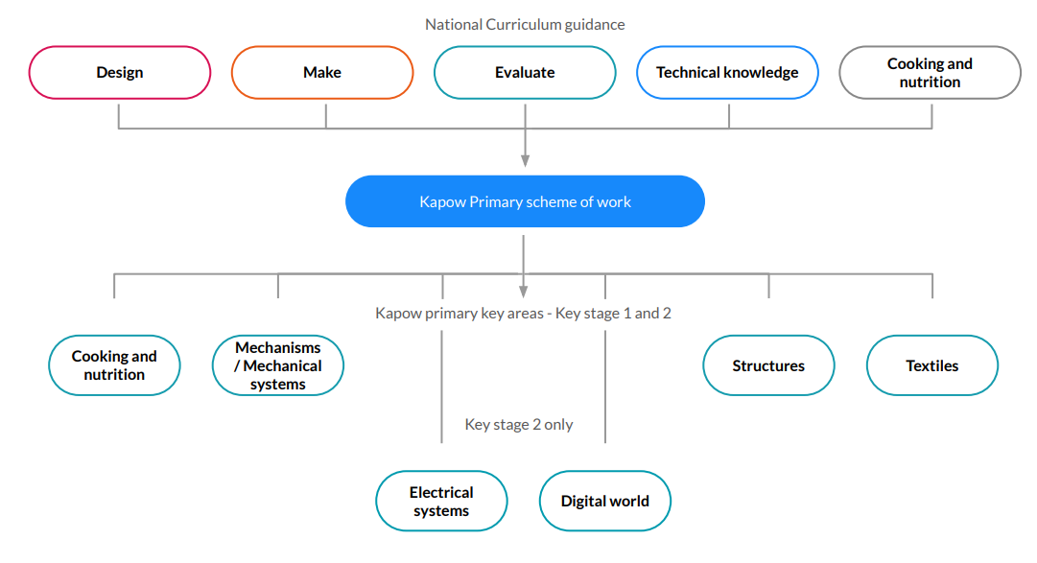
Our National curriculum mapping shows which of our units cover each of the National curriculum attainment targets as well as each of the five strands. Our Progression of skills shows the skills that are taught within each year group and how these skills develop to ensure that attainment targets are securely met by the end of each key stage. Through Kapow Primary's Design and technology scheme, pupils respond to design briefs and scenarios that require consideration of the needs of others, developing their skills in six key areas:
- Mechanisms
- Structures
- Textiles
- Cooking and nutrition (Food)
- Electrical systems KS2) and
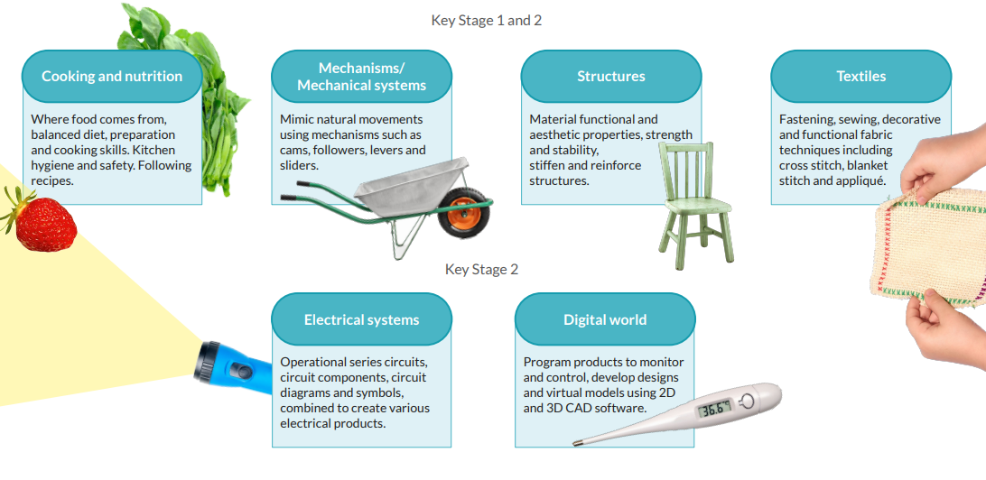
- Digital world (KS2)

Each of our key areas follows the design process (design, make and evaluate) and has a particular theme and focus from the technical knowledge or cooking and nutrition section of the curriculum. The Kapow Primary scheme is a spiral curriculum, with key areas revisited again and again with increasing complexity, allowing pupils to revisit and build on their previous learning.
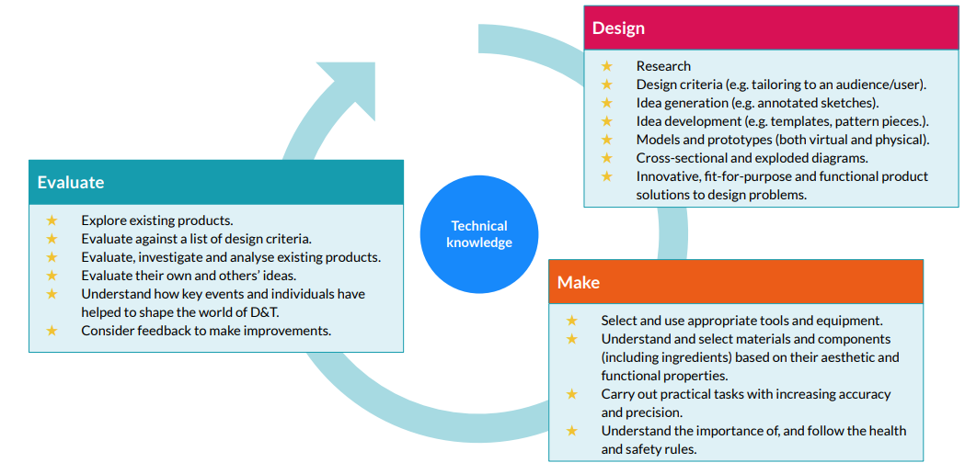
Lessons incorporate a range of teaching strategies from independent tasks, paired and group work including practical hands-on, computer-based and inventive tasks. This variety means that lessons are engaging and appeal to those with a variety of learning styles. Differentiated guidance is available for every lesson to ensure that lessons can be accessed by all pupils and opportunities to stretch pupils' learning are available when required. Knowledge organisers for each unit support pupils in building a foundation of factual knowledge by encouraging recall of key facts and vocabulary.
Strong subject knowledge is vital for staff to be able to deliver a highly effective and robust Design and technology curriculum. Each unit of lessons includes multiple teacher videos to develop subject knowledge and support ongoing CPD. Kapow has been created with the understanding that many teachers do not feel confident delivering the full Design and technology curriculum and every effort has been made to ensure that they feel supported to deliver lessons of a high standard that ensure pupil progression.
EYFS
In the Early Years Foundation Stage children focus on Cooking and Nutrition, Structure and Textiles. The outcomes for these units are carefully linked with the Early Learning Goals (ELGs) within the Development Matters 2021 statements.
The table below demonstrates the links between our Kapow units and the ELGs which the children will tackle in the Early Years.
Early Years Foundation Stage (Reception)  Kapow Primary’s units | Early Years Outcomes: Prime Areas  Development Matters 2021 statements  Early Learning Goals | Early Years Outcomes: Specific Areas  Development Matters 2021 statements  Early Learning Goals
Structures: Junk Modelling | Physical development -Develop small motor skills so that they can use a range of tools competently, safely and confidently.  -ELG: Fine Motor Skills. Use a range of small tools, including scissors, paint brushes and cutlery. | Expressive Arts and Design -Explore, use and refine a variety of artistic effects to express ideas and feelings.  -Return to and build on their previous learning, refining ideas and developing their ability to represent them.  -Create collaboratively, sharing ideas, resources and skills.  -ELG: Creating with materials. Safely use and explore a variety of materials, tools and techniques, experimenting with colour, design, texture, form and function.  -ELG: Creating with materials. Share their creations, explaining the process they have used.
Food: Soup | Communication & language -Learn new vocabulary.  -Use new vocabulary throughout the day.  -ELG: Speaking. Participate in small group, class and one-to-one discussions, offering their own ideas, using recently introduced vocabulary.  Personal, social and emotional development -Know and talk about the different factors that support their overall health and wellbeing: healthy eating.  -ELG: Managing self. Manage their own basic hygiene and personal needs, including… understanding the importance of healthy food choices.  Physical development -Develop small motor skills so that they can use a range of tools competently, safely and confidently.  -ELG: Use a range of small tools, including scissors, paint brushes and cutlery. | Understanding the world -Explore the natural world around them.  -ELG: The Natural World. Explore the natural world around them,making observations and drawing pictures of animals and plants.  Expressive Arts and Design -Explore, use and refine a variety of artistic effects to express ideas and feelings.  -ELG: Creating with materials. Safely use and explore a variety of materials, tools and techniques, experimenting with colour, design, texture, form and function.
Textiles: Bookmarks | Physical development -Develop small motor skills so that they can use a range of tools competently, safely and confidently.  -ELG: Fine Motor Skills. Use a range of small tools, including scissors, paint brushes and cutlery. | Expressive Arts and Design  -Explore, use and refine a variety of artistic effects to express ideas and feelings.  -Return to and build on their previous learning, refining ideas and developing their ability to represent them.  -ELG: Creating with materials. Safely use and explore a variety of materials, tools and techniques, experimenting with colour, design, texture, form and function.  -ELG: Creating with materials> Share their creations, explaining the process they have used.
Structures: Boats | Communication and language -Articulate their ideas and thoughts in well-formed sentences.  -Connect one idea or action to another using a range of connectives.  -Use talk to help work out problems and organise thinking and activities, and to explain how things work and why they might happen.  -ELG: Speaking. Participate in small group, class and one-to-one discussions, offering their own ideas, using recently introduced vocabulary.  -ELG: Speaking. Offer explanations for why things might happen. | Understanding the world -Explore the natural world around them.  -ELG: The Natural World. Explore the natural world around them, making observations and drawing pictures of animals and plants.  Expressive Arts and Design  -Explore, use and refine a variety of artistic effects to express ideas and feelings.  -ELG: Creating with materials> Safely use and explore a variety of materials, tools and techniques, experimenting with colour, design, texture, form and function.  -ELG: Creating with materials. Share their creations, explaining the process they have used.

Impact

The impact of Kapow Primary's scheme can be constantly monitored through both formative and summative assessment opportunities. Each lesson includes guidance to support teachers in assessing pupils against the learning objectives. Furthermore, each unit has a unit quiz and knowledge catcher which can be used at the start and/ or end of the unit.
After the implementation of Kapow Primary Design and technology, pupils should leave school equipped with a range of skills to enable them to succeed in their secondary education and be innovative and resourceful members of society.
The expected impact of following the Kapow Primary Design and technology scheme of work is that children will:
- Understand the functional and aesthetic properties of a range of materials and resources.
- Understand how to use and combine tools to carry out different processes for shaping, decorating, and manufacturing products.
- Build and apply a repertoire of skills, knowledge and understanding to produce high quality, innovative outcomes, including models, prototypes, CAD, and products to fulfil the needs of users, clients, and scenarios.
- Understand and apply the principles of healthy eating, diets, and recipes, including key processes, food groups and cooking equipment.
- Have an appreciation for key individuals, inventions, and events in history and of today that impact our world.
- Recognise where our decisions can impact the wider world in terms of community, social and environmental issues.
- Self-evaluate and reflect on learning at different stages and identify areas to improve.
- Meet the end of key stage expectations outlined in the National curriculum for Design and technology.
- Meet the end of key stage expectations outlined in the National curriculum for Computing.

Teaching and Learning

Our Kapow Primary scheme of work fulfils the statutory requirements outlined in the national curriculum (2014). The national curriculum Programme of study for Design and technology aims to ensure that all pupils:
- develop the creative, technical and practical expertise needed to perform everyday tasks confidently and to participate successfully in an increasingly technological world.
- build and apply a repertoire of knowledge, understanding and skills in order to design and make high-quality prototypes and products for a wide range of users.
- critique, evaluate and test their ideas and products and the work of others.
- understand and apply the principles of nutrition and learn how to cook.
Kapow Primary’s Design and Technology scheme identifies five key strands which run throughout:
- Design
- Make
- Evaluate
- Technical Knowledge
- Cooking and Nutrition
The six key areas are revisited each year, with Electrical systems and Digital world beginning in KS2. The key areas enable all teachers to see prior and future learning to make it explicit to our pupils. It is easy to see, at a glance, how the unit being taught fits into the wider learning journey.
Cooking and Nutrition - Where food comes from, balanced diet, preparation and cooking skills. Kitchen hygiene and safety. Following recipes.
Mechanisms/Mechanical Systems - Mimic natural movements using mechanisms such as cams, followers, levers and sliders.
Structures - Material functional and aesthetic properties, strength and stability, stiffen and reinforce structures.
Textiles - Fastening, sewing, decorative and functional fabric techniques including cross stitch, blanket stitch and appliqué.
Electrical Systems - Operational series circuits, circuit components, circuit diagrams and symbols, combined to create various electrical products.

Digital World - Program products to monitor and control, develop designs and virtual models using 2D and 3D CAD software.

The Design Process
The Design and Technology National Curriculum outlines the three main stages of the design process: design, make and evaluate. Each Kapow Primary unit follows these stages, to form a full project. Each stage of the design process is underpinned by technical knowledge which encompasses the contextual, historical and technical understanding, required for each strand.

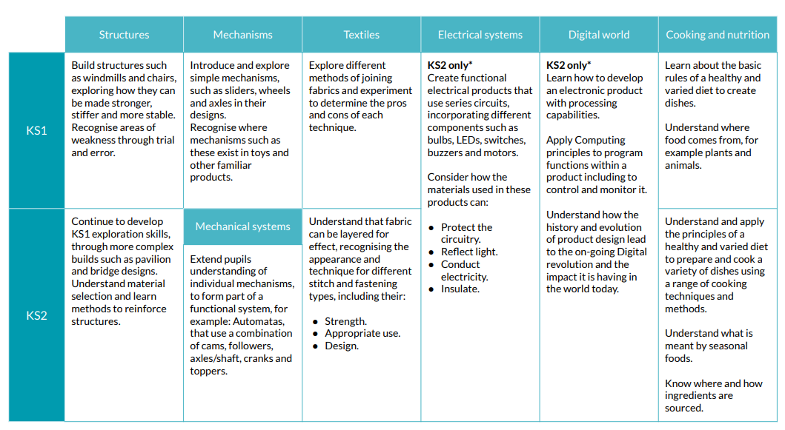

Design:
- Research
- Design criteria (e.g. tailoring to an audience/user).
- Idea generation (e.g. annotated sketches).
- Idea development (e.g. templates, pattern pieces.).
- Models and prototypes (both virtual and physical).
- Cross-sectional and exploded diagrams.
- Innovative, fit-for-purpose and functional product solutions to design problems.

Make:
- Select and use appropriate tools and equipment.
- Understand and select materials and components (including ingredients) based on their aesthetic and functional properties.
- Carry out practical tasks with increasing accuracy and precision.
- Understand the importance of, and follow the health and safety rules

Evaluate:
- Explore existing products.
- Evaluate against a list of design criteria.
- Evaluate, investigate and analyse existing products.
- Evaluate their own and others’ ideas.
- Understand how key events and individuals have helped to shape the world of D&T.
- Consider feedback to make improvements.

Assessment

Children’s existing knowledge of the topic and the key related knowledge from previous year groups, is checked at the beginning of each unit as part of the KWL process. Children’s knowledge and skills are continually assessed and developed by the teacher during lessons, in accordance with the lesson’s success criteria. Assessment quizzes and knowledge catchers are available and should be used for/with every unit of work.
iTrack assessment grids will be completed at the end of each unit so teachers understand which children are secure with the knowledge and can demonstrate the skills necessary for each unit.
The children review the identified ‘key’ knowledge as part of the assessment process. This indicates which key knowledge statements require further consolidation.

Planning and Resources

The key vocabulary for each topic is mapped and should be shared with the children, with reference to the ‘knowledge mat’ that is available for each unit of work. This provides a graphic organiser of the key vocabulary, the previous relevant knowledge and the current key knowledge of the topic with an explanation. This also includes the key facts, for the unit of work.

All lesson plans and resources, produced by Kapow Primary are available via a login on Kapow Primary’s website. Teachers consult these to ensure technical accuracy in their teaching and to inform the programme of study for their year group. The key skills and knowledge for each Design and Technology Topic have been mapped to ensure that these are progressive from one year to the next. Planning considers cross-curricular opportunities and these are stated on the Kapow Primary’s knowledge and skills progression mapping and embedded in practice. To support CPD and inform specific projects, Kapow Primary provides helpful videos to support teacher knowledge and skills.
Children are taught to use tools and equipment in a sensible, safe and efficient manner.

Organisation

Kapow Primary’s Long-term plan gives an order for teaching our Design and Technology units and includes flexibility to adapt the scheme if required. The units are arranged in such a way as to ease pressure on the limited Design and technology equipment which our school has available to us.
The organisation of our Design and technology curriculum is explained, such as detailing the strands which thread through every unit: Design, Make, Evaluate and Technical knowledge and the Cooking and nutrition strand (which is taught as a single unit in every year group). Each unit is hyperlinked and there is a short description of the content to give an overview of Kapow's Design and technology curriculum.
This standard version of the Condensed Long-term plan includes all of our Design and technology units from Year 1 - Year 6, giving full coverage of the National Curriculum.

Equal Opportunities / Inclusion

Whole school policy on equal opportunities will be adhered to in Design and Technology activities. Teachers ensure that children have access to the range of Design and Technology activities and use opportunities within Design and Technology to challenge stereotypes and use Designers from a range of backgrounds, cultures etc. Children are encouraged and supported to develop their Design and Technology capability using a range of materials. Children with special needs or disabilities will be differentiated or scaffolded for and supported appropriately, to ensure development of skills and equal access to the Design and Technology curriculum.

Role of the Subject Leader / Monitoring

The subject leader will monitor the teaching and learning of Design and Technology across the school; ensuring a high quality, broad and stimulating curriculum. They will also support and facilitate opportunities that support the continued professional development of teachers in the teaching and learning of Design and Technology. A range of good-quality materials and tools, which enable teachers to resource and teach the subject effectively, will be maintained by the subject leader.

Policy Written by Rosheen Martin
June 2023

