Churches to close with immediate effect
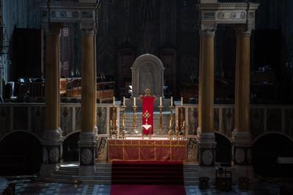
Photo: Mazur/CBCEW.org.uk
Following on from the Prime Minister's message yesterday evening, churches in the Diocese of Westminster are to close with immediate effect and to remain closed until further notice.
In a message to clergy last night, the Cardinal said: 'All churches must be closed, and remain closed. It is essential that we all follow this instruction, painful and difficult though it is.'
Today, in a message to all the faithful, he adds:
'As our churches have to remain closed, let’s open our hearts even wider. As the Psalms say "Grow higher ancient doors and let the King of Glory enter." These are the doors of our hearts. God knows well how to fill our lives. We must open our hearts in prayer and silent welcome.
'Even in this difficult time, there is evidence of so much good. Online congregations at Mass on Sunday were huge. Examples of online participation are so encouraging. Even the experience of the Acts of Spiritual Communion, all made at the same time, were deeply nourishing. God is so good.
‘Today we are learning, step by step, the truth of the old axiom: God is not limited by his sacraments. The Holy Spirit overcomes our distances, prompts and enriches our prayer. Encourage this personal and shared prayer. Don’t finish a telephone call or an online chat without a moment of shared prayer!'
Following some confusion in the guidance published by the Ministry of Housing, Communities and Local Government regarding the opening of churches, where it states that 'places of worship should remain open for solitary prayer', the Bishops' Conference has clarified that churches must close and remain closed:
'The instruction is very clear on the occasions when someone can leave home:
- Shopping for basic necessities, for example food and medicine, which must be as infrequent as possible.
- One form of exercise a day, for example a run, walk, or cycle - alone or with members of your household.
- Any medical need, or to provide care or to help a vulnerable person.
- Travelling to and from work, but only where this absolutely cannot be done from home.
'None of these four specific reasons for leaving home concur with the visiting of a church for solitary prayer. In addition, keeping churches open could undermine the desire of the government for people to remain at home, the very fact of them being open may draw people out of their homes, many of which would be the most vulnerable to infection.
'Professor Jim McManus has spoken with a senior civil servant and it was quite clear they just had not thought through the issues of infection and security of churches and when he made these points clear, they were appalled and agreed they had made a mistake.
'Keeping churches open sends an utterly inconsistent message and therefore they must be closed for the benefit of others and stopping infection.'

