John Henry Newman to be canonised on October 13 2019

Pope Francis has formally approved the canonisation, along with four others
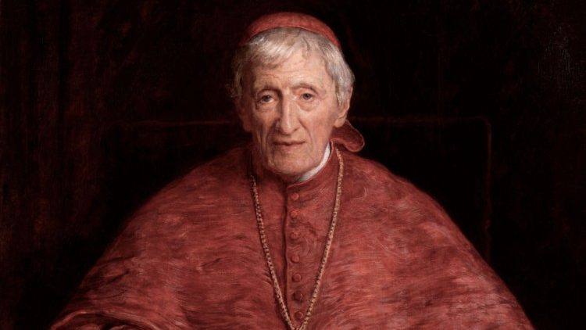

During a consistory of cardinals July 1, Pope Francis decreed that Newman and four other blesseds will be canonized together in St. Peter’s Square.
Indian Sister Marian Theresia, founder of the Congregation of the Sisters of the Holy Family; Italian Sister Giuseppina Vannini; Brazilian Sister Dulce Lopes Pontes, and Marguerite Bays, a Swiss consecrated virgin of the Third Order of St. Francis will be canonized alongside Newman.
Their canonizations will take place during the 2019 Special Synod of Bishops from the Pan-Amazonian region to be held at the Vatican Oct. 6-27.
Newman was a 19th century theologian, poet, Catholic priest and cardinal. Originally an Anglican priest, he converted to Catholicism in 1845 and his writings are considered among some of the most important Church-writings in recent centuries.
Ordained a Catholic priest in 1847, he was made a cardinal by Pope Leo XIII in 1879, although he was not a bishop. Newman’s conversion to the Catholic faith was controversial in England, and resulted in him losing many friends, including his own sister who never spoke to him again.
The British cardinal founded the Oratory of St. Philip Neri in England, and was particularly dedicated to education, founding two schools for boys. He died in Birmingham in 1890 at the age of 89.
In October, Cardinal Newman will become Britain’s first new saint since the canonization of St. John Ogilvie in 1976.
At Newman’s beatification Mass in Birmingham, England in Sept. 2010, Pope Benedict XVI said that Newman’s “insights into the relationship between faith and reason, into the vital place of revealed religion in civilized society, and into the need for a broadly-based and wide-ranging approach to education were not only of profound importance for Victorian England, but continue today to inspire and enlighten many all over the world.”
“What better goal could teachers of religion set themselves than Blessed John Henry’s famous appeal for an intelligent, well-instructed laity: ‘I want a laity, not arrogant, not rash in speech, not disputatious, but men who know their religion, who enter into it, who know just where they stand, who know what they hold and what they do not, who know their creed so well that they can give an account of it, who know so much of history that they can defend it,” Pope Benedict said.
The first miracle attributed to Newman’s intercession involved the complete and inexplicable healing of a deacon from a disabling spinal condition.
His second miracle concerned the healing of a pregnant American woman. The woman prayed for the intercession of Cardinal Newman at the time of a life-threatening diagnosis, and her doctors have been unable to explain how or why she was able to suddenly recover.
“God has created me to do Him some definite service. He has committed some work to me which He has not committed to another. I have my mission. I may never know it in this life, but I shall be told it in the next. I am a link in a chain, a bond of connection between persons,” Blessed John Henry Newman wrote.
“He has not created me for naught. I shall do good; I shall do His work. I shall be an angel of peace, a preacher of truth in my own place, while not intending it if I do but keep His commandments,” he said.
“Therefore, I will trust Him... If I am in sickness, my sickness may serve Him, in perplexity, my perplexity may serve Him... He does nothing in vain... He may take away my friends. He may throw me among strangers. He may make me feel desolate, make my spirits sink, hide the future from me. Still, He knows what He is about.”
