Online Mass Schedule
A number of churches in the diocese are live streaming Mass and can be visited online at any time.
Amongst those Masses currently celebrated on live stream are the following:
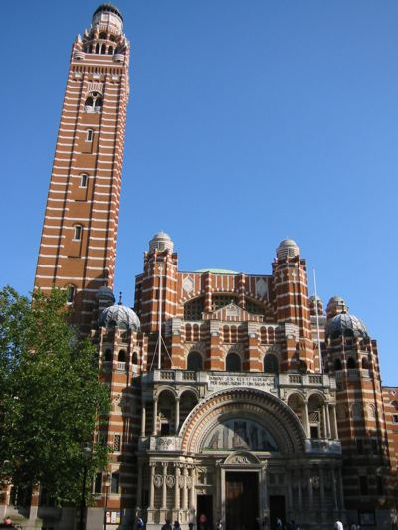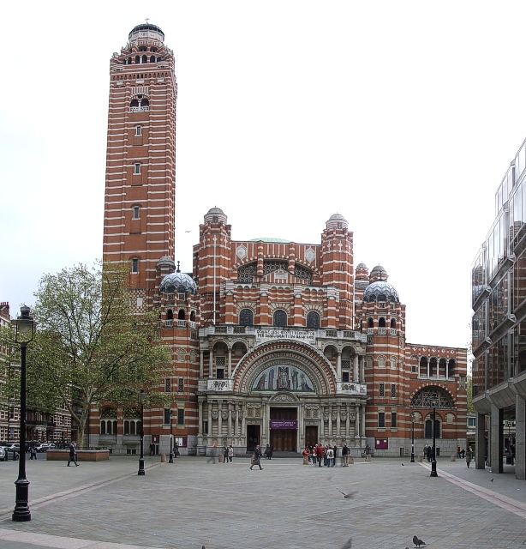

Westminster Cathedral
Sunday
10.30am Mass
4.30pm Solemn Vespers and Benediction
5.30pm Mass
Monday to Saturday
9am Mass
12pm Holy Hour
5.30pm Mass
Find the Cathedral’s live stream here

Parish Sunday Mass
Saturday Vigil:
5.30pm St Gregory the Great, South Ruislip
6.00pm Our Lady and St Vincent, Potters Bar
St Teresa of the Child Jesus, Borehamwood
St Michael and St Martin, Hounslow
St Monica, Palmers Green
St Anselm and St Cecilia, Lincoln’s Inn Fields
Holy Apostles, Pimlico
St Joseph & English Martyrs, Bishops Stortford
St Mary, Hampstead
Our Lady of Mt Carmel and St George, Enfield
6.30pm Our Lady of Lourdes, New Southgate
St Mary Magdalene, Willesden Green
Our Lady and St Joseph, Waltham Cross
Sunday:
7.45am St Monica, Palmers Green
9.00am St Joseph & English Martyrs, Bishops Stortford
St Helen’s, Watford North
St Mary Magdalene, Willesden Green
9.30am St Hugh of Lincoln, Letchworth
Corpus Christi Shrine, Covent Garden
10.00am St Gregory the Great, South Ruislip
Our Lady of Lourdes, New Southgate
St Teresa of the Child Jesus, Borehamwood
Our Lady and St Thomas of Canterbury, Harrow
Catholic Churches of Welwyn Garden City
Mary Immaculate and St Gregory the Great, Barnet
St Francis De Sales, Tottenham
St Erconwald, Wembley
Our Lady of Fatima, White City
Our Lady St John’s Wood
Our Lady of Mt Carmel and St George, Enfield
10.15am Sacred Heart, Berkhamsted
10.30am Holy Apostles, Pimlico
Our Lady, Queen of All Creation, Hemel Hempstead East
St James, Spanish Place
St Mary Magdalene, Willesden Green
11.00am Our Lady and St Vincent, Potters Bar
Our Lady St John’s Wood
Church of the Immaculate Conception, Farm Street (Latin)
St Mark’s, Hemel Hempstead West
St Monica, Palmers Green
St Joseph & English Martyrs, Bishops Stortford
Our Lady and St Joseph, Waltham Cross
Our Lady of Victories, Kensington
English Martyrs, Wembley Park
11.30am St Mary, Hampstead
12noon St Anselm and St Cecilia, Lincoln’s Inn Fields
St Gregory the Great, South Ruislip
Our Lady of Willesden, Willesden
St Mary Magdalene, Willesden Green
Our Lady of Mt Carmel and St George, Enfield
4.00pm Rosary Shrine, Haverstock Hill (Dominican Rite Mass)
6.00pm St Gregory the Great, South Ruislip
Church of the Immaculate Conception, Farm Street
St Michael and St Martin, Hounslow
St Joseph & English Martyrs, Bishops Stortford
6.30pm St Thomas More, Swiss Cottage
St Mary Magdalene, Willesden Green
Our Lady and St Joseph, Waltham Cross

Parish Weekday Mass
Monday to Friday:
7.00am St Thomas More, Swiss Cottage
8.00am Corpus Christi Shrine, Covent Garden
9.00am St Mary, Hampstead
9.15am St Teresa of the Child Jesus, Borehamwood
9.30am St Monica, Palmers Green
St Francis De Sales, Tottenham (Mon-Thur)
St Erconwald, Wembley
St Mary Magdalene, Willesden Green
Holy Apostles, Pimlico
St Joseph & English Martyrs, Bishops Stortford
10.00am St Gregory the Great, South Ruislip
Our Lady and St Vincent, Potters Bar
Our Lady of Lourdes, New Southgate
Our Lady St John’s Wood
Mary Immaculate and St Gregory the Great, Barnet (excl. Wed)
Sacred Heart, Berkhamsted (excl. Wed)
Our Lady of Willesden, Willesden
Church of the Immaculate Conception, Farm Street
Our Lady and St Joseph, Waltham Cross
Our Lady of Victories, Kensington
12nooon Our Lady of Mt Carmel and St George, Enfield
12.30pm St Anselm and St Cecilia, Lincoln’s Inn Fields (Mon, Wed, Fri only)
6.00pm St Anselm and St Cecilia, Lincoln’s Inn Fields
St Francis De Sales, Tottenham (Fri Only)
St Michael and St Martin, Hounslow
Church of the Immaculate Conception, Farm Street
6.30pm St Mary Magdalene, Willesden Green (Fri only)
7.00pm St Monica, Palmers Green
Saturday:
8.00am Corpus Christi Shrine, Covent Garden
9.30am St Erconwald, Wembley
St Mary Magdalene, Willesden Green
St Monica, Palmers Green
10.00am St Thomas More, Swiss Cottage
Our Lady of Lourdes, New Southgate
Mary Immaculate and St Gregory the Great, Barnet
Our Lady St John’s Wood
Our Lady of Fatima, White City
Sacred Heart, Berkhamsted
St Francis De Sales, Tottenham
Our Lady of Willesden, Willesden
St Gregory the Great, South Ruislip
Church of the Immaculate Conception, Farm Street
Our Lady St John’s Wood
Our Lady and St Joseph, Waltham Cross
12nooon Our Lady of Mt Carmel and St George, Enfield

These parishes are also streaming Mass, please check their links below…
St Edwards, Golders Green (Mass recorded each day excl. Wed & Sat)
St Mary of the Angels, Bayswater (Mass celebrated at Noon, uploaded after)

For masses for the deaf community, please visit the CDA’s website.
Several churches will be holding Eucharistic Adoration throughout the day.

Act of Spiritual Communion:
My Jesus,
I believe that you are present in this Holy Sacrament of the altar.
I love you above all things
and I passionately desire to receive you into my soul.
Since I cannot now receive you sacramentally,
come spiritually into my soul
so that I may unite myself wholly to you now and forever.
Amen

