A Short Guide for Catholics Coping with the Coronavirus
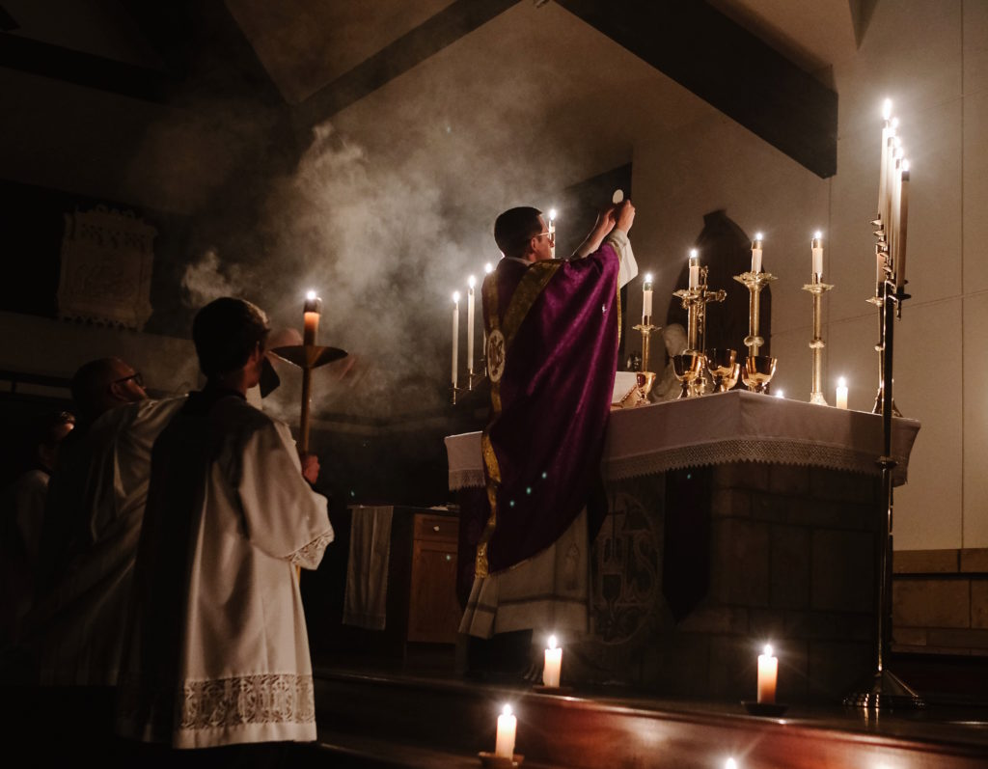
As churches around you have closed or cancelled public Masses and if you are spending more time at home we wanted to share a few online options with you so that you can still watch Mass — and have a fruitful Lent and Easter.
Here are a few options for you:
+ You can watch Mass on EWTN’s live feed here. It looks like they have Mass at 8 am and 12 pm EST on Sunday. Daily Mass throughout the rest of the week is at the same time. Here’s their schedule.
+ You can also make an act of Spiritual Communion by saying a prayer like this one: “My Jesus, I believe that You are present in the Most Holy Sacrament. I love You above all things, and I desire to receive You into my soul. Since I cannot at this moment receive You sacramentally, come at least spiritually into my heart. I embrace You as if You were already there and unite myself wholly to You. Never permit me to be separated from You. Amen.”
+ You can find a live broadcast of perpetual Adoration here.

