Pope Francis urges Catholics to unite through praying the Rosary in May
34.4K364

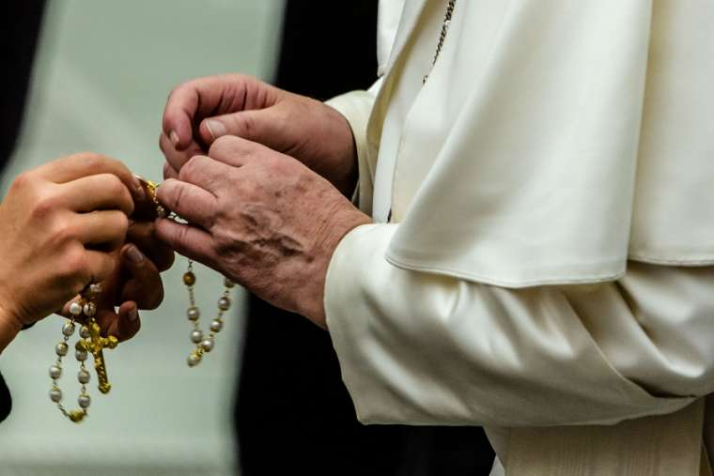

Pope Francis sent a letter Saturday encouraging Catholics to pray the rosary throughout May. He also shared two new prayers to implore the help of the Virgin Mary during the coronavirus pandemic.
“Contemplating the face of Christ with the heart of Mary our Mother will make us even more united as a spiritual family and will help us overcome this time of trial,” Pope Francis said in a letter April 25.
He urged families and individuals to “rediscover the beauty of praying the rosary at home in the month of May,” which is traditionally a time of increased devotion to the Blessed Virgin Mary.
With his letter, the pope included two prayers to Our Lady to recite at the end of the rosary, which he said he would also pray throughout May “in spiritual union with all of you.”
In the first prayer, Mary’s help is invoked “to conform ourselves to the will of the Father and to do what Jesus tells us.”
In the second, longer prayer, the Virgin Mary is asked to “turn your merciful eyes towards us amid this coronavirus pandemic,” and her intercession is asked “that this great suffering may end and that hope and peace may dawn anew.”
The prayer asks for Mary’s comfort for those who mourn and for those who are anxious about the future, and prays for health care workers, scientists, and national leaders.
The prayer also asks Mary to “be close to those who assist the sick night and day, and to priests who, in their pastoral concern and fidelity to the Gospel, are trying to help and support everyone.”
“Mary, Consolation of the afflicted, embrace all your children in distress and pray that God will stretch out his all-powerful hand and free us from this terrible pandemic, so that life can serenely resume its normal course,” the prayer says.
In his letter, Francis said people can pray the rosary as a group or individually, whatever fits their situation best. “The key to doing this is always simplicity,” he underlined, adding that the internet is a good resource for finding prayers to follow.
During May, it is a tradition to pray the rosary “at home within the family,” he said, noting that the restrictions of the COVID-19 pandemic “have made us come to appreciate all the more this ‘family’ aspect, also from a spiritual point of view.”
Pope Francis concluded his letter by saying “I keep all of you in my prayers, especially those suffering most greatly, and I ask you, please, to pray for me.”
“I thank you, and with great affection I send you my blessing.”

Below you can find the full text of the prayers shared by Pope Francis:
First Prayer:
O Mary, You shine continuously on our journey as a sign of salvation and hope. We entrust ourselves to you, Health of the Sick, who, at the foot of the cross, were united with Jesus’ suffering, and persevered in your faith.
“Protectress of the Roman people”, you know our needs, and we know that you will provide, so that, as at Cana in Galilee, joy and celebration may return after this time of trial.
Help us, Mother of Divine Love, to conform ourselves to the will of the Father and to do what Jesus tells us. For he took upon himself our suffering, and burdened himself with our sorrows to bring us, through the cross, to the joy of the Resurrection. Amen.
We fly to your protection, O Holy Mother of God; Do not despise our petitions in our necessities, but deliver us always from every danger, O Glorious and Blessed Virgin.
Second Prayer:
“We fly to your protection, O Holy Mother of God”.
In the present tragic situation, when the whole world is prey to suffering and anxiety, we fly to you, Mother of God and our Mother, and seek refuge under your protection.
Virgin Mary, turn your merciful eyes towards us amid this coronavirus pandemic. Comfort those who are distraught and mourn their loved ones who have died, and at times are buried in a way that grieves them deeply. Be close to those who are concerned for their loved ones who are sick and who, in order to prevent the spread of the disease, cannot be close to them. Fill with hope those who are troubled by the uncertainty of the future and the consequences for the economy and employment.
Mother of God and our Mother, pray for us to God, the Father of mercies, that this great suffering may end and that hope and peace may dawn anew. Plead with your divine Son, as you did at Cana, so that the families of the sick and the victims be comforted, and their hearts be opened to confidence and trust.
Protect those doctors, nurses, health workers and volunteers who are on the frontline of this emergency, and are risking their lives to save others. Support their heroic effort and grant them strength, generosity and continued health.
Be close to those who assist the sick night and day, and to priests who, in their pastoral concern and fidelity to the Gospel, are trying to help and support everyone.
Blessed Virgin, illumine the minds of men and women engaged in scientific research, that they may find effective solutions to overcome this virus.
Support national leaders, that with wisdom, solicitude and generosity they may come to the aid of those lacking the basic necessities of life and may devise social and economic solutions inspired by farsightedness and solidarity.
Mary Most Holy, stir our consciences, so that the enormous funds invested in developing and stockpiling arms will instead be spent on promoting effective research on how to prevent similar tragedies from occurring in the future.
Beloved Mother, help us realize that we are all members of one great family and to recognize the bond that unites us, so that, in a spirit of fraternity and solidarity, we can help to alleviate countless situations of poverty and need. Make us strong in faith, persevering in service, constant in prayer.
Mary, Consolation of the afflicted, embrace all your children in distress and pray that God will stretch out his all-powerful hand and free us from this terrible pandemic, so that life can serenely resume its normal course.
To you, who shine on our journey as a sign of salvation and hope, do we entrust ourselves, O Clement, O Loving, O Sweet Virgin Mary. Amen.

