Prayer Resources for use during the Coronavirus pandemic
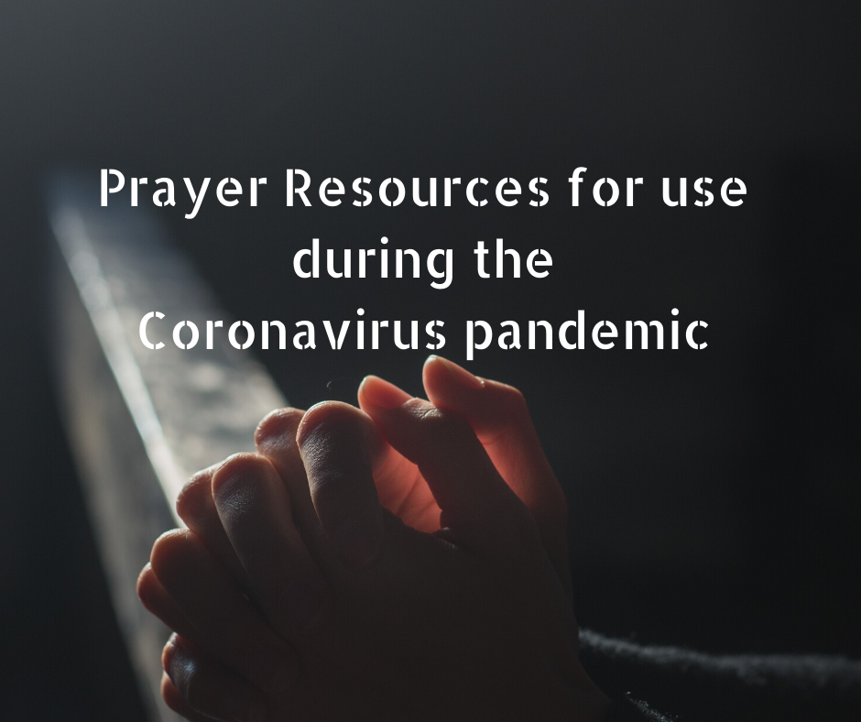
The following prayers and resources are offered to assist the faithful during the threat of the coronavirus:

Pope Francis’ Prayer to Mary during the coronavirus pandemic
O Mary,
you always shine on our path
as a sign of salvation and of hope.
We entrust ourselves to you, Health of the Sick,
who at the cross took part in Jesus’ pain, keeping your faith firm.
You, Salvation of the Roman People,
know what we need,
and we are sure you will provide
so that, as in Cana of Galilee,
we may return to joy and to feasting
after this time of trial.
Help us, Mother of Divine Love,
to conform to the will of the Father
and to do as we are told by Jesus,
who has taken upon himself our sufferings
and carried our sorrows
to lead us, through the cross,
to the joy of the resurrection. Amen.
Under your protection, we seek refuge, Holy Mother of God. Do not disdain the entreaties of we who are in trial, but deliver us from every danger, O glorious and blessed Virgin.

Extract from Saint Patrick’s Breastplate
Christ with me,
Christ before me,
Christ behind me,
Christ in me,
Christ beneath me,
Christ above me,
Christ on my right,
Christ on my left,
Christ when I lie down,
Christ when I sit down,
Christ when I arise,
Christ in the heart of everyone who thinks of me,
Christ in the mouth of everyone who speaks of me,
Christ in every eye that sees me,
Christ in every ear that hears me.

Memorare
Remember, O most gracious Virgin Mary,
that never was it known that anyone who fled to your protection,
implored your help, or sought your intercession was left unaided.
Inspired with this confidence,
I fly to you, O Virgin of virgins, my Mother.
To you I come, before you I stand, sinful and sorrowful.
O Mother of the Word Incarnate,
despise not my petitions, but in your mercy, hear and answer. Amen.

An Act of Spiritual Communion
This is a simple and loving act of Spiritual Communion we are called to make in these times, while we are unable to attend Mass and receive the Eucharist:

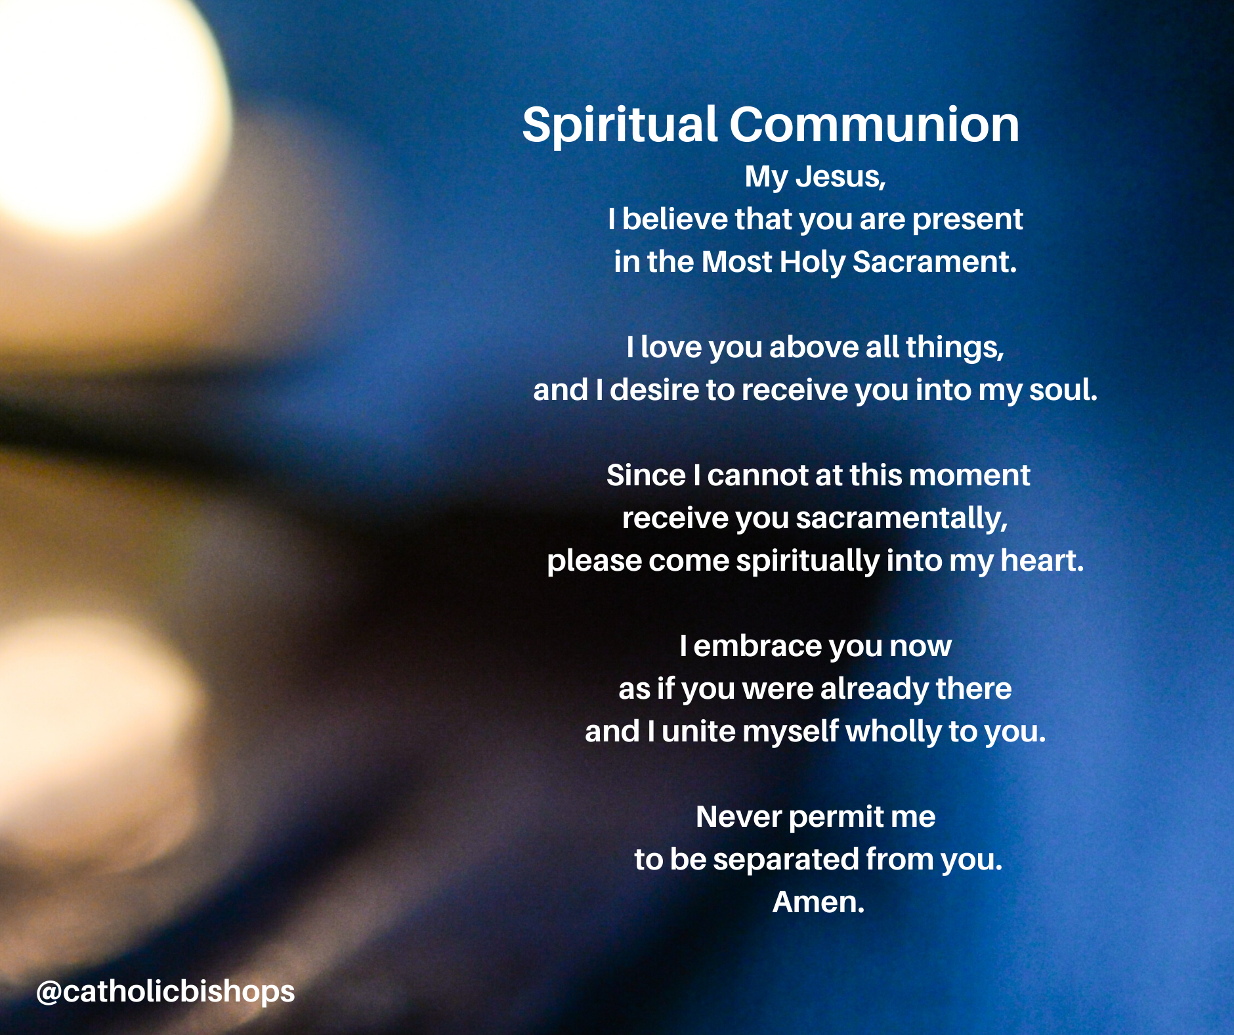

COMECE/CCEE Common Prayer to God for Help
The Presidents of the two bodies representing the Bishops’ Conferences of European
countries (COMECE and CCEE) have released a common prayer to God for help,
comfort and salvation:
God our Father, Creator of the world, almighty and merciful, out of love for us
You sent your Son into the world as the doctor of our souls and our bodies,
look upon your children who, in this difficult time of confusion and dismay in
many regions of Europe and the world, turn to you seeking strength, salvation
and relief, deliver us from illness and fear, heal our sick, comfort their families, give wisdom
to our rulers, energy and reward to our doctors, nurses and volunteers, eternal
life to the dead. Do not abandon us in the moment of trial but deliver us from all
evil.
We ask this of Thee, who with the Son and the Holy Spirit, live and reign for
ever and ever.
Amen.
Mary, mother of health and hope, pray for us!
May our blessing be with you,
Jean-Claude Card. Hollerich SJ
Archbishop of Luxembourg
President of COMECE
Angelo Card. Bagnasco
Archbishop of Genoa
President of CCEE

Give Us This Day – texts for Morning and Evening Prayer

Give Us This Day is published by Liturgical Press, Collegeville, MN, USA and it contains texts for a Morning and Evening Prayer, for Mass with daily reflections, commentary on Scriptures, as well as prayers, hymns and colour images. This translation of the Scriptures is that which is used by the Church in the US. Visit GUTD.net and select ‘Digital’ in the upper right hand corner of the screen. Then download the full PDF colour edition on the right hand side of the browser (Chrome is the preferred browser for use with this resource). You can also access this resource by downloading the Give Us This Day app directly from the Apple and Google stores.

A Coronavirus Prayer

Loving and healing God,
we, the people of Ponders End turn to you in prayer,
confident that you are with us and with all people in every moment.
We stand before you as people of hope, trusting in your care and protection.
May your faithful love support us and soothe the anxiety of our hearts.

Generous God,
fill us with compassion and concern for others, young and old,
that we may look after one another in these challenging days.
Bring healing to those who are sick with the virus and be with their families.
May those who have died rest in your eternal embrace.
Comfort their family and friends.
Strengthen and protect all medical professionals caring for the sick
and all who work in our medical facilities.
Give wisdom to leaders in healthcare and governance
that they may make the right decisions for the well-being of people.
We pray in gratitude for all those in our country who will continue to work in the days ahead in so many fields of life for the sake of us all.
Bless them and keep them safe.

O God of creation and life,
we place ourselves in your protection.
May the mantle of your peace enfold us this day and tomorrow.
St Brigid, pray for us.
St George, pray for us.
St Lazerian, pray for us.
May all the saints of God, pray for us. Amen.

A Prayer for Healthcare Workers during this time of the Coronavirus COVID-19
Loving God,
we place into your care
all our doctors, nurses and healthcare workers.
Give them courage of heart
and strength of mind and body.
Keep them safe from harm.
May they know our deep gratitude
for all they are doing
to heal and help those affected by
the coronavirus.
God of all consolation
may they know your protection and peace.
Bless them in these challenging days
and bless their families.
Amen.
A Prayer for our Priests as they exercise their ministry during this time of the Coronavirus COVID-19
Eternal God,
Be with our priests this day as they seek
to minister to your people.
May you be a guiding and protective presence with them
as they bring the consolation and hope of Your word
and the grace and nourishment of Eucharist
to those entrusted into their care.
Grant them the strength of mind and body,
keep them safe to do your will,
And give them the courage and peace
to face each day with trust and confidence in You.
Into your hands O God, we commend them;
fill them with your grace and healing.
Amen.
Holy Michael the Archangel,
defend us in the battle.
Be our protection against the wickedness
and snares of the devil.
Rebuke him, O God, we humbly beseech thee;
and do thou, O Prince of the
heavenly host, by the divine power,
cast into hell Satan and
all the other evil spirits
who wander through the world
seeking the ruin of souls. Amen.

Lockdown – A Reflection by Brother Richard Hendrick OFM Cap
Yes there is fear.
Yes there is isolation.
Yes there is panic buying.
Yes there is sickness.
Yes there is even death.
But,
They say that in Wuhan after so many years of noise
You can hear the birds again.
They say that after just a few weeks of quiet
The sky is no longer thick with fumes
But blue and grey and clear.
They say that in the streets of Assisi
People are singing to each other
across the empty squares,
keeping their windows open
so that those who are alone
may hear the sounds of family around them.
They say that a hotel in the West of Ireland
Is offering free meals and delivery to the housebound.
Today a young woman I know
is busy spreading fliers with her number
through the neighbourhood
So that the elders may have someone to call on.
Today Churches, Synagogues, Mosques and Temples
are preparing to welcome
and shelter the homeless, the sick, the weary
All over the world people are slowing down and reflecting
All over the world people are looking at their neighbours in a new way
All over the world people are waking up to a new reality
To how big we really are.
To how little control we really have.
To what really matters.
To Love.
So we pray and we remember that
Yes there is fear.
But there does not have to be hate.
Yes there is isolation.
But there does not have to be loneliness.
Yes there is panic buying.
But there does not have to be meanness.
Yes there is sickness.
But there does not have to be disease of the soul
Yes there is even death.
But there can always be a rebirth of love.
Wake to the choices you make as to how to live now.
Today, breathe.
Listen, behind the factory noises of your panic
The birds are singing again
The sky is clearing,
Spring is coming,
And we are always encompassed by Love.
Open the windows of your soul
And though you may not be able
to touch across the empty square,
Sing.
Brother Richard Hendrick, 13 March 2020

Prayer of Saint John Henry Newman
