'GOD WHO SPEAKS' The Year Of The Word (30th September 2019 – 31st December 2020)

'The God Who Speaks' The Year of the Word
30th Sep'19 - 31st Dec '20

celebrating, living and sharing God's word

Launch: 30th September 2019

- Feast of St Jerome
http://www.cbcew.org.uk/home/events/the-god-who-speaks/

The Catholic Bishops’ Conference of England and Wales have designated 2020 as 'The God Who Speaks': A Year of the Word to celebrate the 10th anniversary of Verbum Domini - Pope Benedict XVI’s Apostolic Exhortation on ‘The Word of the Lord’, and the 1600th anniversary of death of St Jerome, who translated the Bible into Latin.
Therefore, 2020 will be a year of celebrating, living and sharing God's word, through a range of events, activities and resources, available across the Diocese of Westminster.

We are invited to listen afresh to the word of God as did Our Blessed Lady at the Annunication, to encounter anew the presence of that word, and to proclaim it afresh in the Church and the World.
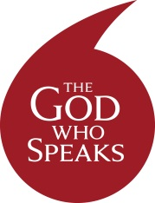

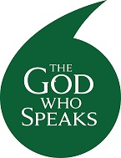

This academic year the Catholic Bishops’ Conference of England and Wales have designated as 'The God Who Speaks - A Year of the Word’ to celebrate the 10th anniversary of Verbum Domini - Pope Benedict XVI’s Apostolic Exhortation on ‘The Word of the Lord’, and the 1600th anniversary of the death of St Jerome, who translated the Bible into Latin. In keeping with the Church’s three year cycle there will also be a specific focus on St Matthew’s Gospel.

The aim of The God Who Speaks - A Year of the Word is ‘Celebrating, Living and Sharing God‘s Word.’ It will be an opportunity in our school to enrich current scripture practices and to develop and explore new ways of responding to the Bible.

The year begins on the 30th September when the Cardinal will release a video from the National Gallery launching the year using a painting of St Jerome. There will be two subsequent videos released on the 1st December 2019 and 26th February 2020 to mark the beginning of Advent and Lent. The year will end on the 31st December 2020.

There is also a website dedicated to ‘The God Who Speaks - A Year of the Word’ which can be found using this link - http://www.cbcew.org.uk/home/events/the-god-who-speaks/

