ST MARY’S CATHOLIC PRIMARY SCHOOL

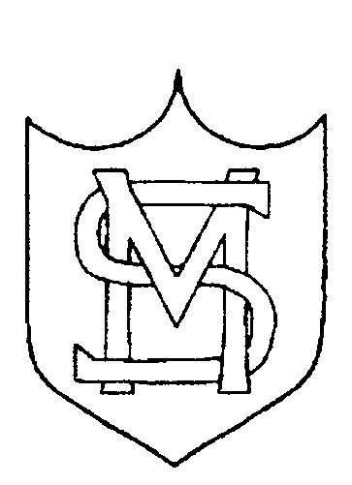

END OF KEY STAGE 2 ACHIEVEMENT OVERVIEW 2017

Mission Statement

St. Mary’s school community follows the teachings of Jesus Christ, working together to develop the whole child, in a spiritual, moral, academic, physical, social and emotional way, within a caring and supportive environment.

END OF KEY STAGE 2

 | SUBJECT | EXPECTED STANDARD | HIGHER STANDARD
National 2017 | Reading | 71% | 25%
School 2017 | Reading | 88% | 45%
National 2017 | Mathematics | 75% | 23%
School 2017 | Mathematics | 90% | 42%
National 2017 | Grammar, Punctuation and Spelling | 77% | 31%
School 2017 | Grammar, Punctuation and Spelling | 95% | 75%
National 2017 | Writing | 76% | 18%
School 2017 | Writing | 92% | 28%
National 2017 | Science | 82%
School 2017 | Science | 90%

Reading, Writing and Mathematics (combined)

 | School | Local Authority | National
% of pupils achieving the expected standard in reading, writing and mathematics | 83% | 59% | 61%
% of pupils achieving the higher standard in reading, writing and mathematics | 22% | 8% | 9%

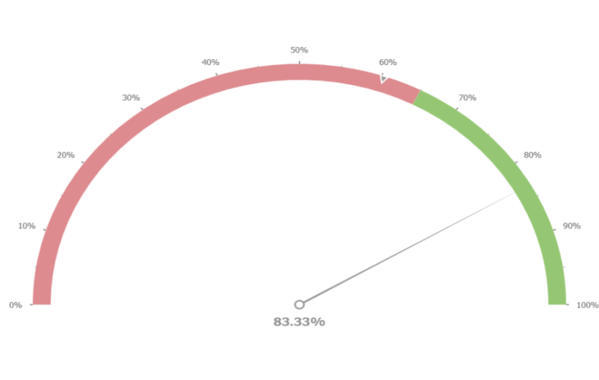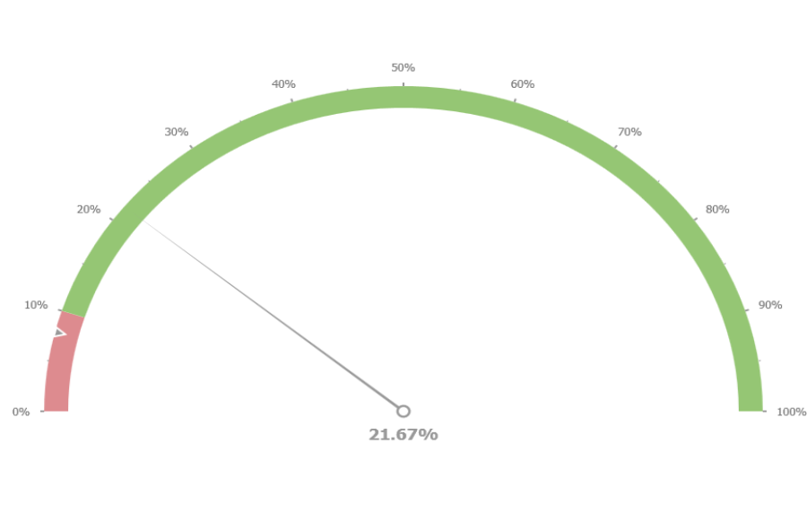

Average Scaled Score

 | School | Local Authority | National
Reading | 107.8 | 103.0 | 104.1
Mathematics | 107.7 | 104.2 | 104.2
Grammar, Punctuation and Spelling | 112.6 | 106.5 | 106.0

Progress

Subject | Progress Score | Progress Rate
Reading | +2.51 | Above Average
Writing | +1.66 | Above Average
Mathematics | +2.49 | Above Average

