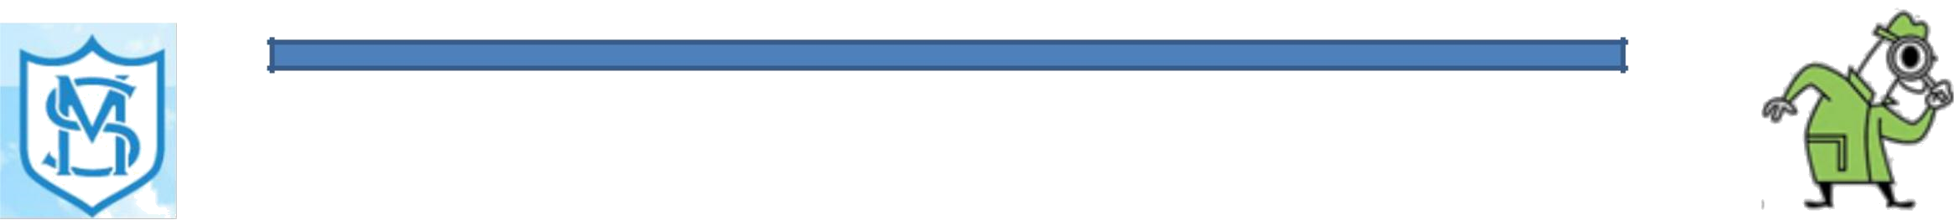
St Mary’s Catholic Primary School- Science 2019-2020
What is Science at St Mary’s?
Science excites, stimulates and incites awe in pupils regarding the world around them.
Year | Topics Studied
Groups
EYFS | Children know about similarities and differences in relation to
 | places, objects, materials and living things. They talk about the features of their
 | own immediate environment and how environments might vary from one
 | another. They make observations of animals and plants, and explain why some
 | things occur, and talk about changes.
Year 1 | Everyday materials
 | Seasonal changes
 | Plants
 | Animals (including humans)
Year 2 | Use of everyday materials
 | Plants
 | Living things and their habitats
 | Animals (including humans)
Year 3 | Rocks
 | Forces and Magnets
 | Animals (including humans)
 | Plants
 | Light
Year 4 | Animals (including humans)
 | States of matter
 | Living things and their habitats
 | Electricity
 | Sound
Year 5 | Living things and their habitats
 | Earth and space
 | Animals (including humans)
 | Properties and changes of materials
 | Forces
Year 6 | Electricity
 | Living things and their habitats
 | Light
 | Evolution and Inheritance
 | Animals (including humans)

Our approach to science fosters a positive attitude, confidence both inside and outside of the classroom, and a high level of engagement towards their learning.
Pupils will make links between their scientific knowledge, the world around them, and other parts of the curriculum.

Science Aims At St Mary’s
The aim of teaching Science at St Mary’s School is to:
- Provide children with high quality scientific experiences that develop their understanding.
- Introduce and extend children’s knowledge of scientific ideas.
- Inspire children to investigate and explore the world
around them.
• Enable children to communicate their ideas using scientific vocabulary.
- Engage pupils as learners, through linking ideas with
practical experiences.
  - Help pupils to question and discuss scientific issues.
    - Encourage safety and awareness of risk
- Develop enquiry skills of predicting, questioning, inferring,
concluding and evaluating.
- Provide pupils with the competence and confidence to deal with a life in an increasingly scientifically complex society.
  - Show pupils how major scientific ideas contribute
to technological change.
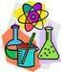
    - Encourage children to challenge themselves and further.

Assessment
Assessment for learning will take place following the completion of a unit. Each term, children will take a
general science assessment. Reporting to parents occurs annually in
written form at parent’s evening and in the form of the child’s report.

St Mary’s Catholic Primary School- Science 2019-2020

Examples of Work
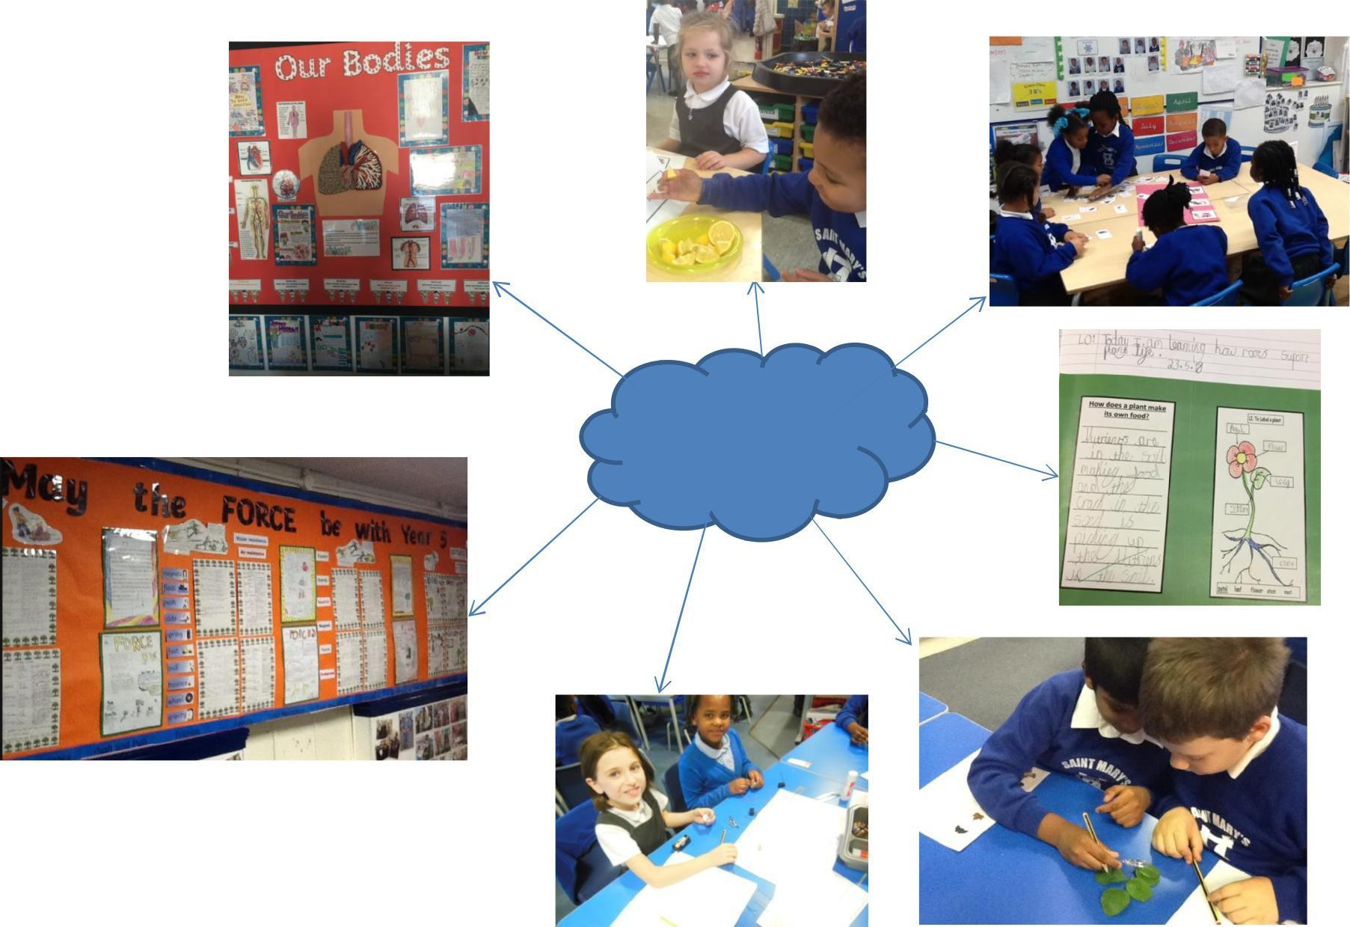
Examples of
our Science work

St Mary’s Catholic Primary School- Art 2019-2020

What is Art?
Year Groups | Topics Studied
EYFS | Exploring and Using Media and Materials
 | Being Imaginative
 | Using collage
 | Recognising primary colours
 | Studying Warhol
Year 1 | Self Portraits
 | Fairy Tale Pictures
 | Kandinsky
 | Using clay
Year 2 | Self-Portraits
 | Vincent Van-Gogh
 | Using different Mediums
Year 3 | Egyptian Art
 | Weather in Art
 | Roman Art
Year 4 | William Morris
 | Pablo Picasso
 | Jamaican Art
 | Portraits of Henry VIII
Year 5 | Mayan Art
 | Art linked with Kensuke’s Kingdom
 | Viking Art
 | Kandinsky
Year 6 | L.S Lowry
 | A sense of Place
 | Investigating Pattern (William Morris)
 | Victorian art and Puppetry

St Mary’s Primary school delivers the Art curriculum both as a stand-alone subject butSchoolalsolinedwith- Artthetopic2018oftheterm-2018orhalfterm. Children will
always haveExamplesaspecificartskillasofafocusWorkforthelesson and they are
continuously being challenged to refine and hone their art skills.
Your child will develop their skills within drawing, painting, printing, clay and textiles. Children will learn that art skills can be developed and built upon, throughout the school, and they will learn how to plan and produce a final piece of work within or linked to various topics.
At times they will use sketchbooks to focus on building skills within drawing and painting or as a reference when evaluating finished pieces.

Art Aims

Produce creative work, exploring their ideas and recording their experiences
Become proficient in drawing, painting, clay sculpture and print making Evaluate and analyse creative works
Know about great artists and understand the historical and cultural development of their art forms.

Assessment
Assessment for learning will take place on a continual basis using techniques such as
teacher observation, group discussions and questioning but is formally recorded once a term. Reporting to parents will occur annually in the form of a written report at the end of the year, and through ‘Parent’s evening’.

St Mary’s Catholic Primary School- Art 2019-2020 Examples of Work
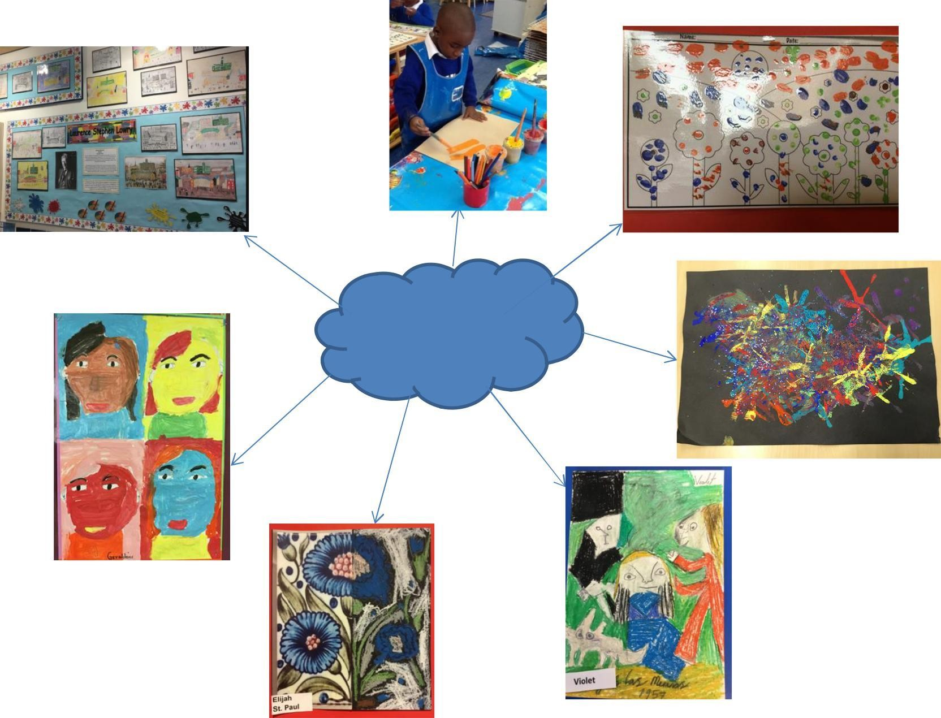
Examples of
our Art work

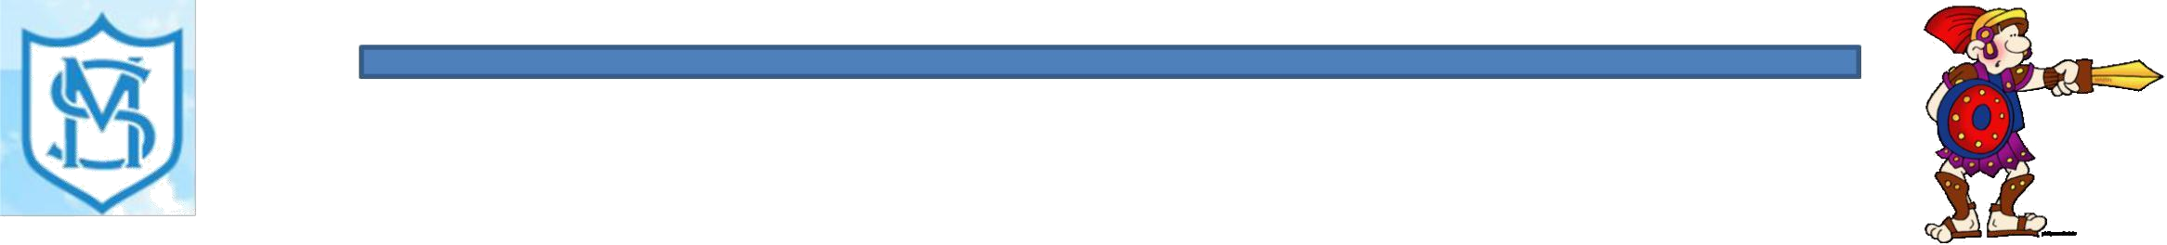

St Mary’s Catholic Primary School- History 2019-2020
What is History?
Year Groups | Topics Studied
EYFS | Children know about similarities and differences in relation to places, objects, materials and living
 | things. They talk about the features of their own immediate environment and how environments
 | might vary from one another.
 | They make observations of animals and plants, and explain why some things occur, and talk about
 | changes.
Year 1 | Toys from the past: What are you favourite toys? What is old? What is new? What does it mean
 | to ‘change’? What are the characteristics of modern toys? Who might be able to tell us more
 | about toys from the past?
 | Seaside holidays in the past: When do we have holidays? What were seaside holidays like for our
 | parents? What is different/similar about seaside holidays then and now? What do souvenirs tell
 | us about seaside holidays in the past?
Year 2 | Significant people: How can we find out about the past? Who is Neil Armstrong? What did he do?
 | When was he born? When was the moon landing? What was the moon landing?
Year 3 | The Egyptians: Who were the Egyptians? Why was the Nile so important? What was the Rosetta
 | Stone? What jobs did they do? Who was the Pharaoh? What was his role?
 | The Romans: When and where did the Romans live? Who were the Romans? How do we know
 | about Boudicca? Why were the Romans so good at fighting? What did Romans eat?
Year 4 | The Ancient Greeks: Who were the Greeks? What landmarks are they famous for? How were the
 | lives of men, women and children different in Greece? What was Athens and Sparta? Why were
 | Greek soldiers so powerful?
 | The Tudors: How many times did Henry VIII marry? What was Henry VIII like as a person? What
 | did Henry do all day? Why did his marriages fail? What was different about the rich and poor?
Year 5 | The Mayan Civilisation: Who were the Mayans? Where did they live? Who had the best/worst
 | lifestyle? What places or buildings are the Mayans famous for? What did they eat?
 | Vikings: Where did the Vikings come from? How did they travel? Why did they raid monasteries?
 | Who was King Alfred the Great?
Year 6 | The Anglo-Saxons: Who were the Anglo Saxons? Where did they settle? What were their religious
 | beliefs? What happened at Sutton Hoo?
 | How did our locality change in Victorian times? What was our locality primarily used for? How
 | has the land changed? What caused these changes? What was the effect?

History is the study of events over time. It covers how the past influences our lives and shapes our customs and beliefs. History helps children to develop a sense of identity and make sense of the world they live in.

History and the Primary Curriculum
At St Mary’s Primary School, the curriculum is delivered through the use of specific topics to aid learning which can very often be cross-curricular. Therefore, the knowledge and skills taught in History are embedded within a cross- curricular approach.

History Aims
The aim of teaching History at St Mary’s School is;
-to stimulate the children’s interest and curiosity about the
past
-to foster interest and enjoyment in learning through the use of artefacts, practical activities and outings.
-to enable children to gain knowledge and understanding about historical periods, significant events in the past and lives of people in the past and to appreciate how things have changed over time.
-to develop a sense of chronology.
-to help children understand society and their place within it so that they develop a sense of their own identity. -to
develop the skills of enquiry, investigation, analysis,
evaluation and problem solving.

Assessment
Assessment for learning will take place on a continual basis using techniques such as
teacher observation, group discussions and questioning but is formally recorded once a term. Reporting to parents will occur annually in the form of a written report at the end of the year, and through ‘Parent’s evening’

St Mary’s Catholic Primary School- History 2019-2020 Examples of Work

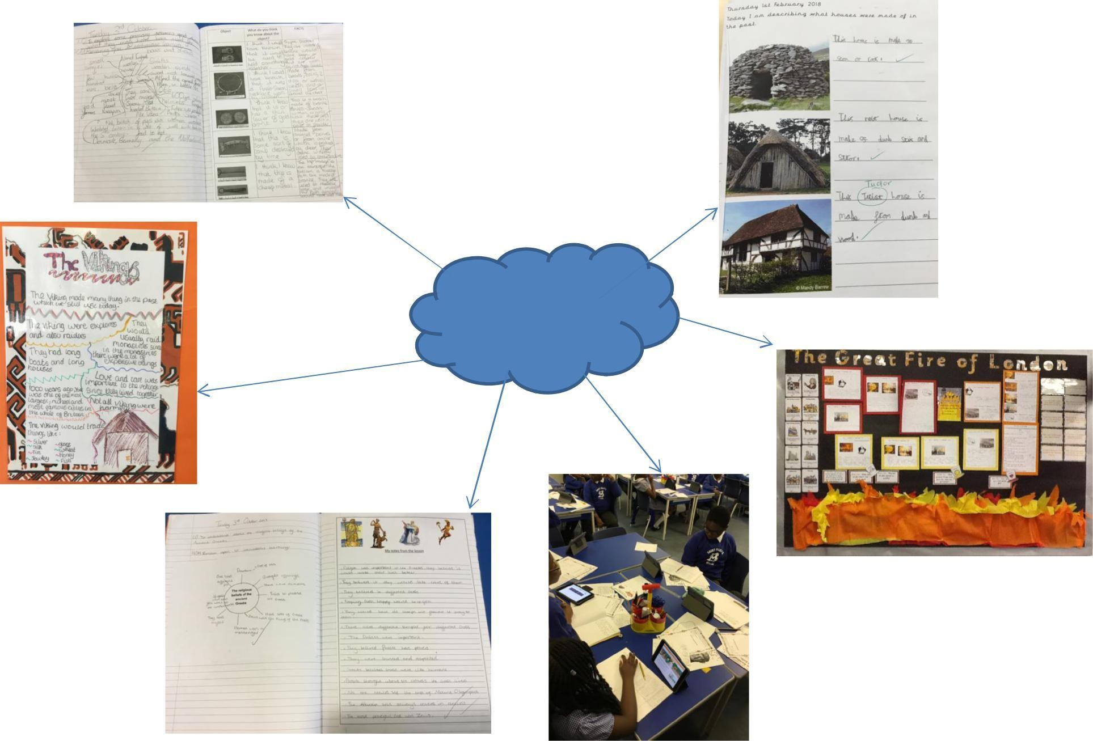
Examples of our History work

St Mary’s Catholic Primary School- Geography 2019-2020

What is Geography?
Geography is essentially about the study of places, the human and physical processes which shape them and the people who live in them. It is not simply learning about countries and what the weather is like. Skills developed through Geography help pupils to make sense of their surroundings and the wider world.
Year | Topics Studied
Groups
EYFS | Children talk about past and present events in their own lives and in the lives of
 | family members. They know that other children don’t always enjoy the same
 | things, and are sensitive to this. They know about similarities and differences
 | between themselves and others, and among families, communities and traditions.
Year 1 | Our Local Area: What are our immediate surroundings like? What jobs do people
 | do near me? How do people spent their leisure time? What changes are taking
 | place?
 | Our Country- The UK: Where do I live? Where is the UK on the map? What
 | continent so I live on?
Year 2 | Human and Physical Geography: What are the seasons? What is a daily weather
 | pattern? How can we describe physical and human features using geographical
 | vocabulary?
 | Location and Place Knowledge: What is a continent? How many continents are
 | there? What are the oceans? How many are there?
Year 3 | Weather Around the World: What types of weather do we know? What is a
 | weather forecast? Why are some places in the world hot/cold? How might
 | weather affect choices made around a holiday?
Year 4 | A Contrasting Locality- Jamaica: What links does Jamaica have with Britain? What
 | jobs are available in Jamaica? What food is grown in or comes from Jamaica?
 | What is Jamaica commerce like?
Year 5 | Coasts: What is a coast? What is coastal erosion? How can we prevent coastal
 | erosion? What are coastal defences?
Year 6 | The Mountain Environment: What is a mountain environment? Where are
 | mountain environments found? What are these places like? How are mountain
 | ranges formed? How does weather compare in these places?

Geography and the Primary Curriculum
At St Mary’s Primary School, the curriculum is delivered through the use of specific topics to aid learning which can very often be cross-curricular.
Therefore, the knowledge and skills taught in History are embedded within a cross-curricular approach.

Geography Aims
The aim of teaching Geography at St Mary’s is;
--to stimulate interest in, and to encourage an appreciation of the world around us.
--to enable children to gain knowledge and understanding of places and themes.
--to encourage children to investigate and ask questions about real people in real places and their interaction with the environment.
--to gain a greater understanding of the ways of life and cultures of people in other places.
--to help children begin to understand their own role and the role of others in influencing their environment.
--to become competent in the geographical skills needed to collect, analyse and communicate geographical data.
--to help children understand the relationship of their actions to their health and to the welfare of others.
-to help children to learn graphic skills, including how to use, draw and interpret maps.

Assessment
Assessment for learning will take place on a continual basis using techniques
such as teacher observation, group discussions and questioning but is formally recorded once a term. Reporting to parents will occur annually in the form of a written report at the end of the year, and through ‘Parent’s evening’

St Mary’s Catholic Primary School- Geography 2019-2020

Examples of Work

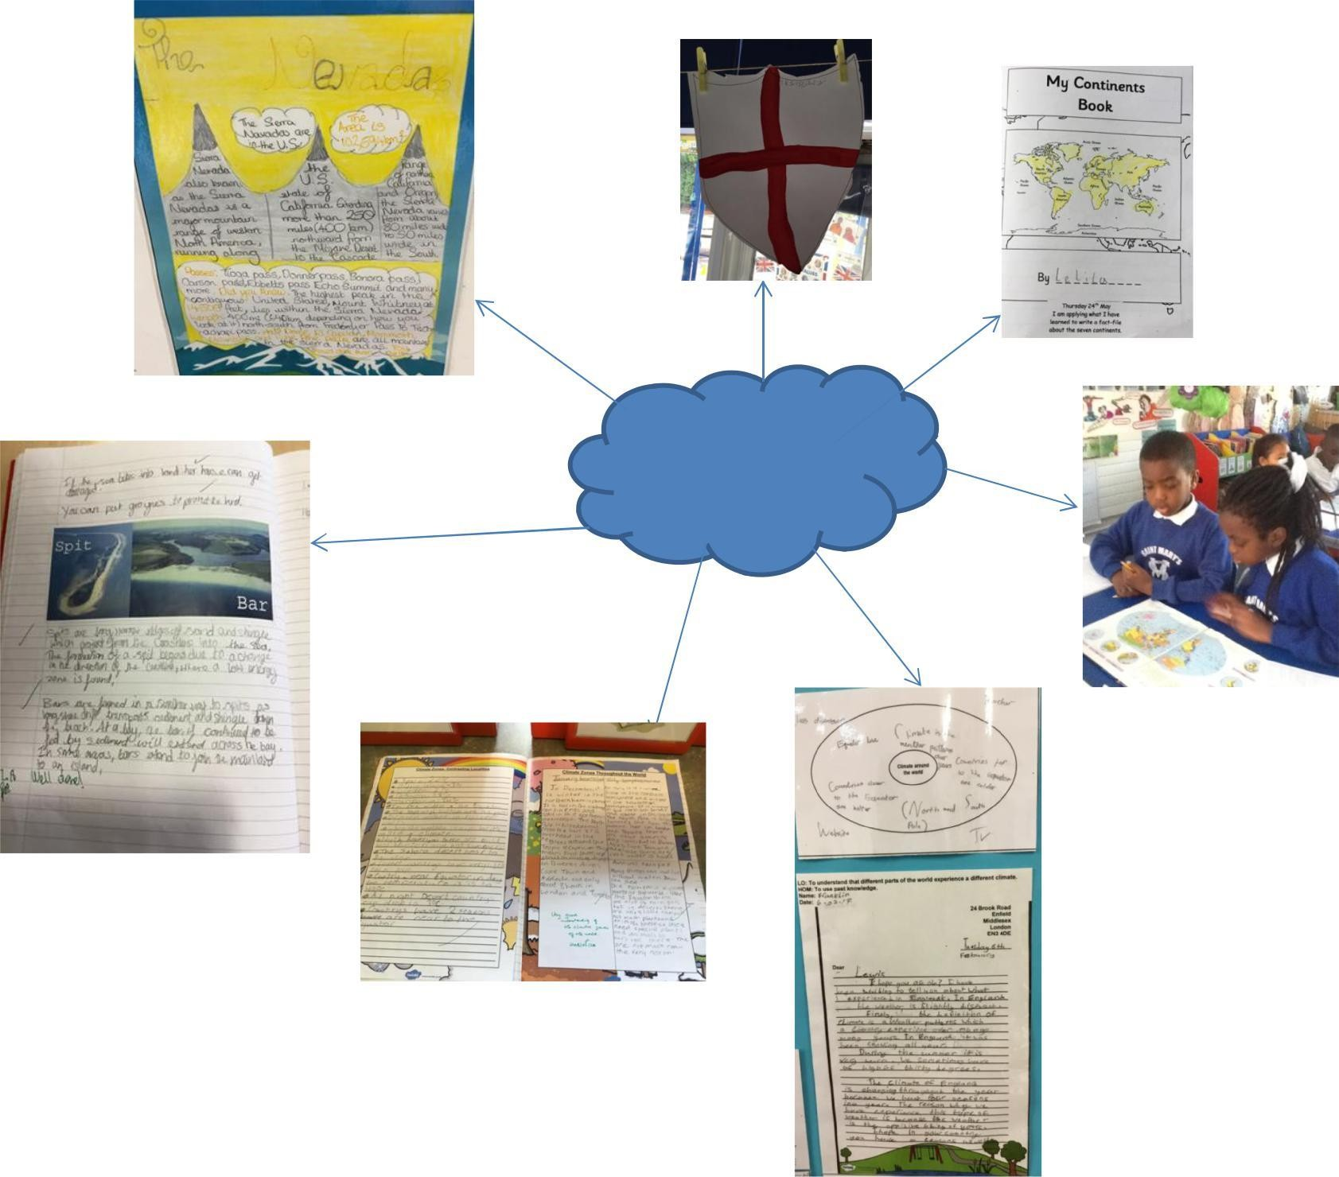
Examples of our Geography work

St Mary’s Catholic Primary School- D&T 2019-2020

What is Design and Technology?
Year Groups | Topics Studied
EYFS | Exploring a variety of resistant materials such as wood,
 | thick card and ridged plastic. Learn about cutting and
 | joining materials and about how to decide whether or not
 | different materials are fit for their purpose. Learn necessary
 | skills to handle tools, equipment and materials safely and
 | effectively.
Year 1 | Moving Pictures
 | Making porridge/fruit salad
 | Healthy Pizza
Year 2 | Rocket Making
 | Healthy Eating
 | Making Moving Vehicles
Year 3 | Egyptian Hieroglyphic Hanging
 | Weather Biscuits
 | Roman Boat Models
Year 4 | Making Containers
 | Making a money purse
 | Making a Tudor house
Year 5 | A Mayan Wall Hanging
 | Island biscuits
 | Viking longboat models
Year 6 | Strong Structures
 | Cooking and Nutrition
 | Fairground Rides

Design and technology is an inspiring, rigorous and practical subject. Using creativity and imagination, pupils design and make products that solve real and relevant
problems within a variety of contexts, considering their own and others’ needs, wants
and values.

Design and Technology and the Primary Curriculum
Often our Design and Technology units are taught with a cross curricular link and have been inspired by our History or Geography topics. Each year children design, plan, make and evaluate their own products in purposeful projects, develop knowledge and understanding in technical mechanisms and develop skills when working with a variety of materials.

Design and Technology Aims
The aim of teaching Design Technology at St Mary’s School is to:
- Develop the creative, technical and practical expertise needed to perform everyday tasks confidently and to participate successfully in an increasingly technological world.
* Build and apply a repertoire of knowledge, understanding and skills in order to design and make high quality prototypes and products for a wide range of users.
* Critique, evaluate and test their ideas and products and the work of others.
* Understand and apply the principles of nutrition and learn how to cook.

Assessment
Children’s designs and evaluations will be assessed in a variety of ways;
-annotated pictures and diagrams
-detailed instructions
-well-structured evaluations
-photo evidence of practical activities
Formal assessments will be made once a term and will be reported to parents at both
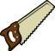
the Spring parent’s evening and in the annual end of year written report.

St Mary’s Catholic Primary School- D&T 2019-2020 Examples of Work

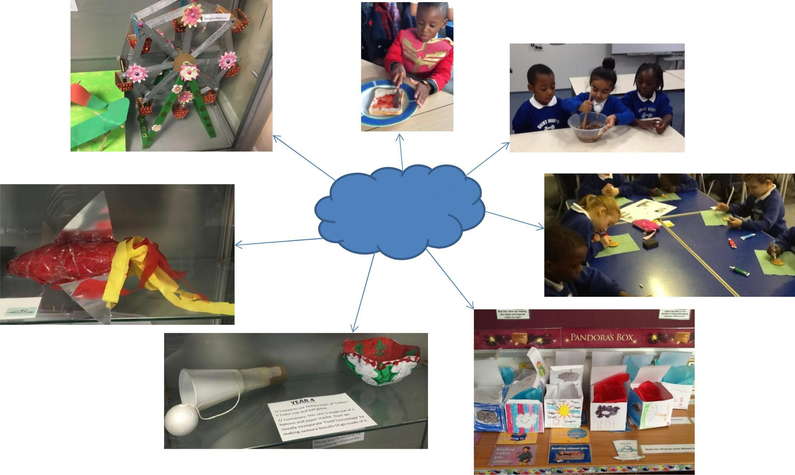
Examples of our D&T work

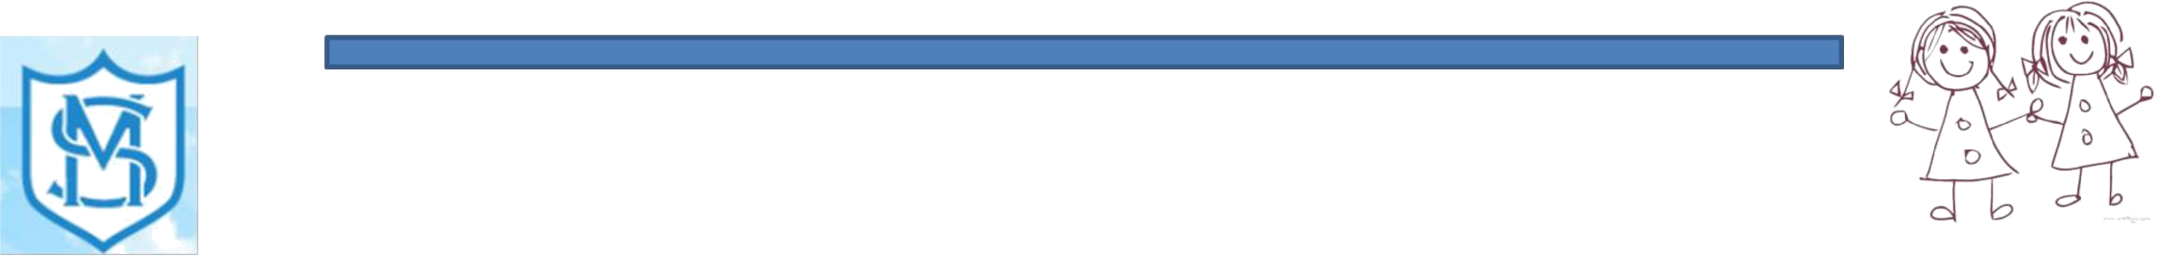PSHE education equips pupils with the knowledge, understanding, skills and strategies required to live healthy, safe, productive, capable, responsible and balanced lives. It encourages them to be enterprising and supports them in positive learning, making effective transitions and in understanding economic wellbeing. A critical component of PSHE education is providing opportunities for children and young people to reflect on and clarify their own values and attitudes and explore the complex and sometimes conflicting range of values and attitudes they encounter now and in the future.
St Mary’s Catholic Primary School- PSHE 2019-2020
What is PSHE?
Year Groups | Topics Studied
EYFS | PHSE OBJECTIVES COVERED | SEAL UNITS
 | 1. Developing confidence and | New Beginnings
 | responsibility and making the most | Getting On and Falling Out
 | of my abilities. | Say no to Bullying
 | 2. Preparing to play an active role as | Going For Goals
 | citizens | Relationships
 | 3. Developing a healthy, safer | Good to be Me
 | lifestyle | Changes
 | 4.Developing good relationships and
 | respecting the differences between
 | people
Year 1
Year 2
Year 3
Year 4
Year 5
Year 6

PSHE and the Primary Curriculum
PSHE contributes significantly to the teaching of English in our school by actively promoting the skills of reading, writing, speaking and listening. Children develop oracy through discussing questions or presenting their findings to the rest of the class. PSHE
teaching significantly contributes to the teaching of Mathematics by promoting the skills
of money and money management linked to budgeting. Children use Computing in PSHE to enhance their understanding of how the digital media affects theirs’ and others’ point of view by researching information using the Internet. PSHE contributes significantly to the teaching of History as children develop self-confidence by having opportunities to explain their views on a number of historical and social questions. They learn how society is made up of people from different cultures and start to develop tolerance and
respect for others. PSHE contributes greatly to the children’s SMSC (social, moral, cultural and spiritual development). Through relevant discussion children are taught how to explore their understanding and thinking about the world around them whilst listening to and reflecting upon the views of others.

The aims of PSHE in our school are:
develop confidences and responsibilities and make the most of their abilities prepare to play an active role as citizens
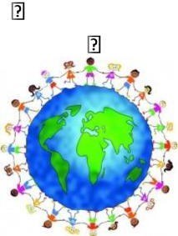develop a healthy, safe lifestyle with the ability to make appropriate risk assessments develop good relationships and respect the differences between people
understand some basic principles of finances
make a positive contribution to the life of the school be positive and active members of a democratic society
develop self-confidence and self-esteem; make informed choices.

St Mary’s Catholic Primary School- PSHE 2019-2020

Examples of Work

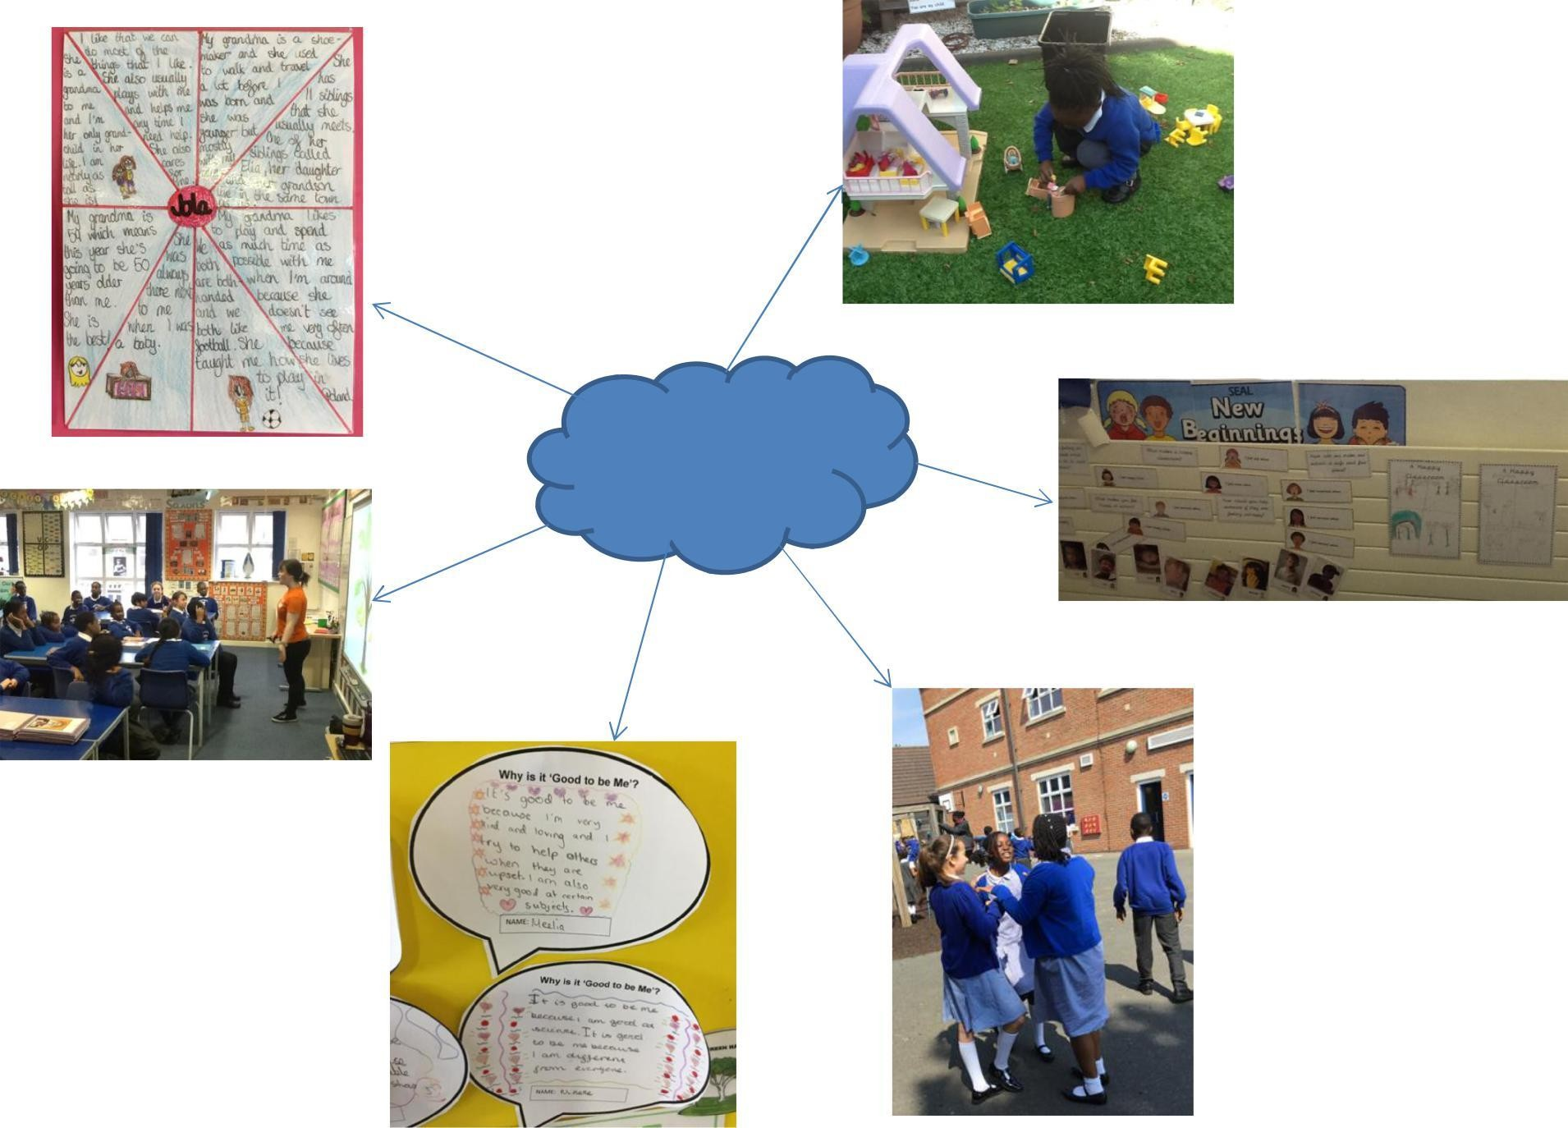
Examples of our PSHE work

St Mary’s Catholic Primary School- Music 2019-2020
What is Music?
Music is a universal language that embodies one of the highest forms of creativity. A high-quality music education should engage and inspire pupils to develop a love of music and their talent as musicians, and so increase their self-confidence, creativity and sense of achievement. As pupils progress, they should develop a critical engagement with music, allowing them to compose, and to listen with discrimination to the best in the musical canon.
Year Groups | Topics Studied
EYFS | Joining in with dancing and ring games, singing, moving
 | rhythmically, imitate movement in response to music and
 | performing together. Exploring instruments.
Year 1 | Sounds All Around
 | Musical Instruments and Composition
 | Pitch and Singing
Year 2 | Long and Short Sounds with their voices and instruments
 | Percussion Instruments
 | Feel the Pulse
Year 3 | Learning to play the Recorder
 | Composing their own pieces based on environment and
 | poetry.
Year 4 | Choral Work
 | Go for Gold
 | Exploring composition and Pitch
Year 5 | Enfield sings
 | Cyclic Patterns
 | Exploring tuned instruments, pulse, percussion, rhythm and
 | beat.
Year 6 | Music Express Scheme: Roundabout
 | Music Express Scheme: Cyclic Patterns
 | Stars Hide Your Fires

Subject Aims
At St Mary’s, the music curriculum is delivered as an independent subject by a music specialist across KS1 and KS2.
Children will perform, listen to, review and evaluate music across a wide variety of
music across a variety of historical periods, genres, types and traditions.
Children will learn to use their voices and learn to play a variety of instruments and use these skills to compose their own music.
Children will develop an understanding of how music is created, produced and
communicated.
Children will be encouraged to express their ideas and feelings through music. Children will develop resourcefulness and perseverance, tolerance and self-
confidence. They will also develop teamwork skills such as negotiation and discussion.

Music across the curriculum
The children develop many additional skills through their music education. The reading and writing of music links strongly to both literacy and maths and nurtures cognitive thinking. Listening skills are improved due to the discerning activities required in music. Composing and performing music cultivates social and creative skills in equal measure.

Assessment
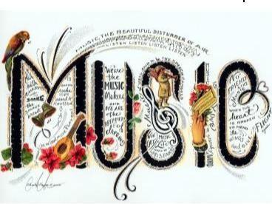
Assessment for learning will take place on a continual basis (although will be formally recorded once a term) using techniques such as teacher observation, group discussions and questioning. Reporting to parents will occur annually in the form of a written report at the end of the year, and through ‘Parent’s evening’.

St Mary’s Catholic Primary School- Music 2019-2020 Examples of Work

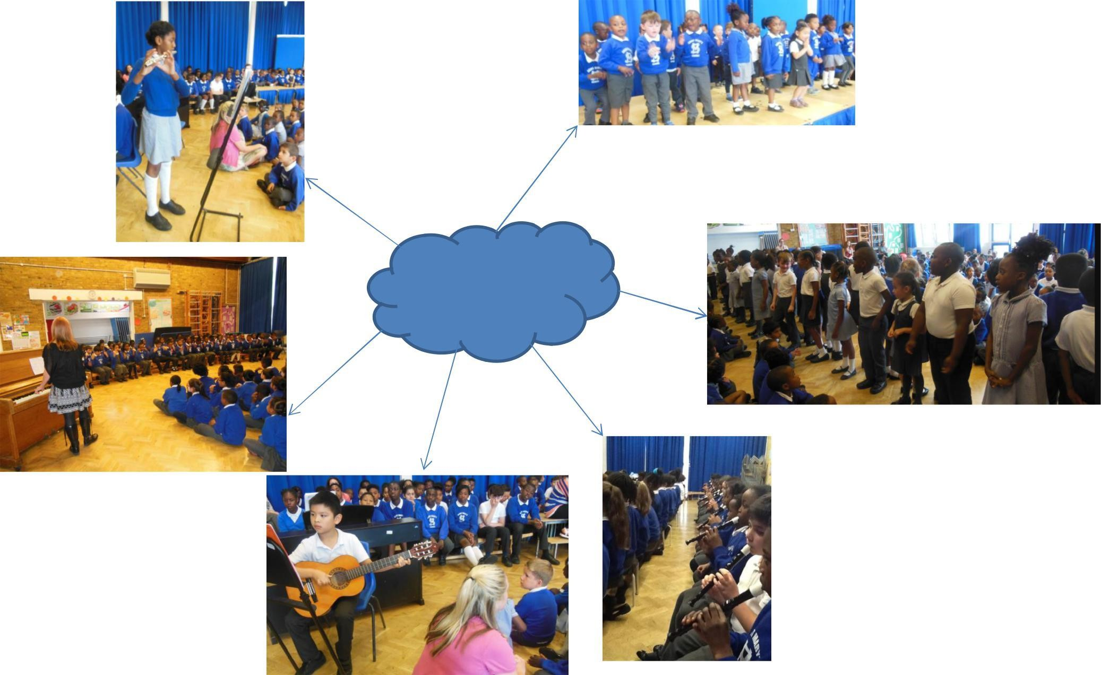
Examples of our Music work

St Mary’s Catholic Primary School- Computing 2019-2020
What is Computing?
Computing is the study of how computers and the computer system works and how they are both constructed and programmed. Its aspects of theory, systems and applications are drawn from the disciplines of technology, design, maths and science. Building on their knowledge and understanding of computer science, pupils are equipped to use information technology to create programs, systems and a range of other content. Computing at St Mary’s also ensures that pupils become digitally literate, providing them with the ability to use and express themselves and develop their ideas through information and communication technology at a level which is suitable for the future workplace and as active participants in the digital world.
Year Groups | Questions Explored
EYFS | In Reception, children will acquire basic skills in turning on and
 | operating some ICT equipment such a mice and keyboards. They
 | will talk about ICT apparatus, what they can do with it and how to
 | use it safely. In addition, they will complete simple programs on a
 | computer and use hardware to interact with age appropriate
 | software.
Year 1 | How do I use a computing independently? How do I record
 | sounds and pictures? How do I present data using pictures? What
 | is an algorithm? What is a program?
Year 2 | How do I use a computer as a writer? How do I create a
 | multimedia story? What is a branching database? How do I
 | improve my algorithms? How do I improve my programs?
Year 3 | What makes a good poster? How do I use the computer as a
 | musician? How do we use data bases to find out information?
 | How do I draw complex shapes in logo? How do I design and
 | program in Scratch?
Year 4 | How do I use the computer as an artist? What makes an excellent
 | multimedia story? How is data shared online? How do I write
 | efficient programs in Logo and Scratch? How do I use interaction
 | to tell stories in Scratch?
Year 5 | How do we collaborate online? How do I create a radio advert?
 | How do I search safely and effectively? How do I program physical
 | systems? How do I create a maths game in Scratch?
Year 6 | How do I use the computer as a designer? What makes an
 | excellent film? Why do we use spreadsheets? How do I build
 | complex systems in Flowol? How do I use Scratch as a gamuese the
 | designer?

Aims of Computing
The aim of teaching Computing at St Mary’s Primary School is to ensure that all
pupils:
  - Can understand and apply the fundamental principles and concepts of computer science, including abstraction, logic, algorithms and data representation.
    - Can analyse problems in computational terms and have repeated practical evidence of writing computing programs in order to solve problems.
    - Can evaluate and apply information technology including new or unfamiliar technologies, analytically to solve problems.
      - Are responsible, competent, confident and creative users of information
and communication technology.

Writing Across the Curriculum:
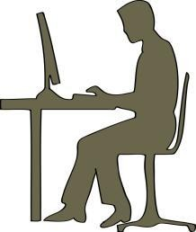
Once children have acquired the necessary skills through explicit computing lessons, they can then use and apply these in order to support and extend their learning in a wide range of curriculum areas. They will
ir technology skills to produce written outcomes, for example in the form of online blogs, posters, news reports and power-point presentations.

St Mary’s Catholic Primary School- Computing 2019-2020

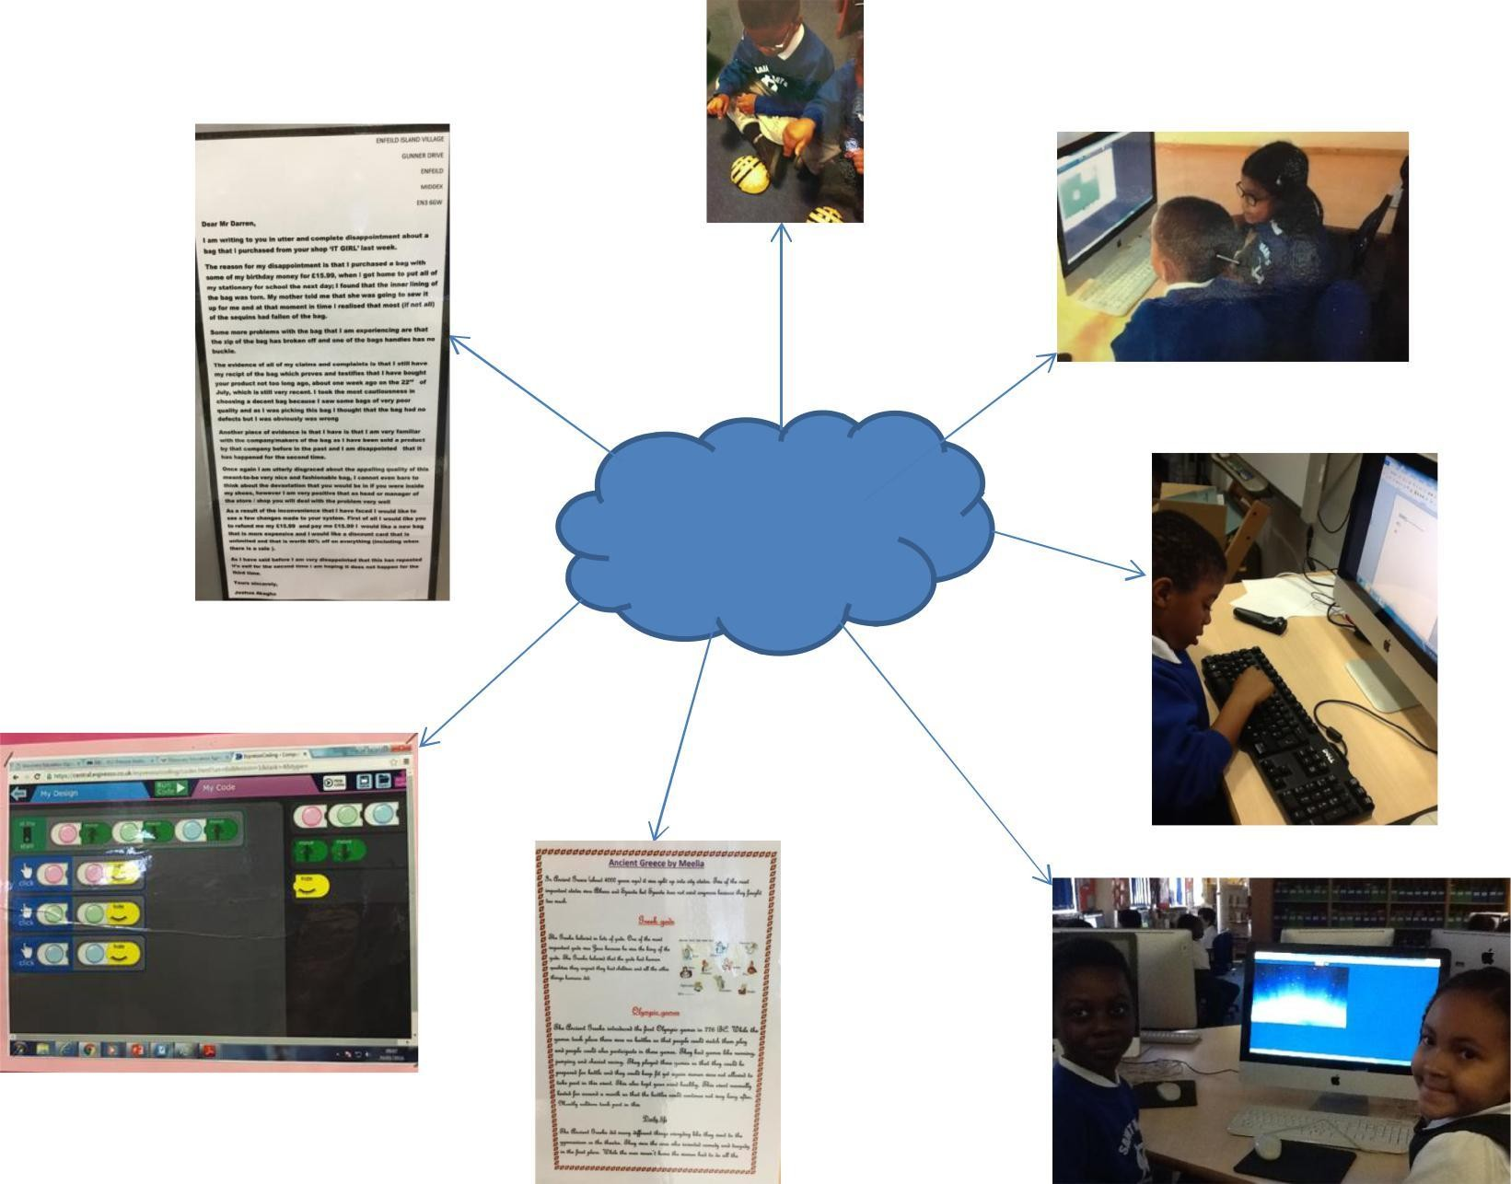Examples of Work
Examples of
our Computing work

Religious Education

St Mary’s Catholic Primary School- RE 2019-2020
Through the Religious Education at St Mary’s, we aim to lead children to a deeper, more living, active and personal faith. This means that we want to help them to meet God, to form a personal relationship with Him, and to respond to Him through prayer, worship and by living as members of our parish/school. To lead children to a living faith we will help them to relate faith to life and to develop a Christian vision of the world and of their lives. This means that we must explore with them their experience of the world and interpret it in the light of faith as a sign of the presence of God and as a place where they are called to follow God’s ways in accordance with the teaching and example of Jesus Christ in the power of the Holy Spirit. We plan to achieve these aims through our RE programme, the ‘Resource Framework for Religious Education in Catholic Schools in the Diocese of Westminster’, in which the ‘Religious Education Curriculum Directory’ is central to teaching RE. This framework is an exemplar resource that models the linear teaching of content according to the Attainment Levels.
Year Groups | Units Covered
EYFS | Beginnings
 | From Advent to Christmas
 | Sacramental People
 | From Lent to Easter
 | From Easter to Pentecost
 | A Virtuous Life
Year 1 | Beginning with God
 | From Advent to Christmas
 | Jesus at Prayer
 | From Lent to Easter
 | To Easter to Pentecost
 | Discipleship
Year 2
Year 3
Year 4
Year 5
Year 6

Aims for each child at St Mary’s Catholic Primary School
Whilst at St Mary’s School I will learn about being a Christian, I will experience the
beliefs, traditions and practices of the Catholic Faith.
I will achieve as much as I possibly can in each area of the National Curriculum. I will know how to learn and enjoy learning and will view work in a positive and
conscientious manner.
I will co-operate and communicate with others effectively, independently and in a group and try to win and lose graciously.
I will tolerate and respect the religious beliefs, views and values of others,
understand the need for good behaviour and moderate my behaviour accordingly.
I will respect the belongings and property of others.
If I have a problem I know I can find someone who will discuss it with me.
I will try to learn from mistakes and accept there is always room for improvement. I will share a sense of responsibility for my school, parish, local community and the wider environment.

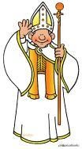
Assessment
Pupils will be formally assessed following the completion of each unit of work. These assessment score will be provided for parents both on parent’s evening and in their child’s formal written report. RE is still currently assessed using levels.

St Mary’s Catholic Primary School- RE 2019-2020 Examples of Work
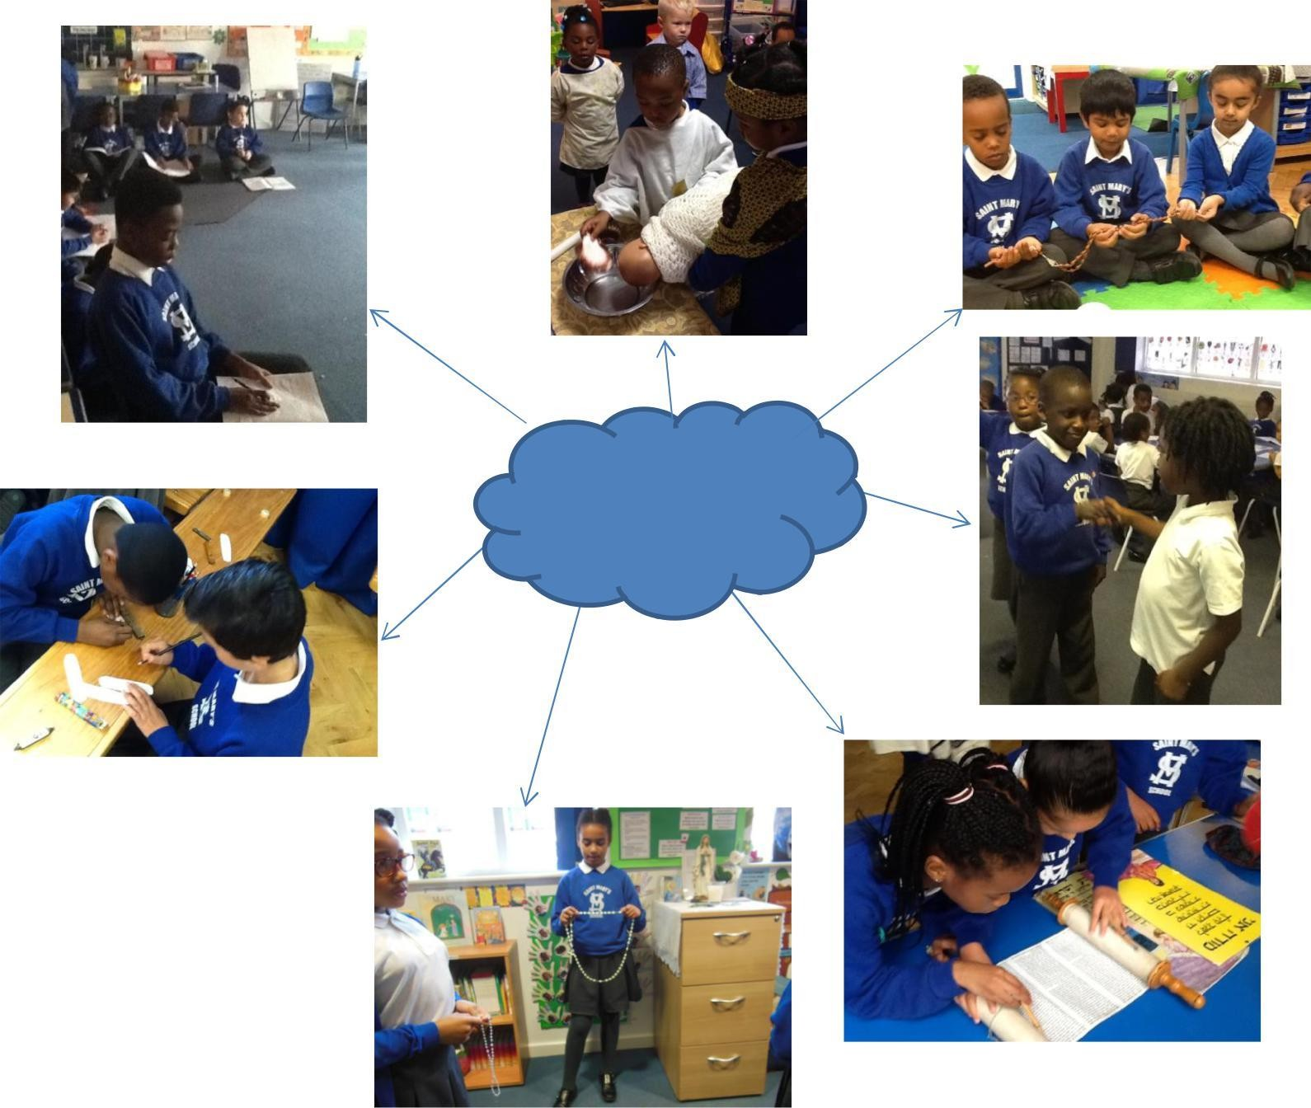
Examples of
our RE work

St Mary’s Catholic Primary School- PE 2019-2020

What is Physical Education?
Year Groups | Units Covered
 | Outdoor PE | Indoor PE
EYFS | Dance | Throwing and catching
 | Gymnastics | Outdoor Games
Year 1 | Tag Games | Dance
 | Agility Games | Gymnastics
 | Throwing and Catching
 | Athletics
 | Co-ordination Games
Year 2 |  | Dance
 |  | Gymnastics
Year 3 | Tag Rugby | Linking dance actions
 | Football | Gymnastics unit 1- Flight
 | Volleyball | Gymnastics unit 2- Bridges
 | Rounders
 | Athletics
Year 4 |  | Invasion games- controlling
 |  | and receiving
 |  | Swimming
Year 5 |  | Swimming
 |  | Gymnastics
Year 6 |  | Gym-counter balance and
 |  | tension
 |  | Dance
 |  | Indoor Athletics

Physical education combines dance, gymnastics, games, athletics, swimming and outdoor adventurous activities to provide a broad and balanced range of experiences to enable
children to face challenges and attain goals. It is intended to help pupils’ development of individual, paired and group work, in co-operative, collaborative and competitive situations to cater for the strengths, preferences and needs of every pupil, regardless of their age, gender, cultural or ethnic background.

Aims
Our aims in teaching PE are:
- To promote physical activity and healthy lifestyles, so pupils know the effects of exercise on the body, and the appreciation of safe exercising.
- To develop social co-operation and positive attitudes towards physical education and to compete with a sense of fair play.
- To provide an opportunity for children to develop skills as an individual, in pairs and in small groups, by repeating and refining actions and to perform with increasing
control, co-ordination and fluency.
- To provide children with an opportunity to achieve personal goals, including the ability to communicate and respond positively towards others.
  - To promote an understanding of safe practice, and develop a sense of responsibility toward their own and others safety and well-being.

Assessment in PE
Non Stop Action will complete their own half termly assessment which will be handed to the subject leader who will then file in a school assessment tracker. Class teachers will be aware of the outcomes for their children and will be expected to track the children on the iTrack system in school. These assessment score will be provided for parents both on parent’s evening and in their child’s formal written report. RE is still currently assessed using levels.
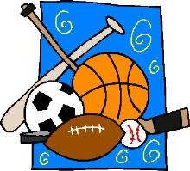

St Mary’s Catholic Primary School- PE 2019-2020 Examples of Work
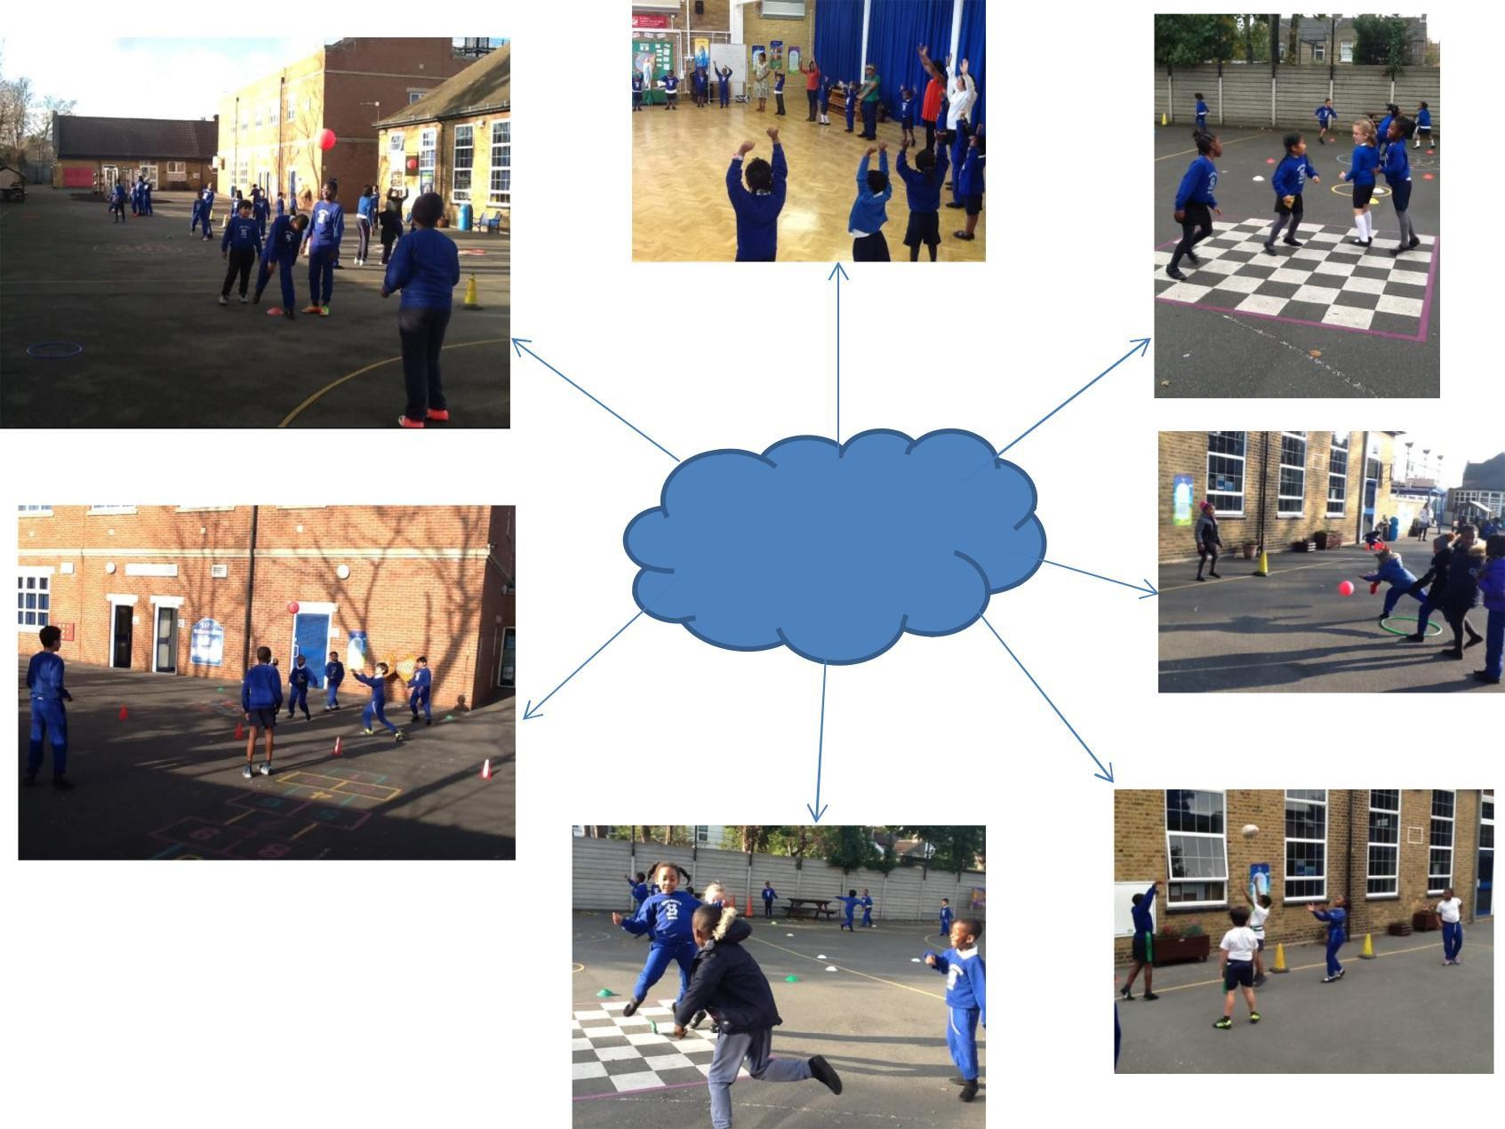
Examples of
our PE work

St Mary’s Catholic Primary School- French 2019-2020

What is Modern Foreign Languages?
Year Groups | Units Covered
Year 3 | Greeting, Numbers, Family, Colours, Christmas, Shapes,
 | Where I live, Body Parts, Easter, The weather, Clothes,
 | Animals, The Eiffel Tower
Year 4 | Greetings, Family, Colours, Classroom objects, Where I
 | live, Body parts, The weather, Days, months and Dates of
 | birth, Clothes, Animals, Fruits and Vegetables, Sports
Year 5 | Greetings, Numbers, Family, Descriptions, School subjects,
 | Sports and hobbies, Time, Body Parts, Prepositions,
 | Clothes, Animals, Fruits and vegetables, Adjectives, French
 | Revolution.
Year 6 | Greetings, Numbers, Day and months, dates of birth,
 | Euros, Family, Town and Direction, Description and
 | clothing, School Subjects, Sports and Hobbies, Time,
 | Adjectives, Food, Daily Routine, House, Conjugation

MFL prepares pupils to participate in a rapidly changing world in which work and other activities are often carried out in languages other than English. The rise of
international commerce means that pupils need to be equipped with the skills needed by the international workplace. The choice of which language to teach is secondary to the lifelong language learning skills that the pupils will be encouraged to develop.
Skills that they will be able to access in the future to learn new languages or to improve their competence in an existing language. Increased capability in the use of MFL promotes initiative, confidence and independent learning and encourages diversity within society.
Subject Aims
The overall aim for Modern Foreign Languages is to enrich learning for all pupils and to ensure that teachers develop confidence and competence to teach MFL and use MFL effectively in their teaching of other subjects. However, this aim can be further broken down.
To increase children’s linguistic competence through regular timetabled MFL
sessions.
To help children develop their awareness of cultural differences in other countries and exploit cultural links and experiences when opportunities arise.
To promote positive attitudes towards language learning through a range of learning
activities.
To develop listening, speaking, reading, writing skills and phonological awareness To lay the foundations for future language learning
To encourage children to be aware that language has a structure and that the structure differs from one language to another
To stimulate and encourage children’s curiosity about language
To encourage children’s confidence and creative skills.

Assessment
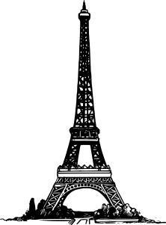
The children are continuously being assessed in the four main areas; Reading, Writing,
Speaking and Listening. Termly, these results are recorded on the school’s iTrack assessment system and they are reported to parents in the form of the child’s formal end of year written report.

St Mary’s Catholic Primary School- French 2019-2020 Examples of Work

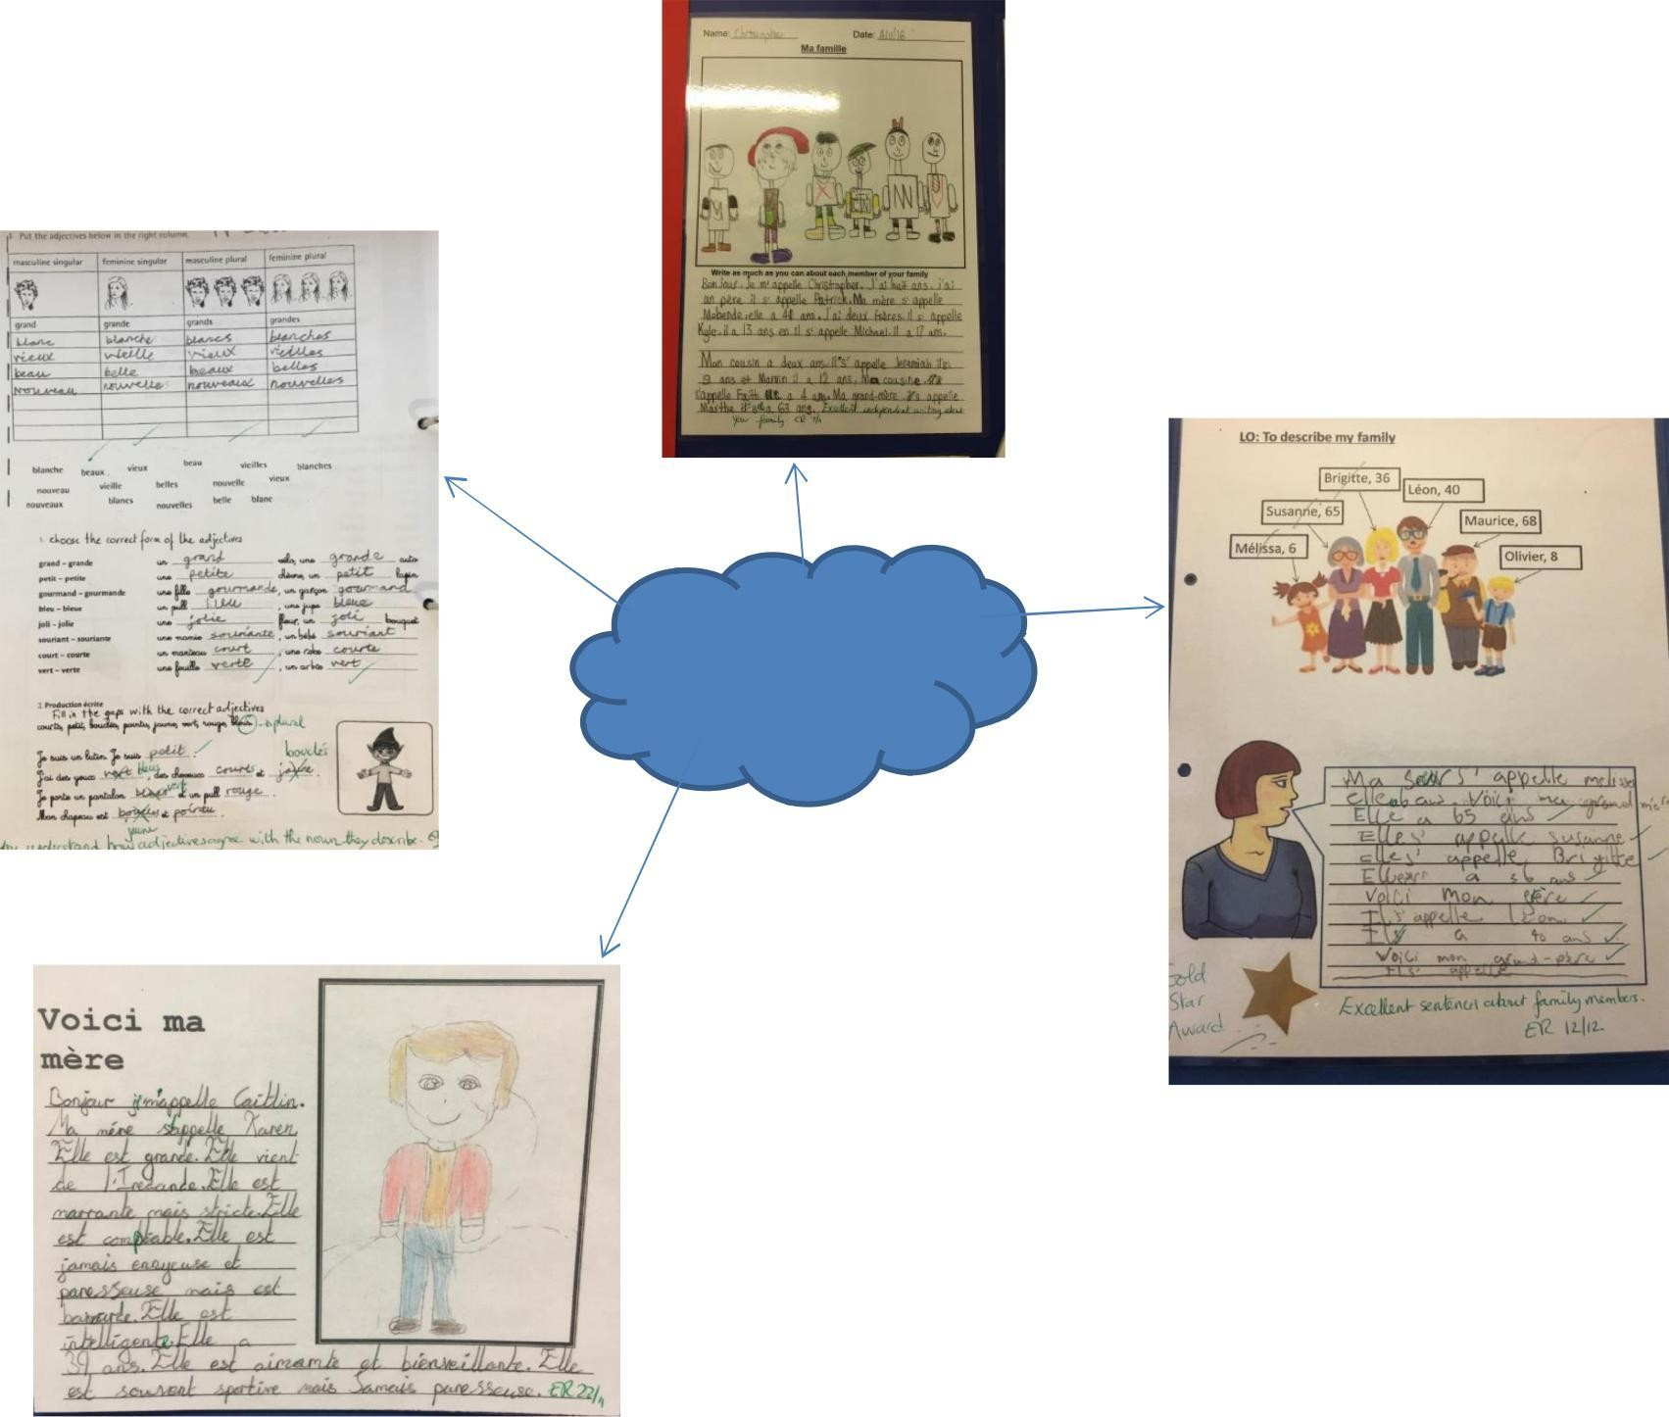
Examples of our French work

