Everyday Evangelising

Daily Missionaries
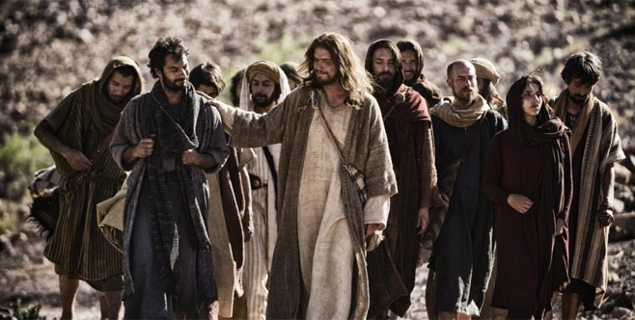
To evangelise is to share the good news of the Gospel, and to invite others to get to know Our Lord, Jesus Christ.
We share the good news by telling people about Jesus and by the way we live - we are witnesses to our Faith. We are all called to be witnesses by our baptism, responding to Jesus' command to 'go and make disciples!'

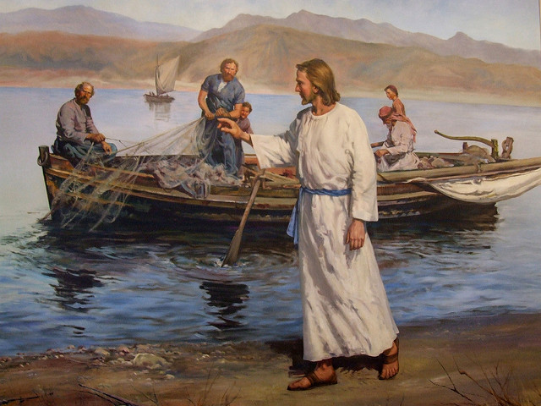
Pope Francis calls us all to be Missionary Disciples as part of Missionary Parishes.

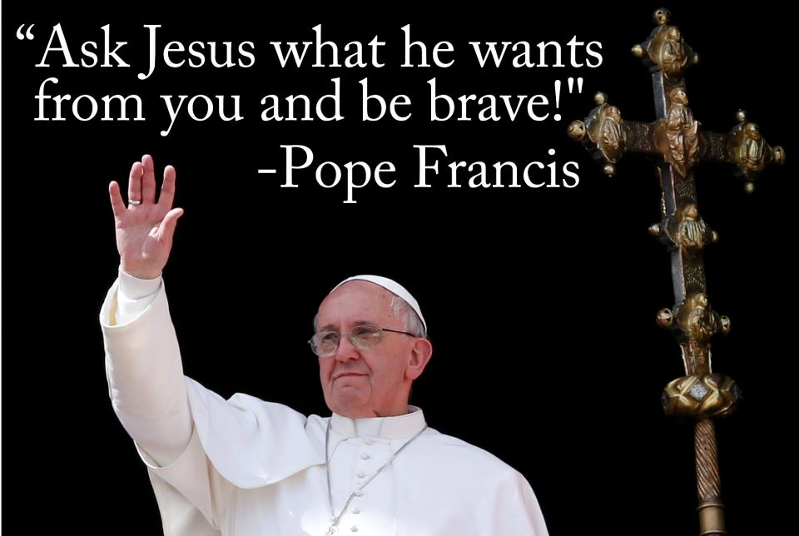

We can do this by 'everyday evangelising':
- Be prepared - by growing in our own faith through prayer, listening to God's word in the Scriptures and receiving the sacraments regularly. Also, keep up to date with the news in the Church, and in the local and wider community. Participate in local parish events and activities.
- Be Visible - by being courteous, kind and open in how we communicate we can help people to trust us, and perhaps then to be curious about why we are a nice person to know. Smile when you greet others. You may consider wearing a symbol of your faith, such as a cross, which will show people that you are a Christian.
- Respond - if there is an issue which is important to you and your faith, let your feelings be known. Where appropriate opportunities arise, don't be afraid to talk about your faith. Answer questions about your faith as best you can. Offer to pray for or with people should the occasion arise.

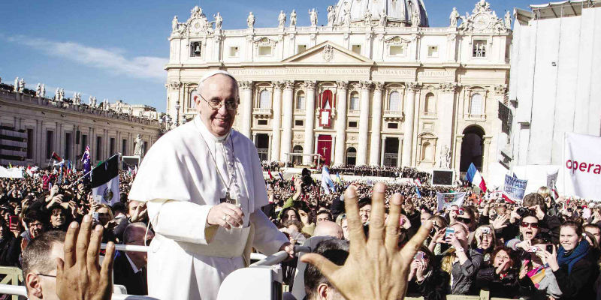

In all that we do, we are firstly to keep Jesus in our thoughts and heart. Always try to be courageous, knowing that the Holy Spirit will guide us. Know always that God loves us, we are his children. He is always merciful to us, and we in turn are to be merciful to others.
Above all, love those we meet, be patient and always listen.

