Our Prayers

These are some of the prayers we say with the children each day in school. You might like to say these in the morning with your child or before he / she goes to bed.

Morning Offering

O My God, you love me,

You are with me night and day.

I want to love you always in all I do and say.

I’ll try to please you Father.

Bless me through the day. Amen



Night Prayer



God our Father, I come to say,

Thank you for your love today.

Thank you for my family,

And all the things you give to me.

Guard me in the dark of night.

And in the morning send your light. Amen.

Grace Before Meals

Bless us O Lord

As we sit together.

Bless the food we eat today.

Bless the hands that made the food.

Bless us O Lord. Amen.

Grace After Meals

Thank you God

For the food we have eaten.

Thank you God

For all our friends.

Thank you God

For everything.

Thank you God. Amen.

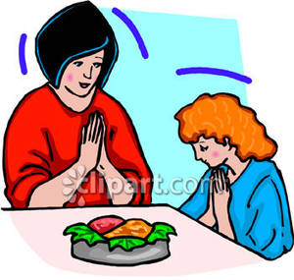

Our School Prayer

This is our school.

May we all live here

Happily together.

May our school be full of joy.

May love dwell here among us

Every day.

Love of one another,

Love of all people everywhere,

Love of life itself,

And love of God.

Let us all remember that

As many hands build a house,

So every child

Can make this school

A lovely place. Amen

MC900433678[1]