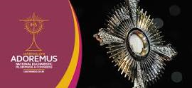

The bishops of England and Wales have just announced that they plan to hold a National Eucharistic Pilgrimage and Congress in Liverpool next year (7-9 September 2018). Eucharistic Congresses are gatherings of clergy, religious and laity which promote an awareness of the central place of the Eucharist in the life and mission of the Church. The last Eucharistic Congress in England was held in Westminster in 1908 when permissions for a public procession of the Blessed Sacrament were refused.

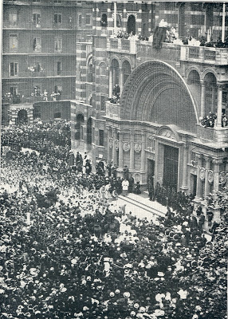1908 Congress at Westminster Cathedral - consecrated two years later

Participants at the Congress will take part in a series of Catechism sessions, focusing on different dimensions of the Eucharist and the daily celebration and adoration of the Blessed Sacrament. On the first day of the Congress, there will be a Theological Symposium, with workshops for Parish catechists, (especially for those involved in First Holy Communion programs), RE teachers, Hospital and Prison Chaplains, Seminary Communities and Extraordinary Ministers. The sessions will focus on Scripture, Ecclesiology, Eucharistic Language and Catechism and a Workshop on the Rites and Music for Eucharistic Adoration.

The Echo Arena in Liverpool (which can accommodate 10,000 pilgrims) will be the home to a six- hour stage programme on the second day of the Congress, which will include a Congress Mass, keynote speakers and a drama highlighting the beauty of reverence and devotion. The day will conclude with Adoration. On the final day of the Pilgrimage and Congress, Sunday, there will be pilgrimage Masses and a street procession, open to all.

In a recent Pastoral Letter to the Diocese of Westminster for the solemnity of Corpus Christi, Cardinal Nichols wrote: "We seek to rejuvenate Eucharistic adoration in our parishes as the source of strength for our lives and for our mission, that of making present the love and compassion of Jesus in our society."

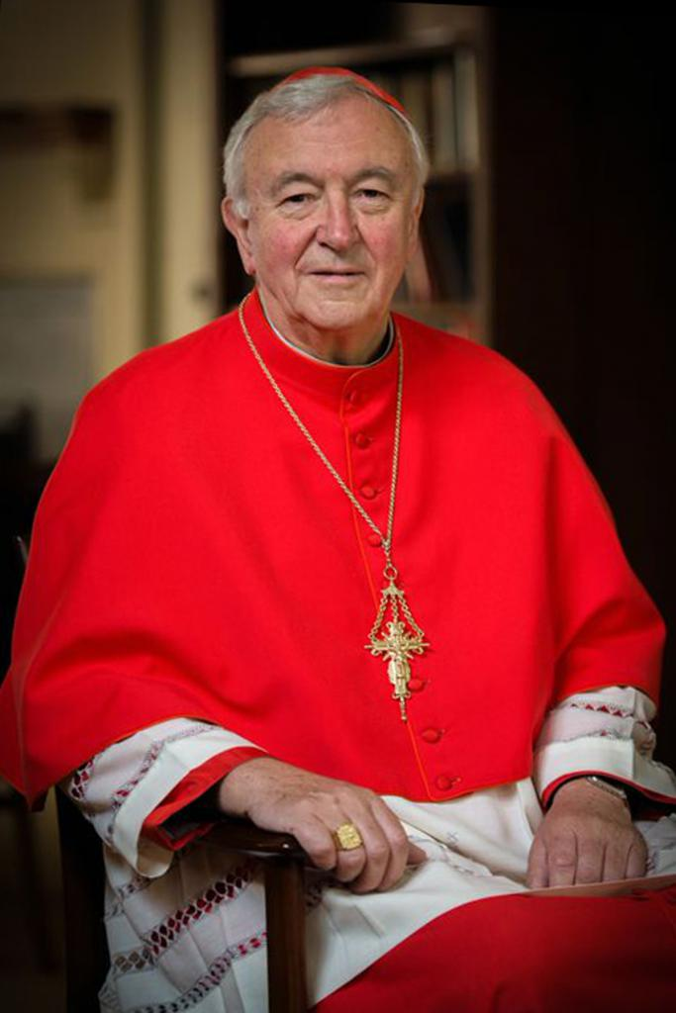
Every diocese in England and Wales will take part in the Congress and in his letter; the Cardinal encourages people to make the pilgrimage to the Eucharistic Congress. Each Diocesan Bishop has nominated a representative whose task is to disseminate information to parishes, groups, religious communities about the Pilgrimage and Congress.

Ahead of the Eucharistic Congress in Genoa in 2016, Pope Francis encouraged everyone to visit the Blessed Sacrament, if possible, every day: "Moreover, I want to encourage everyone to visit – if possible, every day – especially amid life's difficulties, the Blessed Sacrament of the infinite love of Christ and His mercy, preserved in our churches, and often abandoned, to speak filially with Him, to listen to Him in silence, and to peacefully entrust yourself to Him."

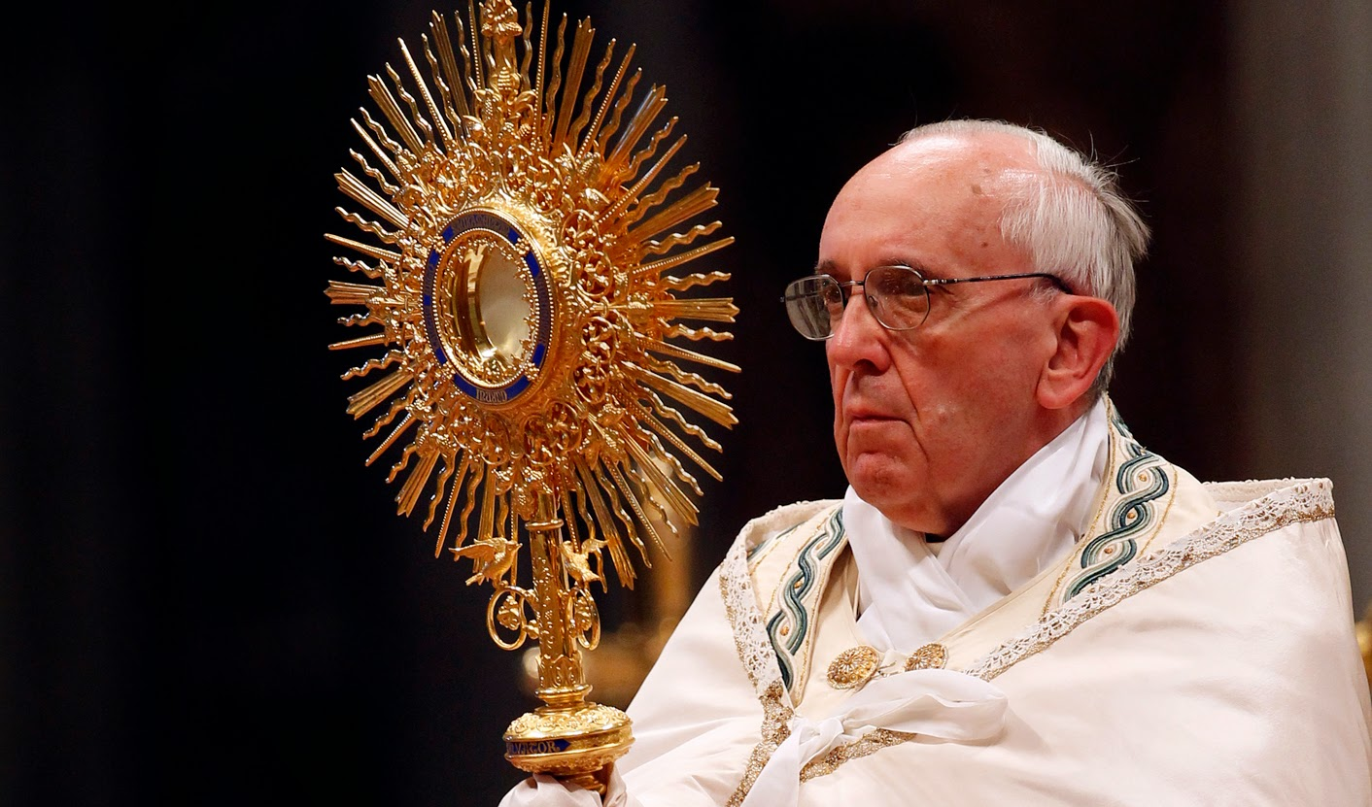

The Eucharistic Congress has been given the title Adoremus (let us adore). This pilgrimage will bring people together from across the dioceses and further the service of the poor and marginalised in our midst. It will also aim to provide practical resources to develop the mission of the Church in prayer, contemplation and adoration of the Blessed Sacrament.
Eucharistic congresses are gatherings of clergy, religious and laity to promote an awareness of the central place of the Eucharist in the life and mission of the Church, bearing witness to the Real Presence of Christ in the Eucharist.
At their spring conference the bishops received a report from Bishop Robert Byrne, auxiliary bishop of Birmingham about the 51st International Eucharistic Congress held this January in Cebu in the Philippines.
At the 2005 Eucharistic Congress in Birmingham Archbishop Vincent Nichols, then of Birmingham, celebrated the opening Mass. Speakers included the preacher to the papal household, Fr Raniero Cantalamessa, Jesuit writer Fr John Edwards and Bishop McMahon OP of Nottingham. Archbishop Nichols described the congress as “a highlight of the summer”.
St Pope John Paul II declared 2005 the Year of the Eucharist, and granted a plenary indulgence to Catholics who venerated the Sacrament in that year.
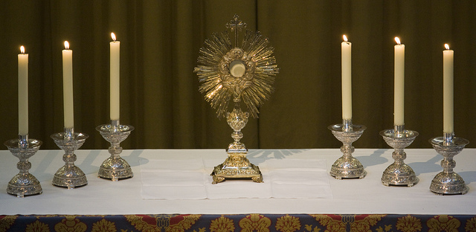
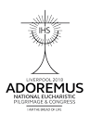

O God, who in this wonderful Sacrament,
have left us a memorial of your Passion,
grant us, we pray,
so to adore the sacred mysteries of your
Body and Blood,
that we may always experience in ourselves
the fruits of your redemption.
Who live and reign with God the Father
in the unity of the Holy Spirit,
one God, for ever and ever.

