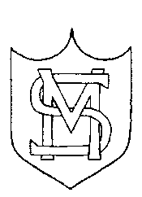

ST MARYS’ CATHOLIC PRIMARY SCHOOL
LOVE, LISTEN & LEARN

This is how we stay safe when we use computers:
- I will ask an adult if I want to use the computer
- I will only use activities that an adult says are OK.
- I will take care of the computer and other equipment.
- I will ask for help from an adult if I am not sure what to do or if I think I have done something wrong.
- I will tell an adult if I see something that upsets me on the screen.
- I know that if I break the rules I might not be allowed to use a computer.

I understand these computer rules and will do my best to keep them

My name: |  | Date
R - Signed (child):
Y1 - Signed (child):
Y2- Signed (child):

