Key Stage 1 – Division
Y1 | Y2
Through practical activities in meaningful contexts.  - Division as sharing.  Emphasise the importance of sharing equally.  Share a bag of 15 sweets between 5 children – one for you, one for you, one for you, one for you, one for me.        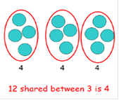  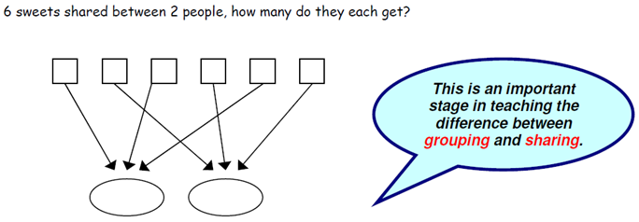  - Introduce halving even numbers up to 10.  Half of 4    National Curriculum requirements:  Solve one step problems involving division, by calculating the answer by using concrete objects, pictorial representations and arrays with the support of the teacher. | Through practical activities in meaningful contexts.  - Recall and use division facts for 2, 5 and 10 times tables.  - Continue to use division as sharing.  - Division as grouping.    - 15 children get into teams of 5 to play a game. How many teams are there?  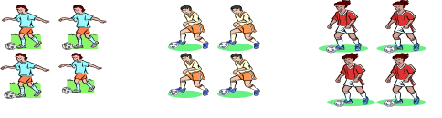  How many groups of 5 in 15?  How many 5’s have been counted?  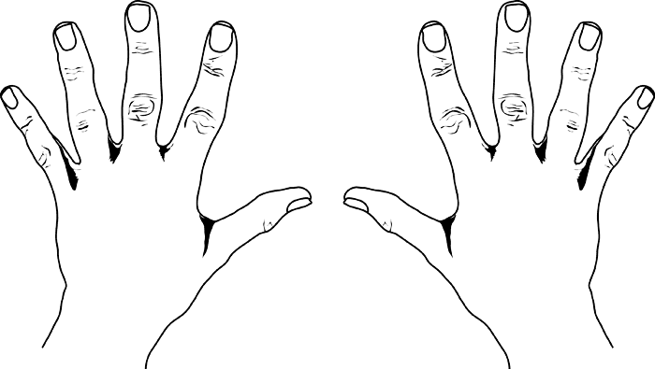  5 10 15 20 25  30 35 40 45 50  -  How many 2’s in 10?  - Understand ‘÷ 2’ as ‘half of’.  - Understand that division is not commutative.  - Recognise relationship between x and ÷  - Record using division (÷) and equals (=) signs.  - Use number lines to answer questions such as 20 ÷ 2 =  20  18  16  14  12  10  8  6  4  2  0  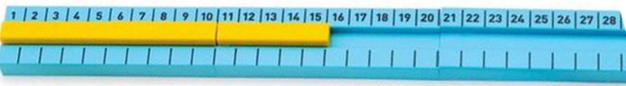  National Curriculum requirements:  Solve problems involving division using materials, mental methods and division facts.
Key Stage 2 – Division
Y3 | Y4
- Recall and use division facts for 3, 4, and 8 times tables.  - Continue with repeated subtraction on a vertical number line.  - Write and calculate mathematical statements for division using the tables they know.  - Introduce grouping method before short division, encourage children to estimate answers before attempting calculation. Create fact box to encourage efficient grouping e.g. not always groups of 10 - 1x, 2x, 5x, 10x, 20x, 50x, 100x.  13  5) 65  - 50 (5 x 10)  15  - 15 (5 x 3)  0  - Introduce short division, with exact answers.  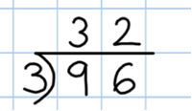  - Progressing to short division involving carrying, with exact answers.  National Curriculum requirements:  Division questions based on multiplication tables they know.  Divide 2 digits by 1 digit, progressing to formal written methods.  The National Curriculum statutory requirements for Year 3 and the use of written methods are not clear therefore our guidance for Year 3 has been based on the skills required to access Year 4 statutory requirements. | - Recall and use all division facts for all tables up to 12 (Including dividing by 1).  - Continue with short division method.  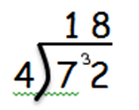  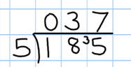  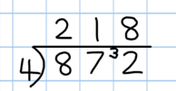  - Progressing to short division with remainders.  National Curriculum requirements:  Divide 2 digits by 1 digit and 3 digits by 1 digit becoming fluent with formal written method of short division with exact answers and progressing to remainders.  The National Curriculum statutory requirements for Year 4 and the use of written methods are not clear therefore our guidance for Year 4 has been based on the skills required to access Year 5 statutory requirements.
  2 0 4  4) 8 1 ¹6 | 1 4 1 r1  3) 4 ¹2 4
Key Stage 2 – Division
Y5 | Y6
- Consolidate the use of the formal written method of short division.  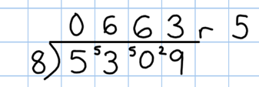  National Curriculum requirements:  Divide 2 digits by 1 digit.  Divide 3 digits by 1 digit.  Divide 4 digits by 1 digit.  Children interpret the remainders appropriately for the context.  e.g. as fractions, decimals or by rounding  98÷4 = 98/4 = 24r2 = 24 ½ = 24.5 rounded to 25  Divide whole numbers and those involving decimals by 10, 100, 1000. | - Consolidate short division.  - Children should be able to interpret remainders as whole number remainders, fractions or by rounding, as appropriate for the context.  - 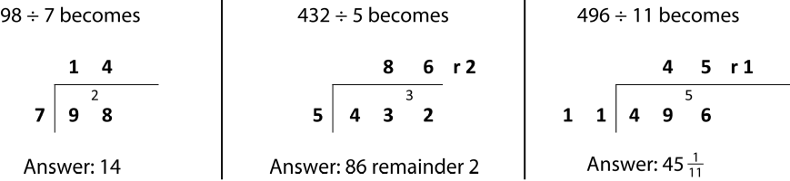  - Introduce long division.  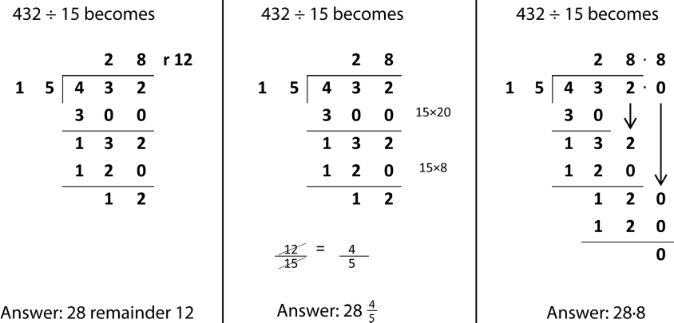  N.B: The above examples are taken from the National Curriculum for Mathematics appendix.  National Curriculum requirements:  Divide numbers up to 4 digits by a 2 digit number using the formal written method of short division where appropriate.  Divide up to 4 digits by a 2 digits whole number using the formal written method of long division.

