AUTUMN 2015 FAITH SHARING
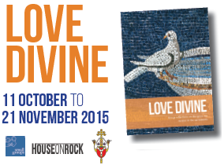A new resource, for small faith-sharing communities, on the grace we receive in the sacraments. Celebrating 25 faith-sharing seasons in the Diocese of Westminster. 11 October to 21 November 2015
Love Divine contains six group sessions on responding to the grace we receive from the Lord in the sacraments:
• 1 - Made in God’s image and likeness
• 2 - Christ the wellspring of Grace
• 3 - The Sacraments as channels of Grace
• 4 - The Sacraments of Initiation
• 5 - The Sacraments of Healing
• 6 - The Sacraments of Marriage and Holy Orders
Contains prayers, artwork and dedicated children’s pages. The resource can also be used for individual meditation. For more information: rcdow.org.uk (see small groups). Leaders and members can subscribe to weekly bulletins during the season via http://eepurl.com/ULaLr

