Faith Sharing for Autumn 2018

The theme for the World Meeting of Families in Ireland in August was The Gospel of the Family means Joy for the World.

This new faith-sharing resource HOLY FAMILIES: The Joy of Love for small communities is a proclamation of this same truth.

Exploring themes from the Holy Father’s 2016 Apostolic Exhortation Amoris Laetitia, it seeks over six sessions to explore the beauty and blessing, the joys and challenges of marriage and family life.

The sessions have been written by Pia Matthews – wife, mother, theologian, and Bishop John Sherrington and Bishop John Wilson.

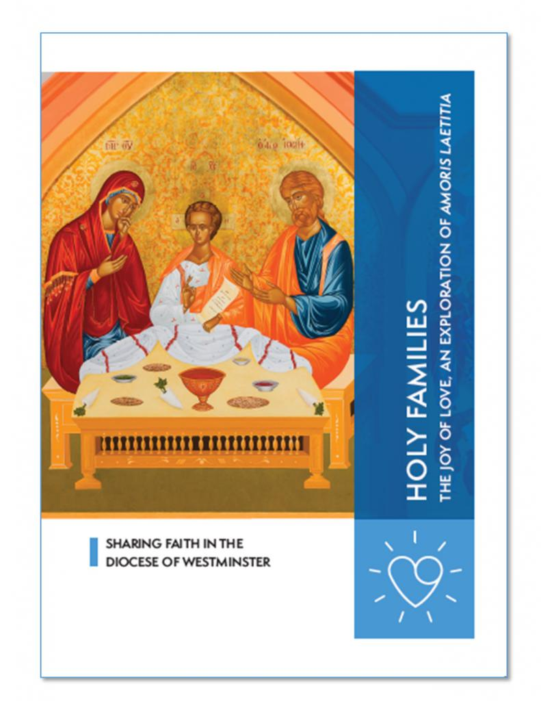

SESSION 1 – The Journey – love at the heart of the family
SESSION 2 – Love is – the fruitfulness of married love
SESSION 3 – I Will – the experiences and challenges of families today
SESSION 4 – I Do – discovering the beauty and dignity of marriage
SESSION 5 – A Family of Families – accompaniment and discernment
SESSION 6 – Home is a Holy Place – family of prayer, hospitality and reaching out

