World Day of the Poor 2018
In his message for the second World Day of the Poor, celebrated on 18 November 2018, Pope Francis asks all of us, whatever our means or background, to rediscover and celebrate in a spirit of joy our capacity for togetherness, for example by sharing a meal after Sunday Mass.

‘On this day, may all of us feel that we are in debt to the poor, because,
in hands outstretched to one another, a salvific encounter can take place to strengthen our faith,
inspire our charity and enable our hope to advance securely on our path
towards the Lord who is to come.’
Pope Francis

Pope’s Message for World Day of the Poor 2018
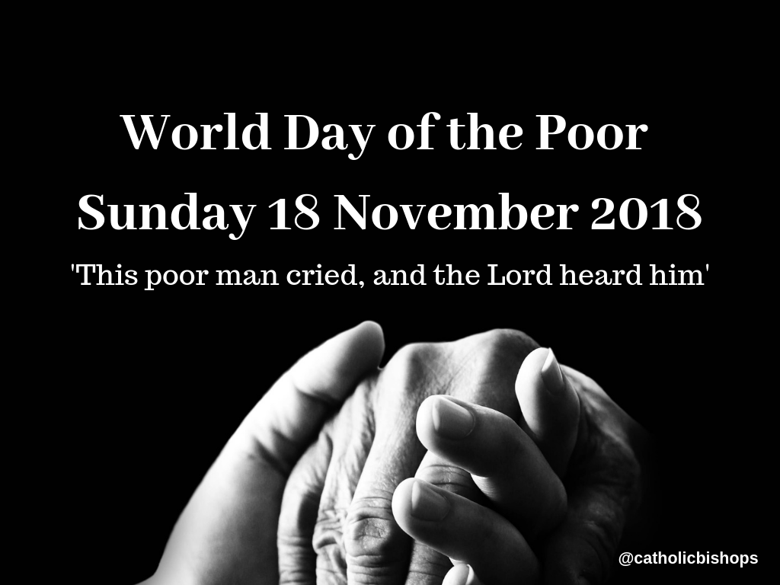
Pope Francis reminded pilgrims gathered in Saint Peter’s Square on Sunday 11 November about the second World Day of the Poor on Sunday 18 November. He said that a First Aid station will be set up in St Peter’s Square where those in need can receive medical care. He also shared his hope that the day will encourage greater attention to the needs of the least and the marginalized.
In his message released for the 2nd World Day of the Poor, Pope Francis said we live in a world “which praises, follows and imitates those who have power and riches, while at the same time marginalizing the poor and considering them an object of shame.”
The theme chosen for this year’s message is “This poor man cried and the Lord heard him”. It comes on the heels of the 1st World Day of the Poor which was established by Pope Francis at the conclusion of the extraordinary Jubilee of Mercy and fixed for the 33rd Sunday of Ordinary Time.

Pointing out that the World Day of the Poor “wishes to be a small answer which the whole Church, spread throughout the world, gives to the poor of every type and in every land, the Pope pointed out that “often it is the case that cooperation with other enterprises, moved not by faith but by human solidarity, enable us to give assistance which by ourselves would have been impossible.
He said that by recognizing that in the immense world of poverty our capacity for action is limited, we are pushed to recognize other forms of assistance and solidarity “albeit that we do not neglect our proper role which is to lead everyone to God and holiness”.
He also spoke of the need to be humble and put aside all forms of protagonism: “Dialogue among the different forms of experience and humility in giving freely of our collaboration, without seeking the limelight, is an adequate and fully evangelical response which we can all give”.
In his message, the Pope also examined the roots of poverty saying it is not brought on by itself, “but is caused by selfishness, pride, greed and injustice”.
“These are evils, he said, as old as man himself, but also sins in which the innocents are caught up, leading to consequences on the social level which are dramatic”.
He also remarked on what he called a contemporary “phobia” for the poor who are considered not only as destitute, but also as “bearers of insecurity and instability, detached from the habits of daily life and, consequently, to be rejected and kept afar”.
On the other hand, Francis continued, “when we find a way to draw near to the poor, we know that the first place belongs to Him who has opened our eyes and our heart to conversion”.
The poor, he stressed, have no need of protagonists, “but of a love which knows how to hide and forget the good which it has done.”
The Lord, the Pope affirmed, “listens to the poor”, He listens to those “who are downtrodden in their dignity and yet have the strength to look up in order to receive light and comfort. He listens to those who are persecuted in the name of a false justice, oppressed by policies unworthy of the name and intimidated by violence.”
He commented on how so many of our brothers and sisters today find themselves on paths that lead to forms of precariousness: “The lack of basic means of subsistence, marginalization stemming from a reduced capacity to work owing to ill-heath, the various forms of social slavery, notwithstanding the progress made by humankind”.
The Pope said that the Disciples of Christ are exhorted never to nourish “sentiments of contempt or pietism” towards the poor, but they are called “to honour them, giving them precedence, out of the conviction that they are a real presence of Jesus in our midst”.
Pope Francis concluded his message pointing out that often it is the poor themselves who undermine our indifference and said that “the cry of the poor is also a cry of hope which manifests the certainty of being liberated”.
Read the full text of the Pope’s message for the World Day of the Poor here.

Prayer for the Poor
God of Justice,
open our eyes
to see you in the face of the poor.
Open our ears
to hear you in the cries of the exploited.
Open our mouths
to defend you in the public squares
as well as in private deeds.
Remind us that what we do
to the least ones,
we do to you.
Amen.
Ends

