A Way of Mercy in Westminster Cathedral
A Way of Mercy has been arranged along the right-hand side of the Cathedral, as an opportunity for us to reflect on aspects of the mercy of God.
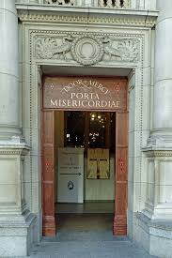

The Holy Door itself is the first station: not the newly-installed glass doors in the large central porch, but the smaller door on the right as you face the Cathedral from the piazza. The beautiful lettering has already received much positive comment, and the five diamonds painted around the door represent the five wounds of Christ.

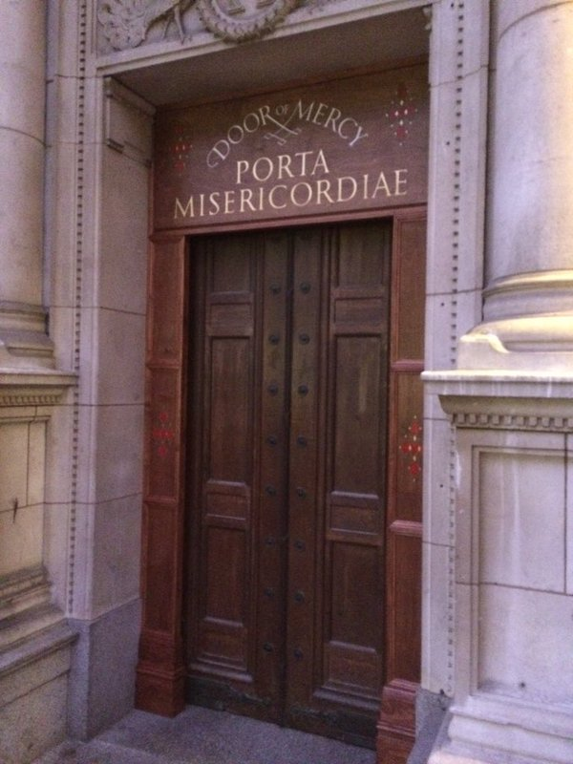

The second and third stations, the Seat of Mercy and the Divine Mercy respectively, are in the two porches immediately beyond the door.
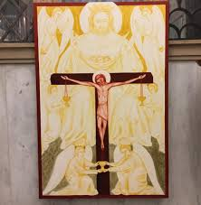

The fourth station is the Baptistry: the artwork is on a striking scale here, and depicts the baptism of Christ.
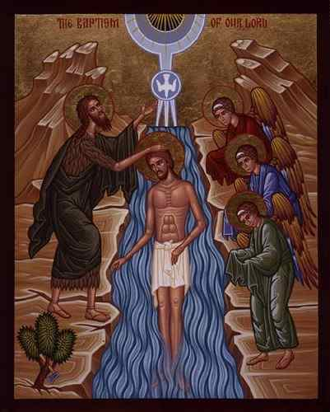

The fifth station, in the Chapel of St Gregory and St Augustine, is devoted to the mercy of God the Father: a painting of the parable of the Prodigal Son is set over the altar.
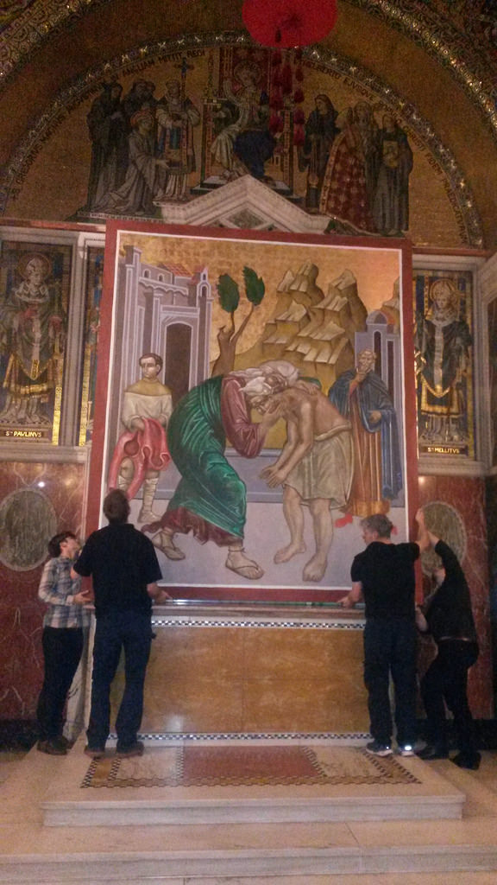

In the Chapel of St Patrick we find the sixth station: God the Son – Mercy Incarnate.
The seventh station, in St Andrew’s Chapel, focuses on the Holy Spirit, and the Spiritual and Corporal Works of Mercy, which are depicted on the side wall.
Given his own dramatic conversion, which is the subject of the artwork of the eighth station, it is appropriate that the Chapel of St Paul is the one where we are invited to think on the call to conversion. It may also be a suitable place to prepare to make a Confession: leaflets are available to offer assistance to those who may be a little unsure about what to say or do.
The ninth station is the Lady Chapel: it would be an appropriate place to pray, for example, the Salve Regina (Hail Holy Queen) in honour of Our Lady, Mother of Mercy.
A tenth and final station is in the porch opposite that leading from the Holy Door: a simple poster invites us to put into practice the things on which we have reflected, and ‘to be merciful as our heavenly Father is merciful.’
By passing through the Holy Door and fulfilling a number of other conditions, it is possible to gain the Jubilee Indulgence.

