SPOTACULAR
The school council were busy planning and decorating for this year’s BBC Children in Need fundraiser this term.

They decided to hold a Spotty Disco. They decorated the hall with lots of different coloured spots and made sure that Pudsey Bear made an appearance on the day.

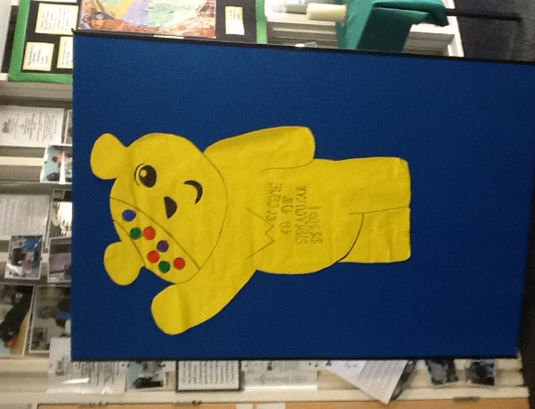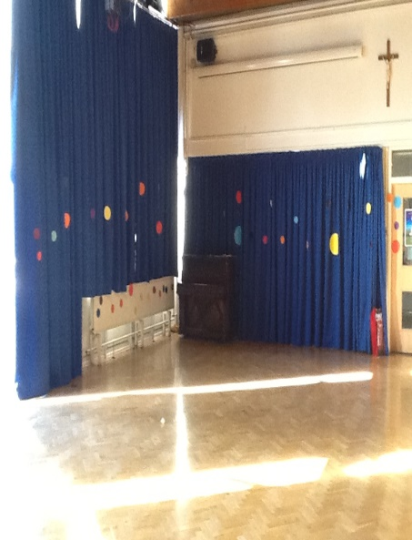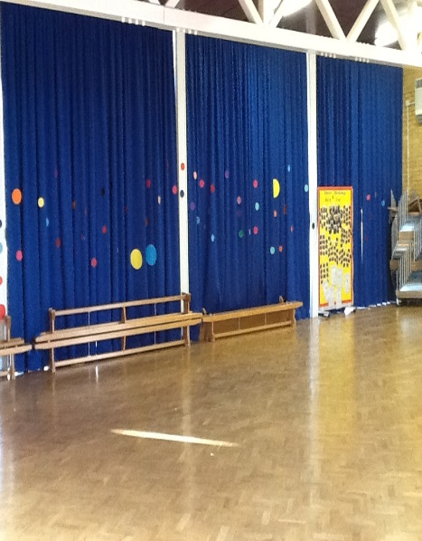

Before each disco, members of the student council reminded children and staff of the importance of BBC Children in Need and how the money we raised could be used to help children in the UK.

Everyone had a great day dancing and most importantly we raised a fantastic £468.

Thank you everyone for your support and for donating.

