The Angelus
The Angel of the Lord declared unto Mary:
And she conceived of the Holy Spirit.

Hail Mary, full of grace, the Lord is with thee;
blessed art thou among women and
blessed is the fruit of thy womb, Jesus.
Holy Mary, Mother of God,
pray for us sinners, now and at the hour of our death.
Amen.
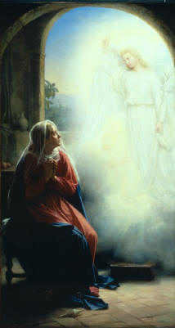

Behold the handmaid of the Lord:
Be it done unto me according to Your word.

Hail Mary . . .

And the Word was made Flesh:
And dwelt among us.

Hail Mary . . .

Pray for us, O Holy Mother of God,
that we may be made worthy of the promises of Christ.
Let us pray:

Pour forth, we beseech You, O Lord,
Your grace into our hearts;
that we, to whom the incarnation of Christ,
Your Son,
was made known by the message of an angel,
may by His Passion and Cross
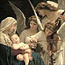
be brought to the glory of His Resurrection,
through the same Christ Our Lord.

Amen.

