ST MARY’S CATHOLIC PRIMARY SCHOOL

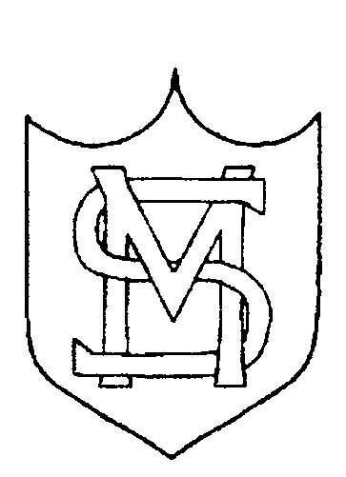

END OF KEY STAGE 2 ACHIEVEMENT OVERVIEW 2019

Mission Statement

St. Mary’s school community follows the teachings of Jesus Christ, working together to develop the whole child, in a spiritual, moral, academic, physical, social and emotional way, within a caring and supportive environment.

END OF KEY STAGE 2 2019

 | SUBJECT | % at EXPECTED STANDARD | % at HIGHER STANDARD
National 2019 | Reading | 73 | 27
School 2019 | Reading | 80 | 25
National 2019 | Mathematics | 79 | 27
School 2019 | Mathematics | 88 | 25
National 2019 | Grammar, Punctuation and Spelling | 78 | 36
School 2019 | Grammar, Punctuation and Spelling | 91 | 64
National 2019 | Writing | 78 | 20
School 2019 | Writing | 88 | 23
National 2019 | Science | 83
School 2019 | Science | 87

Reading, Writing and Mathematics % (combined)

 | School | National
% of pupils achieving the expected standard in reading, writing and mathematics | 77 | 65
% of pupils achieving the higher standard in reading, writing and mathematics | 7 | 11

Average Scaled Score

 | School | National
Reading | 107.0 | 105.0
Mathematics | 106.0 | 104.0
Grammar, Punctuation and Spelling | 111.0 | 106.0

