Ash Wednesday and the Season of Lent

Ash Wednesday – Wednesday 26th February 2020

This year Ash Wednesday (first day of the season of Lent which is a preparation for the season of Easter) falls during the half-term holiday. Ash Wednesday is a day of fasting and abstinence.

Every year when Ash Wednesday falls during term time all pupils and staff (Years 1-6) attend Mass and receive ashes. Children and staff in Nursery and Reception have services in school and receive ashes which have been blessed by Father John at Mass.

The ashes which are used on Ash Wednesday come from the branches of the olive tree or, according to custom, of the palm tree which were blessed the previous year. These are burnt to create the ashes which we receive in the form of a cross shape on our foreheads.

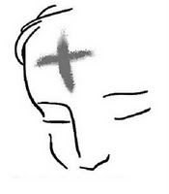

For us Lent (Quadragesima – the 40 days) is a time of spiritual spring cleaning. It is a time when God draws near to heal and restore our lives. Thus receiving ashes is an essential part of our preparation for Easter as Catholics.

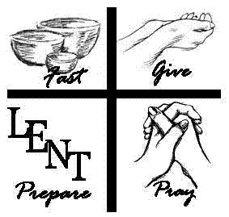

Dies Cinerum, or Ash Wednesday as it is now called, used to be the beginning of a long public penance for those Christians who had either been excommunicated (had to leave the Church) or barred from the sacraments. Bishops would bless sackcloth for these people to wear during the 40 days leading up to Easter – outward signs representing inner repentance. After the 40 days of penance and sacramental confession they were welcomed back home and reunited in Christ and his Church.

During the Council of Beneventum in 1091, Pope Urban 11 decreed that ashes should be received by all the faithful at the beginning of Lent and that all should join in the public act of repentance.

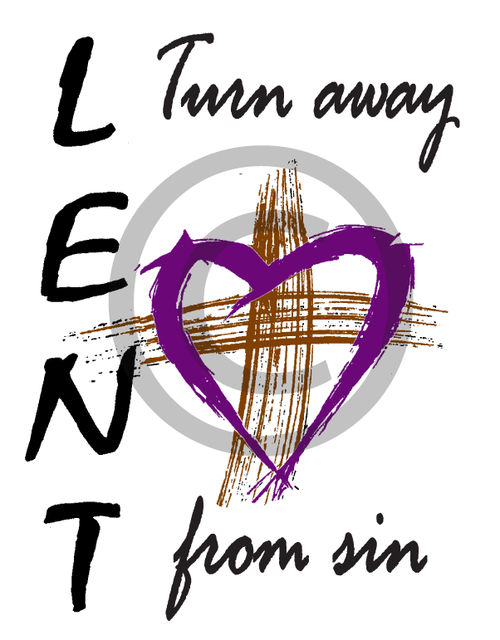

This Ash Wednesday and Lent, we will accept the ashes of penance and mourning as outward signs of our inward repentance. But let us also as Christ teaches, be seen to rejoice and to be cheerful again as we prepare ourselves to celebrate the Resurrection at Easter.

The three Lenten practices of prayer, fasting and alms-giving help to discipline our bodies, minds and spirits.

Prayer
This discipline requires the sacrifice of time and sometimes in Lent it is a good idea to get up a little bit earlier to ensure there is time in the day for prayer. Prayer helps to bring us closer to God and strengthens our hearts against temptation.

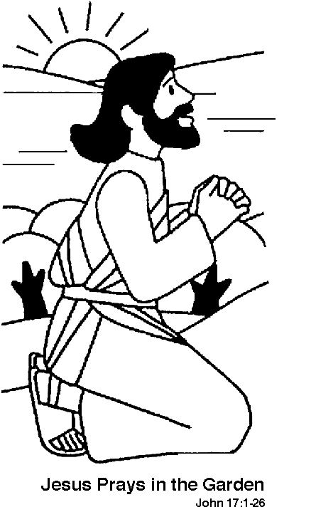

Fasting and Abstinence
Fasts train our bodies which can be prone to self-indulgence. By fasting we use the gift of self-control. By controlling our wants we concentrate on the most basic of needs. As hard as not eating chocolate, drinking alcohol etc. is, fasting is nothing compared to the suffering of so many in the world.

The bishops of England and Wales recognize that simple acts of witness, accompanied by sincere prayer, can be a powerful call to faith. Traditional Catholic devotions such as making the sign of the cross with care and reverence, praying the Angelus and saying a prayer before and after meals, are straightforward actions which both dedicate certain moments in our daily lives to God and demonstrate our love and trust in his goodness and providence. If these devotions have been lost from our homes we have much to gain from learning and living them again.

Every Friday is set aside as a special day of penitence, as it is the day of the suffering and death of the Lord. It is important that all of us are united in a common, identifiable act of Friday penance since the virtue of penitence is best acquired as part of a common resolve and witness. The law of the Church requires Catholics on Fridays to abstain from meat and unite this act to prayer. Those who cannot or choose not to eat meat as part of their normal diet should abstain from some other food of which they regularly partake. This decision came into effect on Friday 16th September 2011.

On a Friday our prayer is in thanksgiving for the gift of the mortal life that we have been given; a life which Christ willingly sacrificed on the cross for our sake. The
act of abstinence itself can be offered consciously as prayer for life and as reparation for sins against life. It can also be put to the service of others if we make a sacrifice and give the financial savings made from our abstinence to charities which assist those who are poor or suffering. If we are unable to make that financial sacrifice, we can still perform a ‘work of charity’, an act of kindness and love to another person who is in need or suffering in some way.

Canon 1251 states that abstinence from eating meat or another food according to the prescriptions of the Conference of Bishops is to be observed on Fridays throughout the year unless they are solemnities. Abstinence and fast are to be observed on Ash Wednesday and on Good Friday.

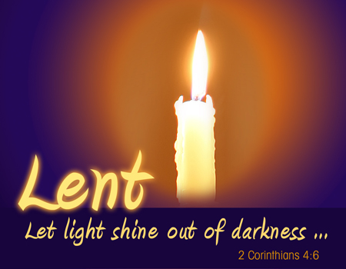

Alms-giving
Giving to the poor ‘is not charity but justice’ (St. Augustine of Hippo). All things belong to God and he desires that the good things of the earth be shared. It is our Christian mission to share, to rejoice in giving and not count the cost as the community of Apostles and early Christians once did (Acts 2: 44-45). By being generous we are given the freedom to love and room is made in our hearts for God’s love, grace and peace.

