St.Mary’s Nursery Spring Term 2024
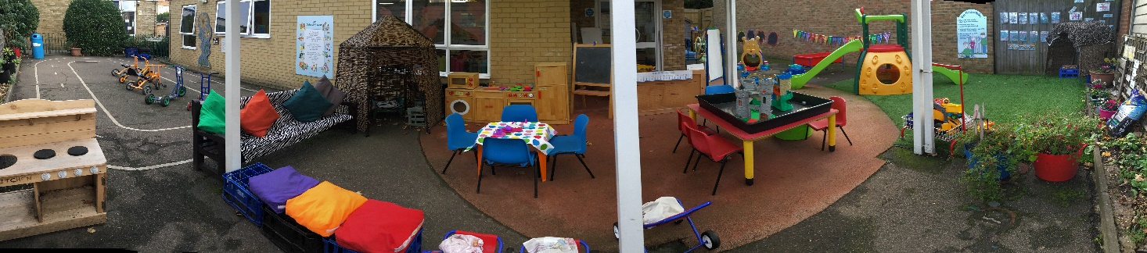

Dear Parents/Carers,

Welcome back to a new term in Nursery.
We hope you are all safe and well.

This Spring term we will –

Be investigating and exploring the season of Spring, looking at the changes in weather, plants, trees and new life.

We will have a Traditional Tales focus each week, starting with Goldilocks and the three bears. Activities will be linked to both literacy and maths concepts.

RE Topic will include –
Term 1 Sacramental People
We will be exploring the symbol of a circle and how it represents God’s never- ending love.
We will look for God in the people who care for us and the world around us.

Term 2 Lent to Easter
Shrove Tuesday – making pancakes
Ash Wednesday – receiving ashes
Lent – colour purple, promises for lent
Palm Sunday- making palm leaves, acting out story
Holy Thursday – foot prints, washing of feet
The Last Supper – acting out story
Good Friday- making a cross
Easter Sunday – make an Easter garden

Please ask us any questions and give us feedback.

Many Thanks

Best wishes
Nursery Team

