j0082965[1]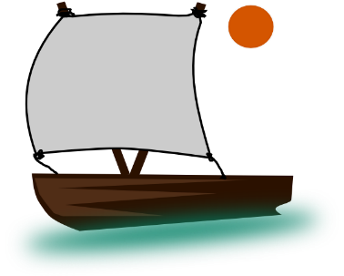

**PE:**

* Chn to learn about the importance of exercise.

**RE:**

In the Beginning:

Become familiar with and retell the second story of creation; Genesis 2: 4-25 (AT1 (i) Levels 1-2)

Recognise, describe and explain Psalms as a form of prayer and how they are an important part of the Christian ritual (AT1 (ii) Levels 1-3)

Pray the Psalms

**Role Play:**

* Space Role Play
* Spaceship, books, play dough mats, astronaut costumes

**Art/DT:**

* Children to create a self-portrait.
* Select from and use a wide range of materials and components, including construction materials, textiles and ingredients, according to their characteristics to create pictures of underpants and aliens.
* To design rockets and evaluate their work.

**PSHE & SEAL**

**Topic: New Beginnings**

To discuss the classroom: what is a happy classroom/how to make it fair and safe.

**Music:**

* Long and short sounds: with their voices and instruments
* Listening to space sound effects
* Using instruments to create own space sounds
* Using instruments to accompany space song ‘Galaxy Song’
* Perform for others.

**Numeracy:**

**Place Value:**

* counting on and back from 100,
* count in 2s, 5s and 10s,
* read and write numbers to 100
* recognise tens and ones

**Addition and Subtraction skills:**

* Number bonds to 20
* Add and subtract 2 digit numbers
* Solve problems

**Year 2**

**‘Explorers’**

Autumn 1

**Science:**

* To describe objects, including naming the material from which they are made from and then moving onto describing their properties.
* From this then moving onto identifying and comparing the suitability of a variety of everyday materials in order to pick suitable materials to make a boat for Christopher Columbus.

**ICT:**

**Word processing skills:**

* Typing out sentences about aliens and Explorers and sequencing their lives and accomplishments.
* Making a poster about the explorers we have learnt about.

**Literacy :**

**Fantasy:** Aliens love Underpants

Beegu

**Non-Fiction:** Neil Armstrong

Christopher Columbus

**Poetry:** Space Poems

* Big writing weekly.
* Guided reading and individual readers.
* Letters and sounds Phase 5.

**Geography/History:**

**History (linked to literacy):**

* To look at the explorers Neil Armstrong andChristopher Columbus; explore their lives and accomplishments.

**Geography:**

* To gain an understanding of the world, concentrating on seas and continents.
* To develop basic mapping skills and put these skills into practice.