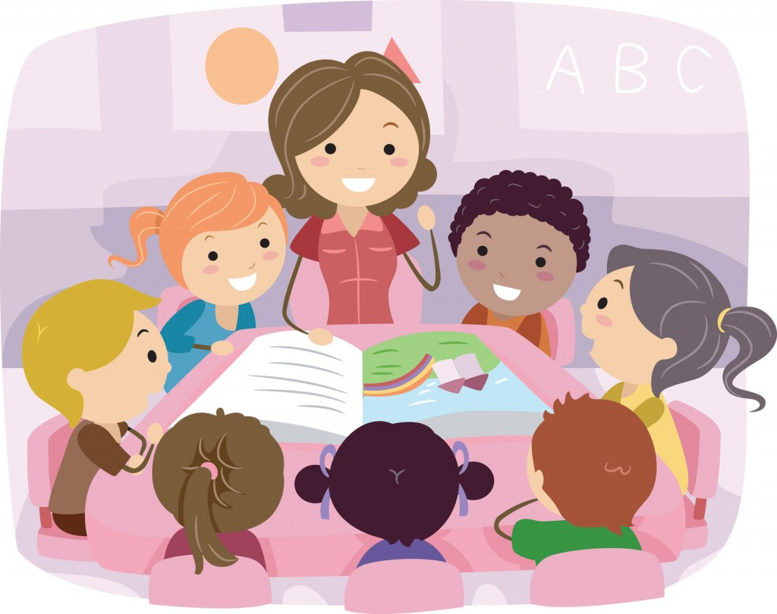 School Motto:
LOVE, LISTEN and LEARN

Autumn 2020: Year 2 Faith Class
Parents’ Newsletter

Welcome back to a new school year. It has been a very different year to what we are used to so far. The children have settled into their new class and the school routine and are working really hard.
At the beginning of the term, the children assisted with making their own class rules and we discussed rewards and sanctions for these rules.

Homework
Homework will be given out on Thursdays and will need to be returned to school for marking on Monday. Alongside homework it would be helpful to your child if you can help them practise reading and writing spellings given each week, reading and spelling common exception words and helping them practise the two, five- and ten-times tables (please note they must know these in sequence /rote. Mixed order and related division facts). Spellings and tables will be assessed weekly. Please note that additional work may be given to your child during the week to aid their learning.
R.E.
This term in R.E. we will be covering the topics of ‘Beginning with the Church’ and ‘Advent to Christmas.’ In the topic ‘Beginning with the Church’ children will become familiar with symbols, words and actions related to the Sacraments of initiation; Baptism, Eucharist and Confirmation. During the sessions we also focus on reflection and praying, linking back to how we welcome people in our School and the local community. In the topic ‘Advent to Christmas’ children will describe and explain the reasons for the preparations for Christmas; they will explain some of the signs and symbols used in the Church during Advent and they will explain the significance of Jesus’ birth for us Christians.
Literacy
There is a daily Literacy lesson based on a shared text which is read each lesson. We will be focusing on Fantasy, Poetry and Non-Fiction this autumn term. We will focus on two books for or fantasy topic; ‘Aliens Love Underpants’ and ‘Beegu’. Children will hear these stories and complete a range of activities based on them. For our non-fiction topic children will learn all about the life and accomplishments of Christopher Columbus. In poetry we will focus on space poems. Alongside this the children will complete a Big Write task, spelling tasks and handwriting tasks weekly.

Reading
Children will read to an adult at least once a week which will include their home reading book and a guided reading session. Currently we are only asking children to return their reading records to school once a week on a Friday morning. However, it is still important that you continue to listen to your child read daily and sign the reading record. When reading with your child in order to enhance and develop their comprehension skills, please ask them some questions about what they have read, an example of questions can be found in their reading record.

Numeracy
There is a daily Numeracy lesson. This term we will be focusing on counting to 100, place value, addition and subtraction, multiplication, division, time, money, real life word problems, and shape, space and measure.

Science
Our topic this term is Materials. Children will learn about different materials and learn to discuss and describe their properties and how they are used in the environment around them. We will continue to use ‘Science Ninja’ in science where the children work towards achieving stickers for different methods of enquiry.

P.E.
Children will continue to have a weekly PE lesson. The session is on Thursday. Due to the current situation, the children are expected to come into school wearing their PE kits and have appropriate footwear in their bags. Please ensure that your child has the correct P.E. kit (a round neck t-shirt, not a polo shirt please) and that each item is clearly labelled with your child’s name. Children are not allowed to wear earrings during P.E and it would be helpful if they were not to wear them at all on this day. We do not encourage children to wear tights under shorts or track suit bottoms.
In addition to the PE lesson, children will do a 15 minute workout in class on the days that they do not have pe. Normal school uniform will be worn.

Humanities
In History we will be learning about Neil Armstrong and the moon landings which includes the 1960’s space race. In Geography we will focus on The World including Continents and Oceans.

ICT
In ICT we will be looking at Communication Using Text and Creating Pictures based on our topic Explorers. Children will learn how to type out sentences about aliens and Explorers and sequencing their lives and accomplishments. They will also make a poster about the explorers we have learnt about.

Art / Design Technology
In Art we will be learning different art skills. The children will be sketching, painting, using pastels and drawing from observation. Our topic this half term is ‘In the Dark of Night’ where the children will learn about contrasting colours such as dark and light colours. In Design Technology we will make Rockets.

De Bono’s Six Thinking Hats
We will be continuing to learn about De Bono’s Six Thinking Hats. We are already using the Red Hat (feelings, intuition), Yellow Hat (positive thinking) and White Hat (information), and will be adding the Green and Black Hats this term (creativity and problem solving). The children enjoy “wearing” the hats and learning to use these methods to develop their thinking.

Thinking Maps
We will be using a selection of thinking maps in our work, for example Bubble Maps, Flow Maps, Double Bubble Maps, Inference grids and Circle Maps.

If you are able to, please provide your child with a box of tissues for whole class use (which will be distributed by an adult when required).

If you have any questions please feel free to make an appointment to see me after school.
Thank you for your continued support.

Miss.Morgan

