Spring Term 2020-2021
Year 5
St Joseph & St Anthony
Miss Mullahy & Miss McAuley
Literacy
History
- The children will write diary entries based on the features they learn about.
- Children will create posters outlining population changes.
- They will structure newspaper articles based on the changes of America.
- They will create brochures outlining the rivers and mountains that can be found.
- The children will be making comparisons between the changes that have taken place in North and South America.
- The children will be identifying the physical features of America and its surrounding areas.

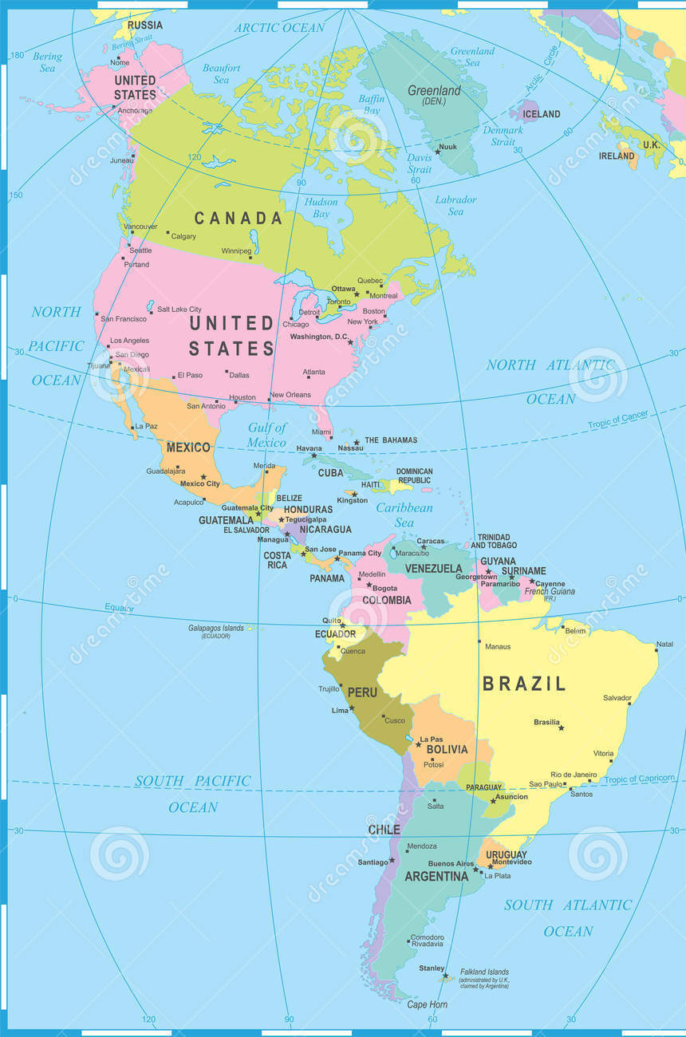

ICT
- The children will be using the internet to research different geographical features found in North and South America.
- During the Enfield Sings project, we will be learning to sing and perform songs related to specific countries.
Art
- The children will be looking closely at architecture within North and South America.
D&T
- Children will research and make island biscuits. They will make notes on their texture, taste, appearance and size.
Music
Geography
- The children will understand the geographical location of North and South America, referring to longitude and latitude.
- The children will use a variety of maps to notice major land features.
- Children will look at specific case studies to understand how people live in different areas of North and South America.

