KIP and Friends
Learning at Home: A3 (b)

The Liturgies of Easter

How to use this workbook!

What I think about your ‘work at home’ time!

I think you will have either a book to work in at home, or some paper to work on. I think you will have pencils or pens to write with and maybe some coloured pencils.
I also think you will have access to the internet.

You might have a printer and glue and scissors.
If you have a printer you can print this book off and do the activities using the pages in it, or cut out the pictures and paste them into your book.
If you don’t have a printer, copy what you need into your workbook.

You will need to choose what activities you can do and which ones you can’t! Easier activities are listed first.

This workbook is to help you learn:

1. What the Church does to remember those events of Holy Week now

The information is in red: the activities are in black

Last workbook you learned about the last week of the life of Jesus. This workbook teaches you about what we do in Church to remember what happened. Each of the four days has a different special action which we are going to learn about.

As you learn about each day, add to this workbook. When you have finished, we will be able to think about all the different actions help us remember and celebrate.

Some things to do! (younger pupils)

Draw this organiser into your book so you can gather the information about each action. You can trace around a round dinner plate to get the basic shape and then rule a line from top to bottom and side to side.

Put another ring around the outside edge for the name of the day (the green ring shown in the workbook).

Palm Sunday

Name each section in the green ring (see above): Palm Sunday, Holy Thursday, Good Friday, Easter Sunday
Now you are ready to go!
Some things to do! (older pupils)

Make a graphic organiser (a visual tool) in your book onto which to gather the information about each day. This is a simple graphic organiser – it’s a table!

Name of the day | Date for 2020 | Event remembered | Symbolic action
Fill in the names of the four days: Palm Sunday, Holy Thursday, Good Friday, Easter Sunday
Now you are ready to go!

An important word!
The three days of Holy Thursday, Good Friday and Easter Sunday are sometimes said to be one liturgy or prayer - divided into three parts. We call these three Masses the Triduum (trid – e – um).

Watch this video, it explains the days of the Triduum and introduces you to the special action we will do at each of these liturgies! https://www.youtube.com/watch?v=TZdgGbdkB_8

Palm Sunday: 5th April

Special action: To remember this day we usually have everyone process (walk in a procession) into the Church to begin Mass. People carry and wave branches, often palm branches.

Here is what the instructions say about organizing the procession.
1. The congregation (all the people who have come to Church) meet at a place away from the church. Sometimes it is the carpark of the Church. The congregation are given branches to carry into the church (sometimes people bring their own from home.

2. The Priest wears red vestments.

3. An antiphon (short prayer) is sung or said as the people come into the Church. Here is one based on Matthew 21: 9
Hosanna to the Son of David;
blessed is he who comes in the name of the Lord,
the King of Israel.
Hosanna in the highest.

Some things to do! (younger pupils)
1. Watch this video. In this Church the adults sit inside and let the children process in with the palms. https://www.youtube.com/watch?v=cbngtsvLSAc

2. See if you can find some thick paper or cardboard. (You might be able to find an old grocery box (cereal box for example). Draw a palm branch on it, like the one below.

Cut out the leaf and use it as a reverse stencil to make palm branches in your book. Hold the leaf shape on the paper and shade over the top of it with a green pencil so that when you remove the card you have the picture of your leaf. (The unicorn below is a reverse stencil image.) Do this a few times to decorate your page. Write: On Palm Sunday we wave branches as we walk into Church.

3. Draw a palm branch onto your organiser in the section marked Palm Sunday.

Some things to do! (older pupils)

1. Tradition says that Jesus rode into Jerusalem through the Golden Gate. Visit this website to see an image of the Golden Gate. http://www.magdalenepublishing.org/blog/jerusalems-golden-gate-history-prophecy/
Scroll down and look at the two images under the picture of the Golden Gate. The first is Jesus riding into Jerusalem; the second is a map of Jerusalem, showing all the gates into the city. Read Answer these questions in your book.

- How many gates were there into Jerusalem during Jesus’ lifetime?
- What were their names?
- What do you notice about the Golden Gate now?

The Golden Gate was blocked up (filled in) in the 800’s to stop people coming through; now there is a Jewish cemetery just in front of it.

2. Watch this video of a Palm Sunday procession in Jerusalem, from the Church in Bethphage where Jesus got the donkey from. https://www.youtube.com/watch?v=9o0kDY1mcuc

3. Summarise the information in Red in the box above and fill in your graphic organiser with information about the Palm Sunday liturgy.

Holy Thursday: 9th April

There are TWO special actions on Holy Thursday.

Special action: We remember that Jesus washed the disciples’ feet at the Last Supper as a wonderful act of service. The Priest re-enacts this action by washing the feet of 12 members of the congregation.

Here is what the instructions say about the washing of the feet.
1. 12 people are chosen to have their feet washed. The washing takes place after the homily (the Priests talk).

2. The Priest takes off his chasuble (the coloured ‘cape’ he wears) and pours water over each person’s feet. He then dries them.

3. An antiphon (short prayer) is sung. This one is based on John 13:12, 13 and 15
The Lord Jesus, after eating supper with his disciples,
washed their feet and said to them:
Do you know what I, your Lord and Master, have done for you?
I have given you an example, that you should do likewise.

Another special action!
After his final meal with the disciples, the Gospels tell us that Jesus went out into the garden of Gethsemane to pray. His disciples were invited to keep him company and to pray with him. We remember and re-enact this by staying to pray in front of the Blessed Sacrament (the consecrated hosts) after Mass.

Here is what the instructions say about praying in front of the Blessed Sacrament.
1. After the Prayer after Communion, the Priest takes the consecrated hosts to a special part of the church. This place is called a place of repose (rest).

2. The Priest places the ciborium (the wine glass shaped container the hosts are kept in), in the tabernacle (the ‘box cupboard’ hosts are left in.)

3. People are invited to continue praying in front of the Blessed Sacrament during the night.

Some things to do! (younger pupils)

1. Watch Pope Francis washing the feet of 12 people during Holy Thursday Mass. https://www.youtube.com/watch?v=4OOkBIrW60w
Washing someone’s feet in Jesus’ lifetime was a way of taking care of them. Write the names of 12 people who take care of you, in your book. Draw some of the things they do to show they care for you. Do they wash your feet?

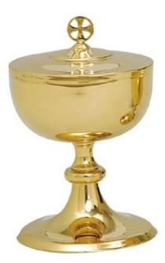
2.

Draw a picture of a ciborium and a tabernacle in your book. Label your drawings. Write what we do on Holy Thursday: “On Holy Thursday we stay and pray in front of the tabernacle, where the ciborium, which contains the Body of Christ, rests.”

3. Draw either a bowl of water and towel, or a ciborium onto your organiser in the section marked Holy Thursday. If you have room, draw both!

Some things to do! (older pupils)

1. Watch this video of Pope Francis washing the feet of some refugees. https://www.washingtonpost.com/videonational/pope-francis-washes-feet-of-refugees-on-holy-thursday/2017/01/30/0649b458-e6fc-11e6-903d-9b11ed7d8d2a_video.html
Pope Francis is the first Pope to wash the feet of people who are not Priests. He chooses the people whose feet he washes very carefully. One year he washed feet at a young person’s prison, another year he included women, another year he washed the feet of people from different faiths including Muslims and Hindus.
Answer these questions in your book.
- Why does Pope Francis choose people from groups who have been left out of society?
- What do you think Pope Francis is trying to say?
- What does he believe about people and about God?
- If you were to choose people for Pope Francis this year who would you choose?
- Write a letter to Pope Francis and tell him whose feet you would like him to wash, and why.

2. A Ciborium (picture above) is the vessel (container) that consecrated hosts (the Body of Christ) are kept in, inside the tabernacle (picture above). The word is a Hebrew word which means tent, pavilion or shelter. It is the resting place of God.
Watch this video of one Church placing the ciborium into the tabernacle. https://www.youtube.com/watch?v=5tGu4zongMk
At 3 minutes you will see the Priest holding the ciborium (under the white umbrella) and 7 minutes you will see his place it into the tabernacle.

3. Summarise the information in Red in the box above and fill in your graphic organiser with information about the Holy Thursday liturgy.

Good Friday: 10th April

Special action: On this day there is no Mass. Although we still receive communion, the Body of Christ is brought from the Tabernacle where it was placed on Holy Thursday night. The altar is kept bare; without a cross, without candles and without cloths. Finally, there is veneration (adoration) of the cross before communion.

Here is what the instructions say about the Good Friday Mass.
1. We have our liturgy at three o’clock to remember the time that Jesus died. Our liturgy has three parts: Liturgy of the Word, the Adoration of the Cross, and Holy Communion.
2. The Priest wears red vestments. He enters the church in silence, he walks to the altar and lies in front of it to pray.
3. After the Prayers of Intercession (the prayers after the homily) candles are placed at each side of the cross and the congregation are invited to come forward and either:
genuflect in front of the cross, touch it or kiss it. (see pictures below)

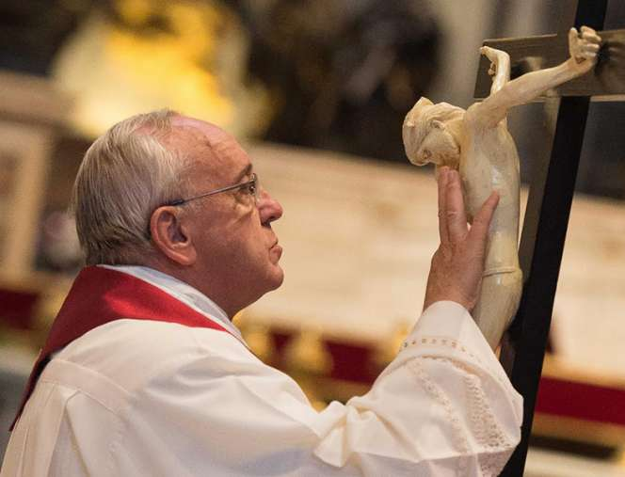
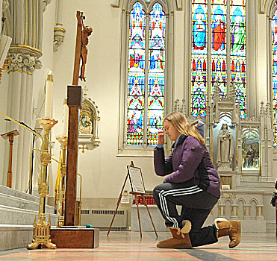
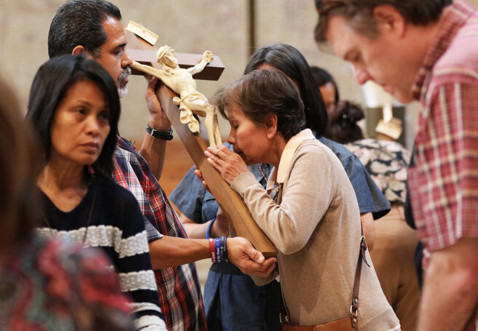

Some things to do! (younger pupils)

1. The cross in the pictures has the body of Jesus on it. When the cross has the body of Jesus on it, we call it a crucifix. Draw a crucifix in your book (a cross with Jesus’ body on it).

2. Talk to as many people as you can and ask them if they have a cross or a crucifix? It may be a piece of jewellery, an ornament, a painting, picture or on a set of Rosary Beads. Write in your book: If someone was going to give you one as a present, would you prefer a cross or a crucifix? Why?

3. Draw someone in front of a crucifix onto your organiser in the section marked Good Friday.

Some things to do! (older pupils)

1. Look at the three pictures. Although the three people venerating the cross are doing it differently, they are all trying to express the same thing.
- What are they trying to show, in praying in front of the cross of Jesus on Good Friday?
- What would you do to show that same level of love or thanks?

2. Use your ideas to make an acrostic poem using the letters of the word ‘adoration’.
(An example of an acrostic poem is the one on the right of the page, describing the qualities of a FRIEND.)

3. Summarise the information in Red in the box above and fill in your graphic organiser with information about the Good Friday liturgy.

Easter Sunday: 12th April

Special Action: The most exciting rituals for Easter Sunday are at the vigil Mass which happens on Saturday night, after sunset. At this mass we have a fire outside the Church and we all walk from the fire into the Church together. The Paschal (Passover) Candle is also prepared for the new year. This candle will sit in the Church for the following year till next Easter. It is the first candle lit from the Easter fire – and it will remind us of the resurrection all year. Once the Paschal Candle is lit, everyone who has gathered lights their own candle, and we walk into the Church together.

Here is what the instructions say about what we do.
1. A fire is prepared in a suitable place outside the church. When everyone is there, the Priest comes with the altar servers one of whom carries the Paschal Candle.
2. The Paschal Candle is brought forward. It is NOT alight. This candle has to be made of beeswax, never be artificial, and be new each year.
3. The Priest cuts the shape of a cross into the candle with a knife. Then he makes the Greek letter Alpha above the cross, the letter Omega below it, and the four numerals of the current year between the arms of the cross. After these rituals, he lights the candle from the fire and says: May the light of Christ, rising in glory, dispel the darkness of our hearts and minds. (EV, no.14)
4. There is then a procession into the Church.

5. The Priest wears white vestments.

Some things to do! (younger AND older pupils)

1. Watch this video. It is a short explanation of the Easter Vigil Mass. https://www.youtube.com/watch?v=gO5romstsQY
You can stop at 2 minutes (when the first song finishes.) You will see the fire and the Paschal Candle.

2. Decorate your own Paschal Candle (on the last page). Don’t forget the year (2020) and the Alpha and Omega – the first and last letter of the Greek alphabet – to remember that God is at the beginning and at the end of everything. Use some Easter colours and Easter symbols on in.

3. Think of words to describe the whole Easter season, from Palm Sunday to Holy Thursday, Good Friday and Easter Sunday. Think of words that remind you of these days – some might be joyful, others might be sad or disappointing. Make a cross like the one below to show all the feelings of Easter

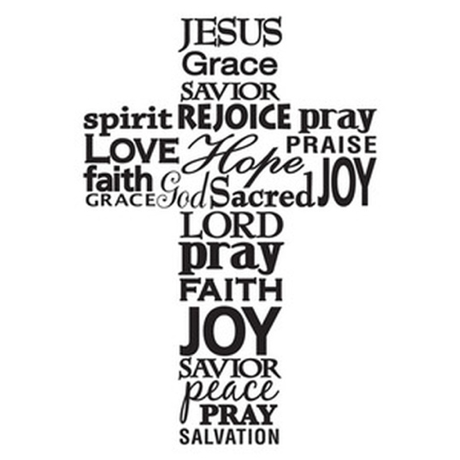

4. Easter Eggs and rabbits are a symbol of Easter because they remind us of new life. Chicks hatch from eggs and rabbits have loads of babies each year! It’s easy to forget that Easter is really about Jesus as we eat our Easter treats so maybe decorate this egg with symbols of a Christian Easter.

5. Fill in the symbol (younger pupils) and information (older pupils) on your chart. Now! A question! Which of the liturgies do you like best? Is it Palm Sunday? Holy Thursday? Good Friday? Easter Sunday? Why don’t you email, text or phone a friend and see what they thought? Can you find out what 10 people thought and make a graph?

