Art:
Last term the children were learning about portraits. They will now look at the work of Giuseppe Arcimboldo and create their own portraits from fruit and vegetables.
https://www.twinkl.co.uk/resource/t-t-14187-food-ks1-giuseppe-arcimboldo-information-powerpoint-presentation

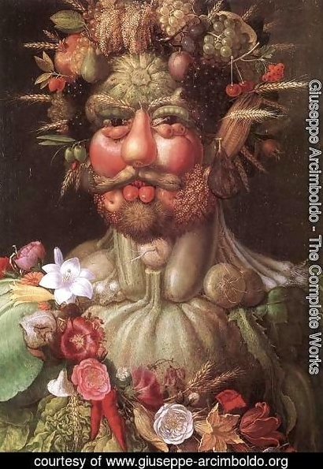
Look at the painting on the left.

What is the man’s portrait made from?

How many plants, fruit or vegetables can you name?

His nose is made from a _____________________
His hair is made out of ______________________
His eyes are made with ______________________
His clothes are made with ____________________
Project: Make your own Arcimboldo style portrait. It can be of yourself, someone in your family, or a famous person.
Use real fruit and vegetables and create it on a table and take a photo.
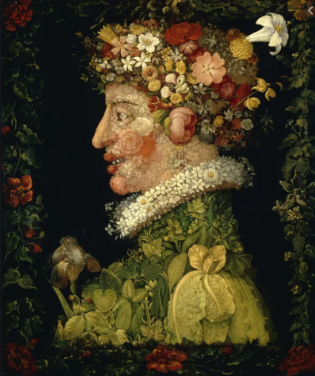
Alternatively, draw or use pictures of fruit, veg and flowers to cut and stick onto paper. There is a sheet of fruit and veg pictures attached. Have fun!



