Design Technology – Week 2
Make a fruit salad.
We hope you enjoyed making your fruit and vegetable pictures last week. This week we want you to use up some of that fruit and make a delicious fruit salad.
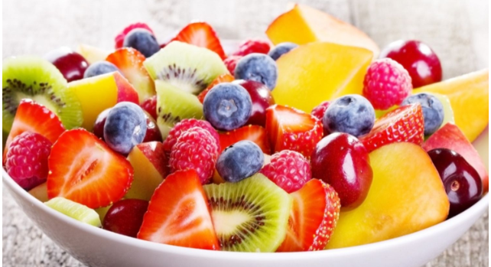

- Make sure you wash your hands.
- Wash the fruit.
- Use a clean knife and chopping board.
- Never cut fruit without an adult present.

https://www.youtube.com/watch?v=XcD2_AmMU6g Basic fruit cutting techniques.
https://www.youtube.com/watch?v=aS3nLa6-VpE A children’s animation about making fruit salad.
https://www.youtube.com/watch?v=716MHYY3buA Getting creative with fruit kebabs
https://www.youtube.com/watch?v=oncIUB3F3VI making creatures out of fruit
https://www.youtube.com/watch?v=53al2aBX3E8 banana creature
https://www.youtube.com/watch?v=6Cl9zcMeq6Q orange goldfish
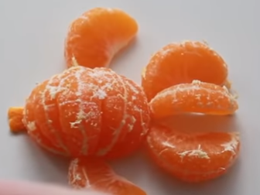
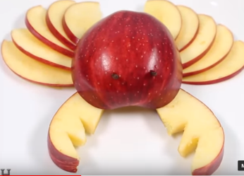
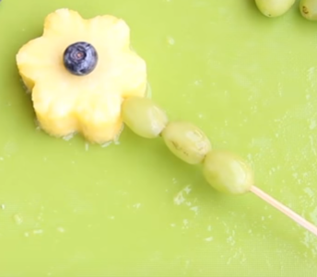

A Recipe for Fruit Salad
Ingredients Try to use three or more different fruits from below:
Apple
pear
Orange
Banana
Grapes
Lemon Use the juice from this to stop the fruit from going brown.
Strawberries
Blueberries
Peach or nectarine
Raspberries
Cherries
Melon
Pineapple
mango

Method
- Wash the fruit. Peel bananas, oranges, pineapple.
- With an adult, chop the fruit into slices. Cut grapes and cherries into halves.
- Leave the banana to one side and sprinkle the fruits with a bit of sugar and some lemon juice (to stop the fruits from browning)
- Cover for a few hours in the fridge so that some of the natural juices come out of the fruits
- Add chopped banana just before serving and mix with other fruits
My Fruit Salad
I made my fruit salad with ________________
________________________________________________________________________
The first thing I did was I ________________
____________________________________
Next, I ______________________________
____________________________________
After that I __________________________
____________________________________
Finally, I _____________________________
____________________________________
I think my fruit salad was _________________
Next time I will use _____________________ for a different flavour.

