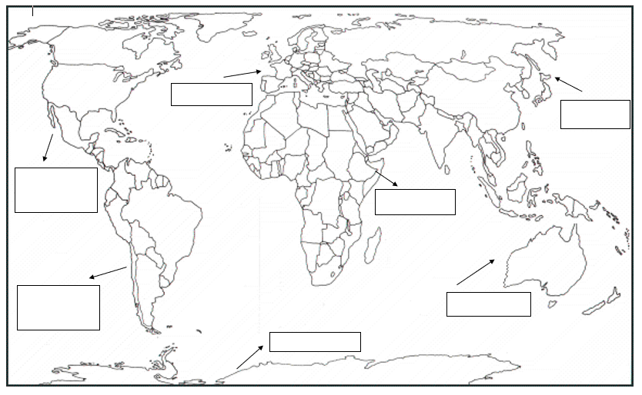

My Geography project
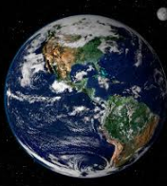
The World and its Seven continents
Take a look at the Earth from space using google Earth and zoom in on your area using your postcode. https://www.google.com/earth/
https://www.youtube.com/watch?v=K6DSMZ8b3LE
7 continents song

https://www.youtube.com/watch?v=dk8zDjQT0aE
A Youtube video about the continents.

My planet is called _________________.
There are ___________________ continents.
England is in ______________________.
The other six continents are called:
____________________________________________________________________________________________________________________

World map Continent Ocean Asia Africa North America South America
Oceania or Australia Europe Antarctica

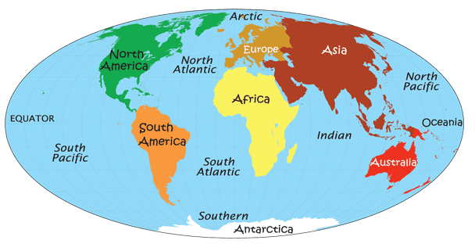
Go back to your world map and add the five oceans:
Pacific Atlantic Southern Indian Arctic

Now go and research the world’s oceans and seas – you can use these websites:
https://www.youtube.com/watch?v=j9elm85IBYA children’s learning video.
https://www.youtube.com/watch?v=qTgPgIc1PXg More detailed exploration of the oceans.
https://www.youtube.com/watch?v=X6BE4VcYngQ A learning song about the oceans.
One interesting fact I learned about an ocean was:__________________________________________________________________________________________________________________________________________________________
- Using the websites below find out an interesting fact about each of the continents and write it next to the image.
- Now choose a continent to research for your own project.
Find out about: Countries
Climate (Weather) Clothing
Animals
Mountains, rivers, habitats
Food
Language
Music Dance
Religion
An excellent website which lets you listen to music from all over the world is https://www.allaroundthisworld.com/listen/#.Xoqpo4hKjIW
Good research sites are:
https://www.dkfindout.com/uk/earth/continents/
https://www.bbc.co.uk/teach/class-clips-video/geography-ks1-ks2-your-world/z67bmfr
BBC videos for children showing differences between continents.
https://blog.ciat.cgiar.org/origin-of-crops/ Scroll down for an interactive world map showing which foods are grown in which countries and continents.
https://www.bbc.co.uk/games/embed/education-ivor-pirate-rabbits?exitGameUrl=http%3A%2F%2Fbbc.co.uk%2Fbitesize%2Farticles%2Fz6vyf4j
CBBC pirate bunnies game – explore the Earth, oceans and climates.
https://www.youtube.com/watch?v=K6DSMZ8b3LE continents song
https://www.youtube.com/watch?v=X6BE4VcYngQ oceans song
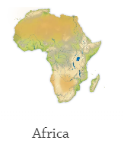
_______________________________________
_____________________________
___________________________________

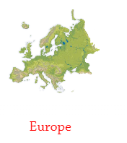
____________________________
____________________________
____________________________
____________________________

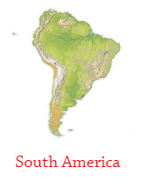

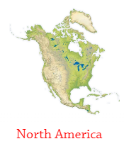

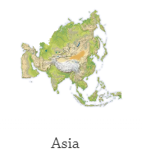
_____________________________
_____________________________
_____________________________
_____________________________

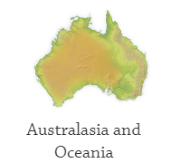

___________________________

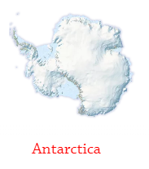

_______________________________________

My continent Project
The continent I have chosen is _______________________________
because _________________________________________________

Draw a picture of the continent, flag from a country, animal, food etc.
As this is a Home learning Project it is not necessary to write about everything you do. If you learn a song or dance or make and eat some food from a region this can be recorded with a picture and a sentence or just done as a practical activity and talked about. As teachers, we often ask the children questions about their learning and write down what they answer to save them the difficulty of writing everything down. We often get very insightful responses this way.
Countries

___________________________________________________________________________________________________________________________________________________________
Animals
__________________________________________________________________________________________________________________________________________________________________________________________________

Climate – weather
___________________________________________________________________________________________________________________________________________________________________________________________________

Mountains, rivers, habitats
___________________________________________________________________________________________________________________________________________________________________________________________________

Food (crops grown, cooking)
___________________________________________________________________________________________________________________________________________________________________________________________________

