- Read these poems with your child. Choose one each week to learn off by heart, by saying it several times a day. There are often versions on the internet with sound and pictures.
- To practise hand writing your child can write a verse every day in their best handwriting and draw pictures to go with it.
- Can they find the rhyming words?

http://www.poetrybyheart.org.uk/poems/eletelephony/
Eletelephony

by Laura Richards
Once there was an elephant,
Who tried to use the telephant.
No! No! I mean an elephone
Who tried to use the telephone.
(Dear me! I am not certain quite
That even now I’ve got it right.)
Howe’er it was, he got his trunk
Entangled in the telephunk.
The more he tried to get it free,
The louder buzzed the telephee.
(I fear I’d better drop the song
Of elephop and telephong!)
Cats sleep Anywhere
by Eleanor Farjeon
Cats sleep anywhere,
Any table, any chair.
Top of Piano
Window ledge,
In the middle, on the edge
Open drawer, empty shoe,
Anybody’s lap will do.
Fitted in a cardboard box,
In a cupboard with your frocks.
Anywhere.
They don’t care.
Cats sleep anywhere.

http://www.dussindaleprimary.co.uk/attachments/download.asp?file=593&type=pdf
(see above link for very cute pictures)
https://www.youtube.com/watch?v=xykQW-xGTw8 cats sleep anywhere music version

I WONDER
By: Jeannie Kirby
I wonder why the grass is green,
And why the wind is never seen?
Who taught the birds to build a nest,
And told the trees to take a rest?
O, when the moon is not quite round,
Where can the missing bit be found?
Who lights the stars, when they blow out,
And makes the lightning flash about?
Who paints the rainbow in the sky,
And hangs the fluffy clouds so high?
Why is it now, do you suppose,
That Dad won’t tell me, if he knows?

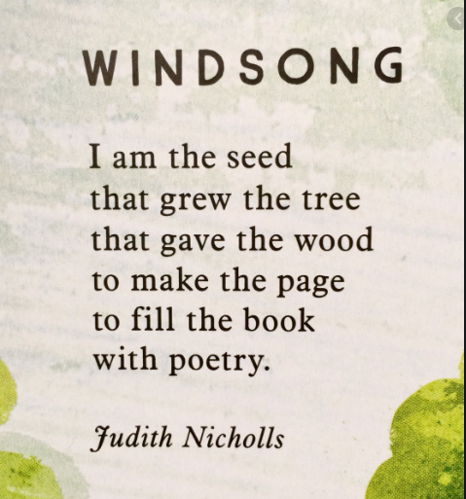

https://www.youtube.com/watch?v=FG3JZXLL_iM

When the wind blows

When the wind blows
Coats flap, scarves flutter.
When the wind blows
Branches groan, leaves mutter.
When the wind blows
Curtains swish, papers scatter.
When the wind blows
Gates creak, dustbins clatter.
When the wind blows
Doors slam, windows rattle.
When the wind blows
Inside is a haven,
Outside is a battle.

By John Foster

The Star by Jane Taylor
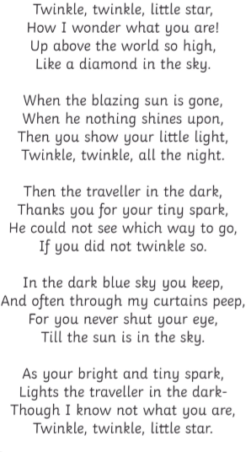

Answer to a Child’s Question

by Samuel Taylor Coleridge

Do you ask what the birds say? The sparrow, the dove,
The linnet and thrush say, ‘I love and I love!’
In the winter they’re silent – the wind is so strong;
What it says, I don’t know, but it sings a loud song.
But green leaves, and blossoms, and sunny warm weather,
And singing, and loving – all come back together.
But the lark is so brimful of gladness and love,
The green fields below him, the blue sky above,
That he sings, and he sings; and forever sings he –
‘I love my Love, and my Love loves me!’

If this is a bit tricky, try this link .
This is just a fun song to sing along with.
https://www.youtube.com/watch?v=AyiEF53jvoY apples and bananas

