SCIENCE: The Tiny Seed by Eric Carle Share and discuss these online books with your child over the coming weeks.
https://www.youtube.com/watch?v=I_A_e6h-DhU This is a narrated version; you can turn off the sound and read to your child or let them read to you.
https://www.youtube.com/watch?v=WoTPiEo2rnI A song about seeds – with clear lyrics that children can read.
https://www.youtube.com/watch?v=w77zPAtVTuI Bean time phase video. Watch what happens to an actual seed underground as it grows into a plant.
https://www.youtube.com/watch?v=9_vElnekJzI A seed is sleepy. A beautifully illustrated book with quite challenging science.
https://www.twinkl.co.uk/resource/t2-s-230-what-plants-need-to-grow-powerpoint
https://www.twinkl.co.uk/resource/t2-s-230-what-plants-need-to-grow-powerpoint
Twinkl has lots of powerpoints and videos on lifecycles of sunflowers, apple trees etc.
WEEK 1
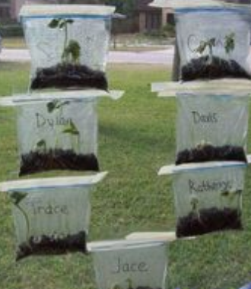
Activity 1: Grow a plant from a seed. Packets of seeds were only 29p in Lidls last time I was in and you can get pots and soil there and in the Poundshop, too. You can use a clear plastic bag and tape it to the window (see below) or use yoghurt pots or cut down milk cartons. If you use a clear container like a water bottle you can see the roots growing.
Grow your own and keep a plant diary, just write a sentence for each day. For example, Day One: I watered the soil but it hasn’t grown yet. See the attached booklet.
Investigation: Plan and conduct an investigation and plant 5 seeds under different conditions (sun, shade, cold, no water, etc), notice what happens (draw pictures and write about).
Look up videos about seeds and plants on Espresso. Also, take a look at the videos about Spring time.

