SCIENCE: The Tiny Seed by Eric Carle Share and discuss these online books with your child over the coming weeks.
https://www.youtube.com/watch?v=I_A_e6h-DhU This is a narrated version; you can turn off the sound and read to your child or let them read to you.
https://www.youtube.com/watch?v=WoTPiEo2rnI A song about seeds – with clear lyrics that children can read.
https://www.youtube.com/watch?v=w77zPAtVTuI Bean time phase video. Watch what happens to an actual seed underground as it grows into a plant.
https://www.youtube.com/watch?v=9_vElnekJzI A seed is sleepy. A beautifully illustrated book with quite challenging science.
https://www.twinkl.co.uk/resource/t2-s-230-what-plants-need-to-grow-powerpoint
https://www.twinkl.co.uk/resource/t2-s-230-what-plants-need-to-grow-powerpoint
Twinkl has lots of powerpoints and videos on lifecycles of sunflowers, apple trees etc.
WEEK 1
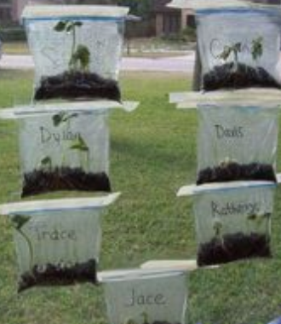
Activity 1: Grow a plant from a seed. Packets of seeds were only 29p in Lidls last time I was in and you can get pots and soil there and in the Poundshop, too. You can use a clear plastic bag and tape it to the window (see below) or use yoghurt pots or cut down milk cartons. If you use a clear container like a water bottle you can see the roots growing.
Grow your own and keep a plant diary, just write a sentence for each day. For example, Day One: I watered the soil but it hasn’t grown yet. See the attached booklet.
Investigation: Plan and conduct an investigation and plant 5 seeds under different conditions (sun, shade, cold, no water, etc), notice what happens (draw pictures and write about).
Look up videos about seeds and plants on Espresso. Also, take a look at the videos about Spring time.

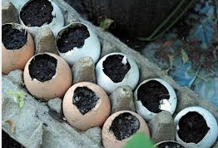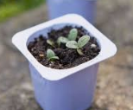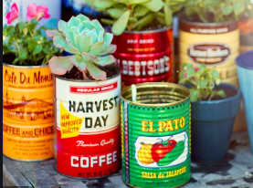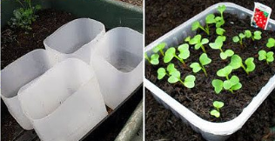
Week 2: Activity 2:
Look out of your window or on your walk at the trees. What do you notice about the leaves? Are there any flowers (blossom)? Draw some pictures.
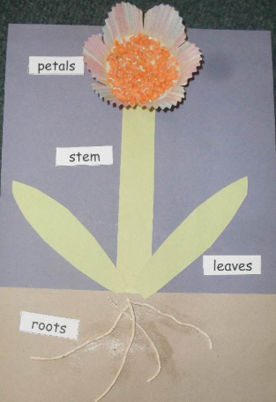
You can pull apart a real flower that has gone over to look at the parts.
https://www.bbc.co.uk/teach/class-clips-video/science-ks1-ks2-ivys-plant-workshop-the-anatomy-of-the-flower/zjmhkmn
https://www.twinkl.co.uk/resource/t-t-9822-parts-of-a-plant-task-setter-activity-powerpoint-with-worksheet
Science/Art Make a plant collage picture using cotton thread or string as the roots. You can use real leaves and petals or sweet wrappers, cake cases and straws for the stem, petals, leaves, and roots. Label the plant. Try sticking some actual seeds into the flower head.
Discussion: Can your child tell you what each part of the plant does?

Activity 3: Seed Investigation See attached PDF
Complete the seed investigation, then use your seeds to make a collage. Remember, lentils, rice, peas and beans are all seeds,
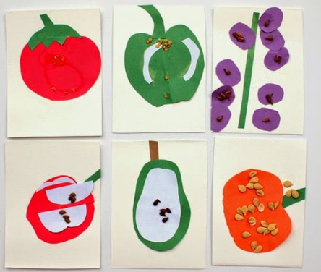
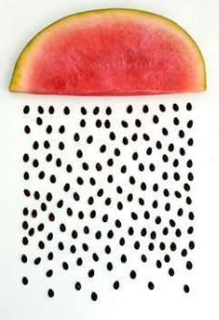
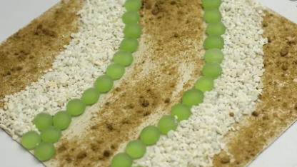

Don’t waste the fruit you cut up for the seed investigation. Use it to make a fruit salad. This will be the Design Technology project.

For those that have created a Twinkl account (free for one month):
https://www.twinkl.co.uk/resource/t2-s-230-what-plants-need-to-grow-powerpointhttps://www.twinkl.co.uk/resource/t2-s-230-what-plants-need-to-grow-powerpointhttps://www.twinkl.co.uk/resource/t2-s-230-what-plants-need-to-grow-powerpoint

Below are links to Spring themed reading comprehensions, and various nature-based non-fiction reading comprehensions – these are at three different levels depending on the skills of the reader. You can read the text and then the questions without having to print them. Either children write the answers into their books or answer orally. The most important thing is that the child can read and understand the text. Discuss the meanings of some of the words with them.

https://www.twinkl.co.uk/resource/t-l-51705-sunflower-plant-life-cycle-differentiated-reading-comprehension-activity
https://www.twinkl.co.uk/resource/t-l-51683-spring-reading-differentiated-comprehension-activity-sheets
https://www.twinkl.co.uk/resource/t-l-51742-ks1-mixed-differentiated-reading-comprehensions-bumper-resource-pack

