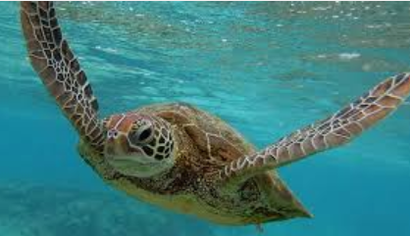
Seven facts about sea turtles
- Turtles are reptiles.

- Leatherback and hawkbill turtles think jellyfish are delicious. Green sea turtle only eat sea-grass (an underwater plant).Some turtles are carnivores, some herbivores and some are omnivores like humans.

- They can’t hide their heads and flippers inside their shells like land turtles and tortoises. This makes them better swimmers.

- Turtles come onto land to lay eggs in nests in the sand. If it is cold, the turtles that hatch will be male and, if the weather is warm, females hatch.

- They’ve been around on earth for a very long time and were around when the dinosaurs were living 110 million years ago!

- They can hold their breath under water for up to five hours.

- They can live to be one hundred years old.

Ten Facts about octopus.
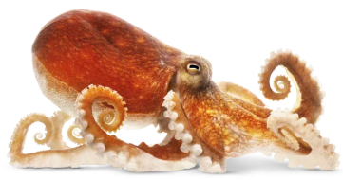
- Octopus are carnivores. They eat mainly crabs, shellfish and shrimp. They use their beaks to drill through hard shells.

- Octopus have eight arms and three hearts.

- Octopus squirt ink at predators. This makes it hard for the predator to see them as they quickly swim away.

- Octopus have blue blood.

- The biggest octopus in the world is called the Giant Pacific Octopus. It lives off the West coast of Canada and can eat sharks!

- The blue-ringed octopus is very small but is one of the most poisonous creatures in the ocean. It lives in the Pacific Ocean around Japan and Australia.

- Most octopus live deep down on the ocean floor and come up at dawn and dusk to feed. They have been called ‘monsters of the deep’.

- Octopus build their own shelters using their arms to collect rocks. They also like shiny objects and can collect pretty shells and rocks and make a ‘garden’.

- Octopus tend to live in warmer water in the tropical areas.

- Octopus are very intelligent. They have been known to climb aboard fishing ships, open the door to the hold with their arms and then feed on the crabs caught by the fishermen!

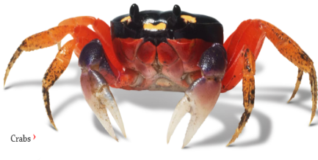
Five Facts about Crabs
- Crabs belong to a group called crustaceans (crust – ay – shuns). They have hard shells on the outside but are soft on the inside. Crabs do not have backbones or spines.

- Crabs have a hard shell to protect them from many predators. Birds, fish and humans may all try to eat them.

- Crabs can breathe in water like fish, but can also breathe out of water for quite a long time.

- Crabs are very good at hiding from predators. In the daytime they bury themselves in the sand, in mud or hide in rockpools or in the shallows.

- Hermit crabs change shells when they grow. They take off their old shells and find another shell that is not being lived in that they can fit into.

Nine Facts about jellyfish
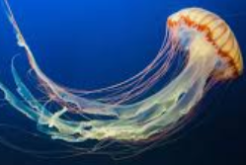
- Some jellyfish are as big as humans,
others are as small as the head of a pin!

- Jellyfish do not have brains, hearts, bones or eyes.

- Jellyfish eat fish eggs, very small fish and tiny sea plants.

- Jellyfish cannot swim, they just drift along with the ocean tides. They can squirt water from their mouth and this moves them forward.

- Jellyfish use their tentacles to catch and sometimes sting creatures to eat. Not all jellyfish sting, but some are very poisonous.

- Jellyfish have been on the Earth for millions of years, for even longer than the dinosaurs.

- Sea turtles love to eat jellyfish.

- Jellyfish do not have backbones so are not really fish, but invertebrates like crabs and snails.

- The most dangerous jellyfish are Box jellyfish whose tentacles can be over 3 metres long. They live near Australia and their stings are very painful.

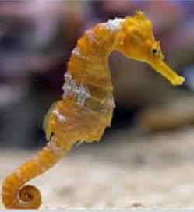
Seven Facts about seahorses

- Sea horses are fish who are named after horses because of the shape of their heads.

- Sea horses swim in pairs with their tails linked together.

- The seahorse does not have many predators because it is so bony. Crabs do eat seahorses.

- Seahorses eat tiny fish called brine shrimp and tiny plants.

- Seahorses swim upright so they look more like plants than fish and do not get eaten.

- Seahorses cannot swim very well and use their tails to hook around coral to keep them from getting washed away or drowned in strong tides.

- The male seahorse carries the eggs around on its tummy until they hatch.

