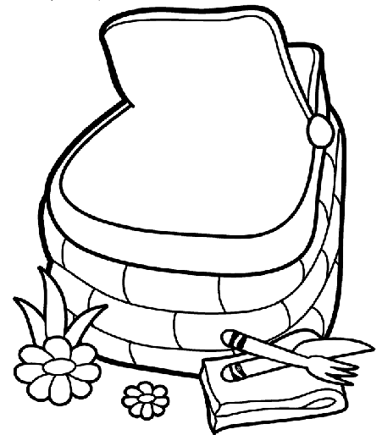
Draw the foods you will take in the basket. What sandwiches will you take? Which fruit will you pack? What drink will you take? Will you bring a home-made cake or pie?

