Read through the sea creature information sheet and choose one or two animals to write about. Find out: what they eat, describe parts of the body, where do they live, find an amazing fact.
Sea Turtle
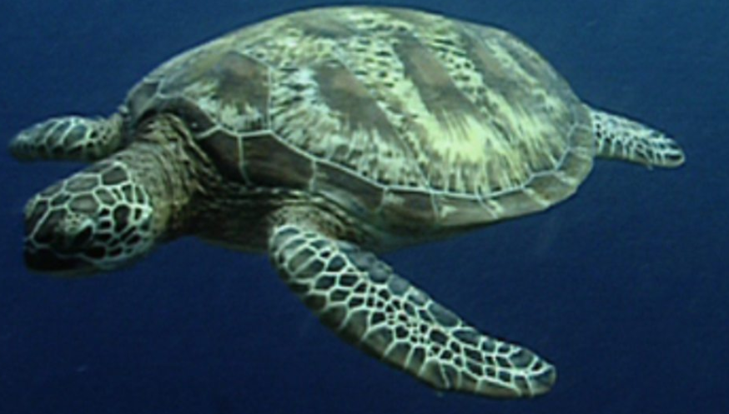
________________
________________
________________
________________
________________
______________________________________________________________________________
An octopus
octopus
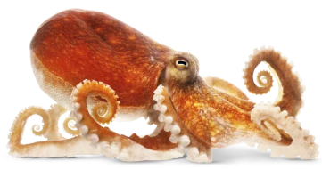

______________________________________________________________________________
swim shell omnivore carnivore plankton fish tentacles flippers ink beak eyes breathe
suction poisonous carnivore herbivore omnivore

Crabs
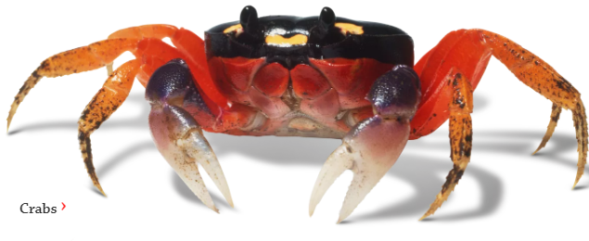

______________________________________________________________________________
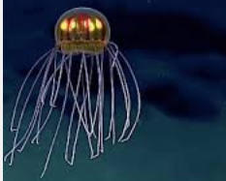
Jellyfish __________________
__________________
___________________
___________________
______________________________________________________________________________
_________________











