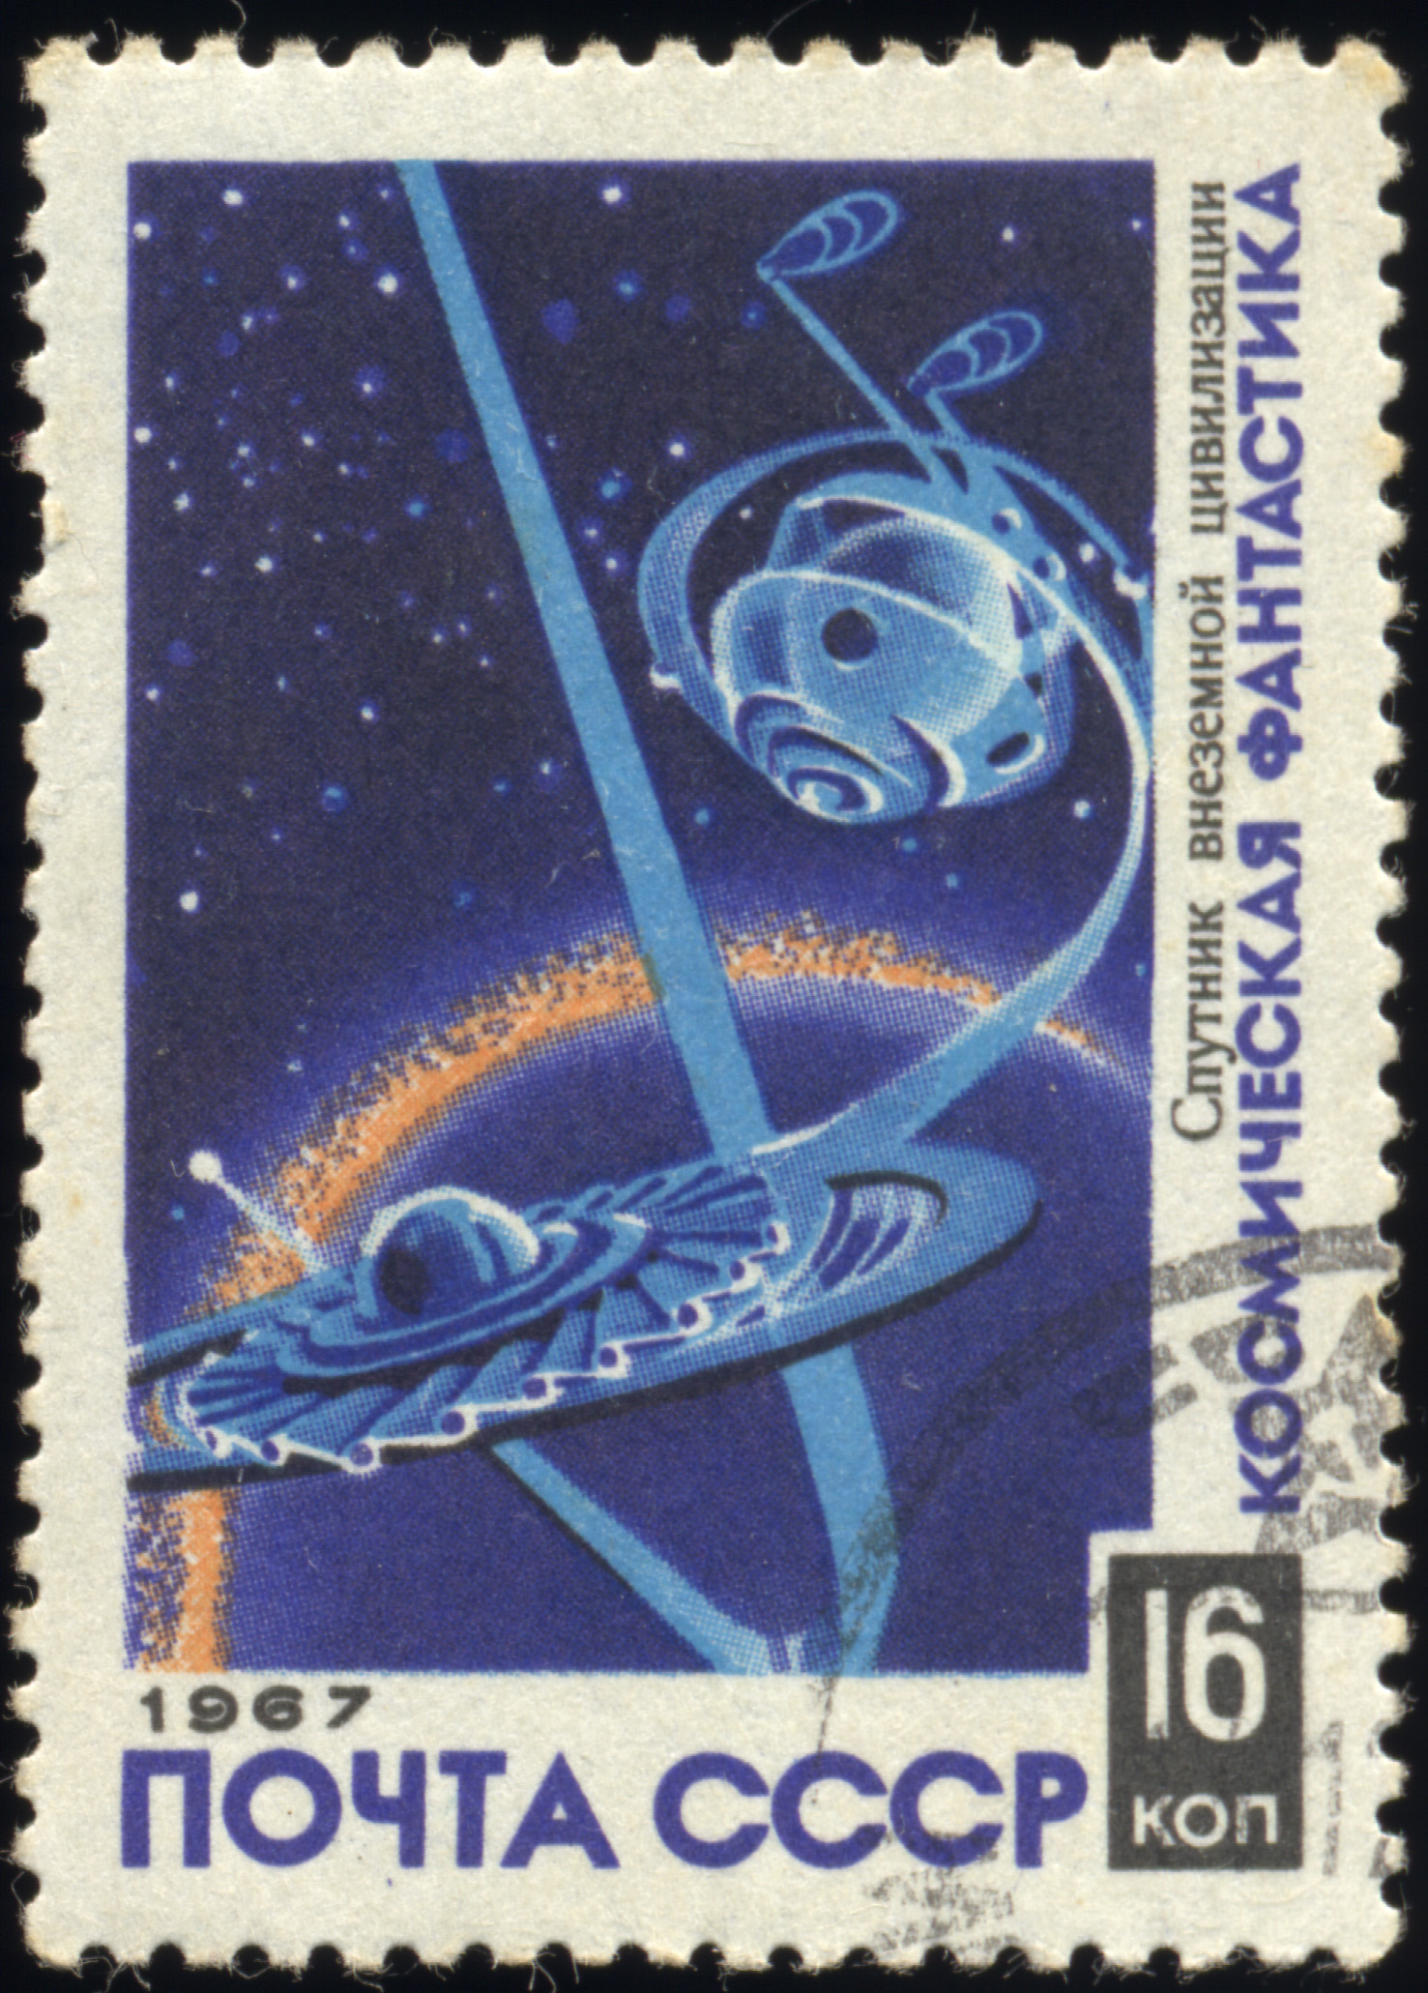
Create a Postcard from the past

____________________________________________________
__________________________________________________________________________________________________________________________________________________________________________________________________________________________________________________________________

