I can explain what the parts of a plant do.

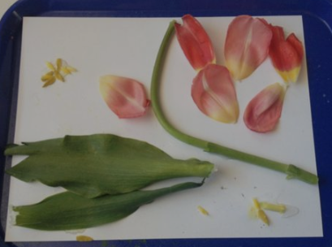
https://www.youtube.com/watch?v=TD60-3rqPXg
another parts of plant animation
https://www.youtube.com/watch?v=-LGh7WEZe7k
nice parts of plant animation and song
https://www.youtube.com/watch?v=R9sn7HZM7uY
flower investigation video
https://www.youtube.com/watch?v=p3St51F4kE8
parts of a plant animation (well narrated)
https://www.youtube.com/watch?v=pEGJAn88NYk
parts of plant – children’s animation – fun, strong accents
Activity One and explanation:
Take a flower apart.
- Notice how the stem is rigid. It has two purposes – to hold the flower and leaves upright like a skeleton, and to send water and nutrients from the roots to the leaves and flowers.

- The petals are bright and attract insects. The petals surround the centre of the flower acting like the outer edges of a target. Bees and wasps are guided by the petals and fly in to the centre to drink the nectar and carry pollen from one flower to another.

- The roots act like an anchor, keeping the plant in the ground, and also soak up water and nutrients from the soil.

- The leaves are green because they contain something called chlorophyll which is used in photosynthesis, they stick out so they catch lots of sunlight. Photosynthesis is how the plant turns sunshine into food.

Activity Two: Pick some leaves from a plant and rub them on a piece of paper to show the chorophyll . Use a straw to show how the stem of a plant sucks up water from the roots in the soil.

Activity Three: Watch the videos or look at the powerpoint. Can you explain what each part of the plant does? (more challenging work below, less challenging over page)
The stem ________________________
________________________________
________________________________
________________________________
The flower _____________________
______________________________
______________________________________
______________________________________
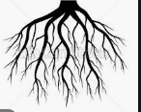
The roots _________________
_________________________
_________________________
_________________________
Leaves ______________________
____________________________
____________________________
____________________________
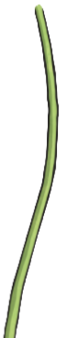
Match the part of the plant to the explanation:
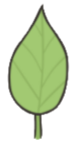
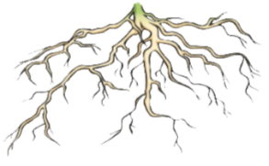
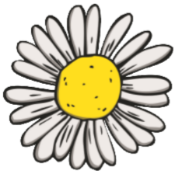
The flower leaves the roots the stem

- What part keeps the plant in the ground?

_______________________________

- What part helps it to stand straight?

_______________________________

- What part absorbs sunlight?

_______________________________

- What part attracts bees and butterflies?

_______________________________

To identify the parts of a tree and understand their function.
Can we identify some parts of the tree?
Branches, leaves, trunk, and roots – Can we see the roots?
Are there any parts of the tree that are the same as a flower?
Are there any parts that do the same job as the parts in a flower?
(Trunk is similar to the stem as it holds it straight and transports water to the plant. Roots are exactly the same but larger. Leaves have the same purpose. Branches hold the food that was made by the leaves.)

