Geography Week 3 and 4
As the children are continuing their project work this page can be completed over the two weeks. There is an additional ocean investigation that can be completed only with adult supervision. See additional page.
https://www.youtube.com/watch?v=X6BE4VcYngQ Oceans song
https://www.youtube.com/watch?v=qTgPgIc1PXg
Play the above video. Can your child point to where the oceans go?
https://www.youtube.com/watch?v=1WZsxVDTqcU
Another learning video with lots of interesting facts.

Which animals did you spot and where do they live?
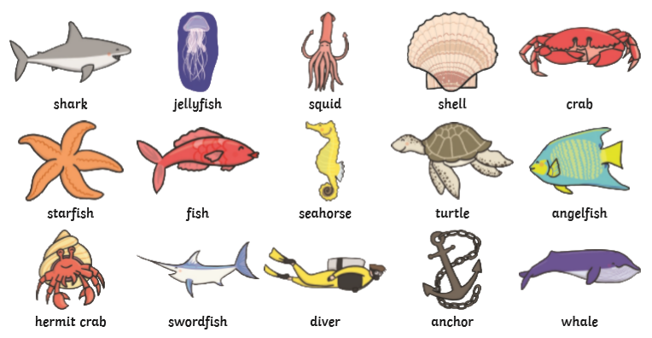
https://www.bbc.co.uk/games/embed/education-ivor-pirate-rabbits?exitGameUrl=http%3A%2F%2Fbbc.co.uk%2Fbitesize%2Farticles%2Fz6vyf4j
Play this game – click on the ship’s wheel to play the ocean’s game.

I know an animal that lives in each of the five oceans.
https://www.worldatlas.com/articles/what-animals-live-in-the-atlantic-ocean.html
The Atlantic ocean

https://www.worldatlas.com/articles/what-animals-live-in-the-pacific-ocean.html
The Pacific ocean

https://a-z-animals.com/animals/location/ocean/indian-ocean/
The Indian ocean

https://a-z-animals.com/animals/location/ocean/southern-ocean/

The Southern
ocean

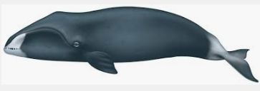
Animals of the Arctic ocean
Bow head whale
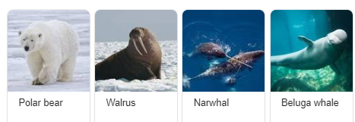

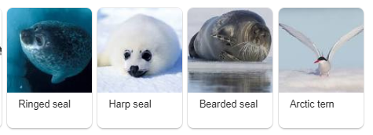

Draw and label your favourite arctic animal. Can you find out what it eats?
Can you find two arctic animals with the same features?
______________________________________________________________________________
Now, choose an ocean to find out some more about.
I am researching the _______________ ocean.
Countries which are near this ocean are _______________.
Creatures which live in are ___________________
_______________________________________.
The __________________ lives in the _________________ ocean. It eats ___________
_______________________________________.
Some plants that grow here are _______________
_______________________________________.
Draw some pictures here.

