Materials needed for the Ocean Currents Science Experiment:
Cold Water
Ice
Boiling Water
Clear or white large baking dish
Red and Blue Food colouring

First, fill the clear baking dish about 1/3 full with cold water and add a few drops of blue food colouring. You won’t want the blue to be too dark or you won’t be able to see the currents forming.
Add a 1-2 cups of ice to the cold water and stir. Let it set for a few minutes for some of the ice to melt. Our goal is to have very cold water. Lukewarm water will not give you the same results.
While the ice is melting, boil about 4 cups of water. Add red food colouring to the boiled water, this one you will want to make darker.
Once both sets of water & dye are ready, gently pour some of the boiling water into a corner of the baking dish filled with cold water.
Then, watch as currents form right before your eyes!
The hot water will push through the cold water, creating currents. In the ocean these are faster moving strips of water (like the East Australian Current…)
As an added bonus, we got to see some eddies form! Eddies are circular moving currents and you can see them very clearly in this picture.
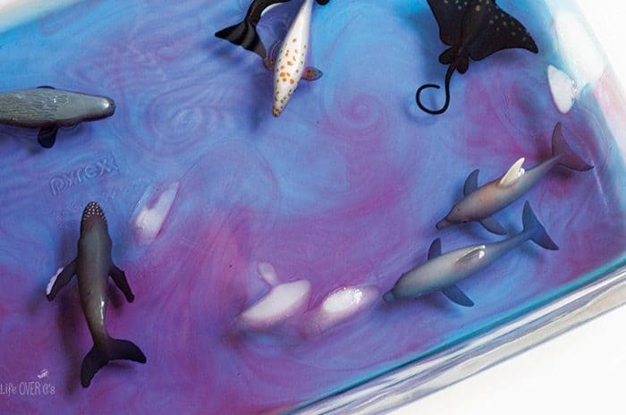
Eventually the water mixed together to create lukewarm (and purple) water which is what it also does in the ocean.
Have fun exploring the ocean with this super fun ocean currents science experiment for kids!

