Science Week 4:
I am learning about the parts of trees.
Watch and listen to the online book: https://www.youtube.com/watch?v=JBZUKKGEeNw
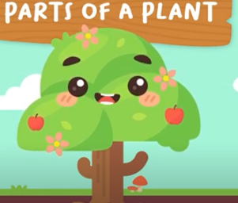
https://www.oxfordowl.co.uk/api/interactives/26361.html Read all about trees in this Oxford Owls ebook.
https://www.oxfordowl.co.uk/api/interactives/29303.html
An online book ‘What’s in the woods’?

Great links for videos and animations to learn about trees:
https://www.youtube.com/watch?v=7vjISSBcHCg
Parts of tree animation
https://www.youtube.com/watch?v=FJqy967xs1c
A song to learn the parts of trees (to the tune of Head, shoulders, knees and toes).
Activity One : Label the parts of a tree see attached sheet

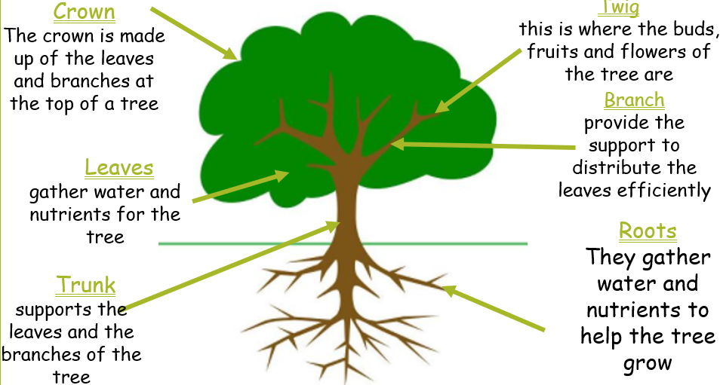

https://www.youtube.com/watch?v=DxuP3iC1Wao&feature=emb_rel_pause
A year in the life of a Field maple
Activity Two:
Go on a walk to a local park or just along your street. Bring crayons or chalks and paper. Find a tree and take one or two leaves. Are there any flowers, fruit or seeds hanging from it? Look at them, take a sample or take a photograph.
Put your paper on the trunk of the tree and make a bark rubbing. This shows how rough and tough the bark is. Why do you think it is so tough and scratchy?
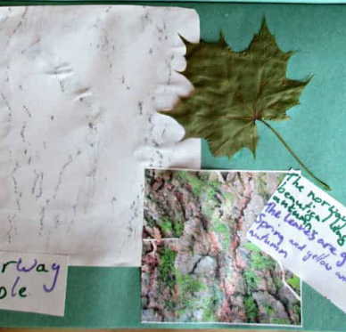
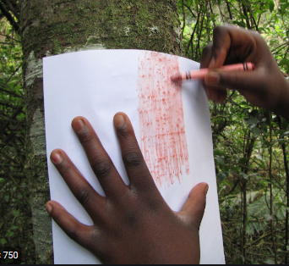
Bark is a bit like our skin but thicker and scratchier. Why do you think trees might need this thick skin?
Trees grow bark to protect their stem which is called a trunk. Just like our skin, bark’s main purpose is to protect the tree. It is like a special armour that the trees grow to protect themselves.
Activity Three:
Take the leaves and any other parts home with you. Make a leaf rubbing on your paper next to the bark rubbing. What do you notice about the shape of the leaf? Can you see the veins in it? Where are your veins? What are they for?
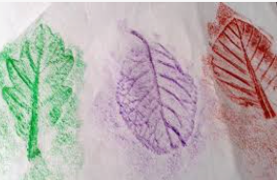
Check it against the leaf and tree chart, or go online at Can you work out what tree it is?
What animals do you think live in this tree?
Now have a look at some of the sample leaves on the leaf page. Next time, you go out take it with you and see if you can identify any other types of tree.
https://www.woodlandtrust.org.uk/media/48345/leaf-id-sheet.pdf
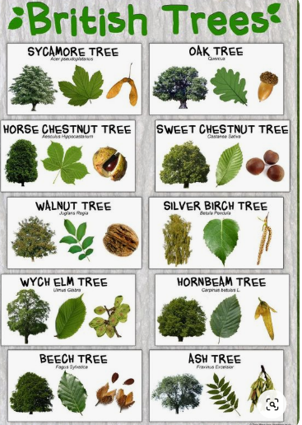
https://www.woodlandtrust.org.uk/media/48346/leaf-idial-sheet.pdf
https://www.youtube.com/watch?v=swLVNljDS64 A children’s animation about leaves.

