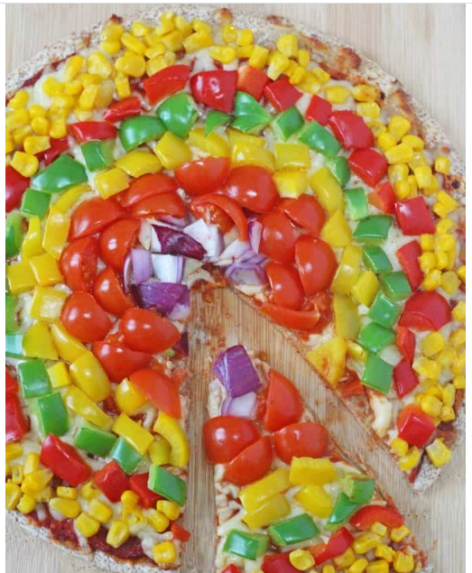
This week we will be cutting some more fruit and vegetables. We are going to chop our pieces smaller so we can make a beautiful rainbow pizza like the one above.
- Are the seeds on the inside or the outside?

- Are they large or small? How many are there?

- Is a tomato a fruit or a vegetable?

- Is a pepper a fruit or a vegetable?

- Did you know that each sweetcorn kernel is a seed?
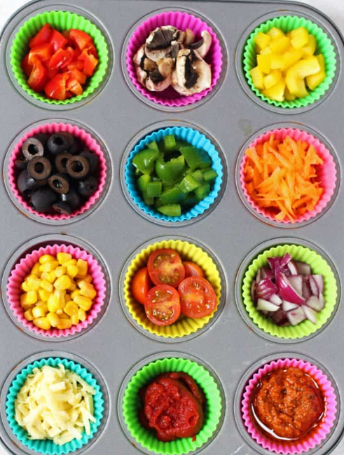
Ingredients
- Wholewheat or white tortilla or flatbread
- Tomato puree / tomato paste / pesto
- Any topping you like, including:
- grated cheese
- red onion
- tomatoes
- sweetcorn
- grated carrot
- green, red and yellow peppers
- olives
- mushrooms
How to make it:
- Wash the vegetables and chop any tomatoes, peppers, onions, mushrooms or olives into small pieces on a chopping board.
- Grate the cheese and carrot and place all your toppings together so you can look at the different colours.
- Heat the oven to (180c / 350f).
- Place your tortilla(s) on a baking tray before you start loading up.
- Spread your tortilla with either tomato puree mixed with pesto or puree on it’s own. Then add the cheese.
- Start your rainbow by placing one of the toppings around the outside edge of the tortilla. Then place the next topping inside that until you end up in the middle of the tortilla.
- Bake in the oven for about 5 - 10 minutes.
- Allow to cool for a couple of minutes before cutting and serving.

