Where does our food come from?
Next time your family goes shopping ask an adult to help you find out where the fruit and vegetables come from. This will be displayed in
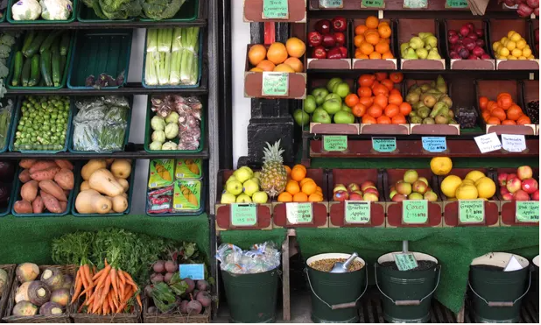
What other countries were the foods from?
What foods did you find and where did they come from?_________________________________________________________________________________________________________________
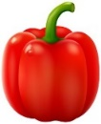
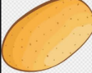
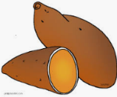
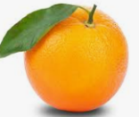
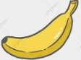
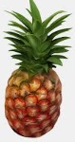
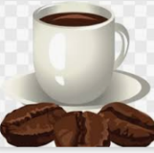
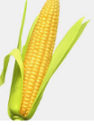
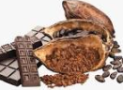
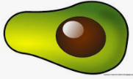
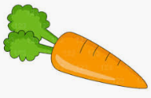
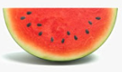
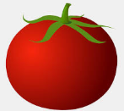
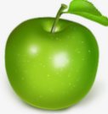
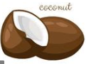

Use these pictures to stick onto the world map on the next page. You can draw some of your own to add.

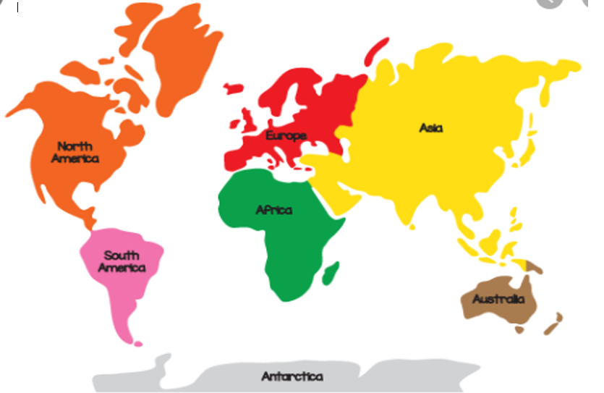

Have a look at where the UK gets different foods from on the interactive map in the link below.
https://www.glotechrepairs.co.uk/news/wp-content/uploads/2018/09/world-food-imports-full-size.png Below is is a non-interactive screen-clip.
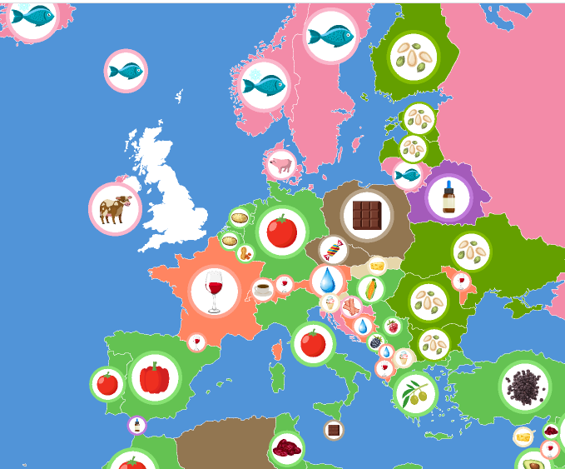
Look at the map of Europe. What foods are grown or made here in this continent?

________________________________________
potatoes carrots tomatoes peppers avocadoes apples oranges coconuts coffee beans sweetcorn pineapples mangoes pawpaw bananas watermelon sweet potatoes

Watch the powerpoint and
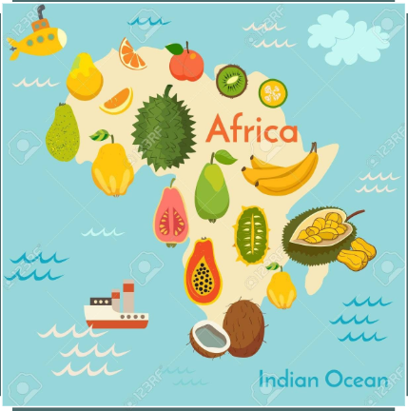
Learn about where some of
the foods we eat come from.

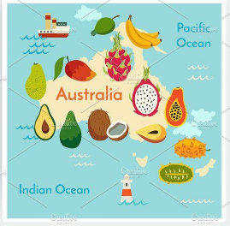

https://www.youtube.com/watch?v=wYYakyS_HOg
