Find wild flowers in your garden, park or street.
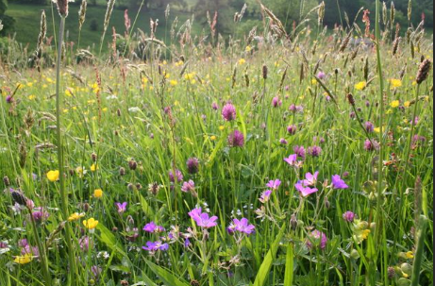

Discuss the questions below.

- Why are flowers so important to plants and to us?

- What do the bright colours and sweet scents attract?

- Why do the flowers need to attract these creatures?

- Why is it important to plant or protect wild flowers around us?

Tick off any of the flowers you find from the following pages. Draw pictures of those you find.
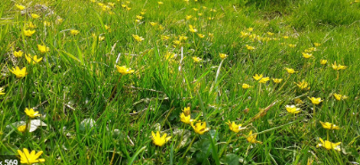
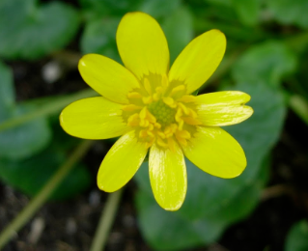

Celandine
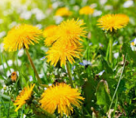
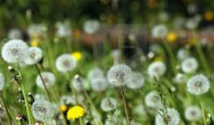

Dandelion
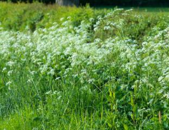
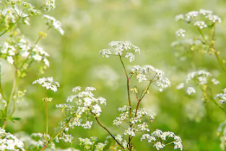
Cow parsley

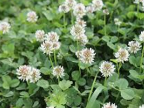
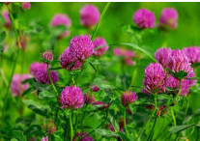
Clover
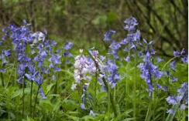

Bluebells

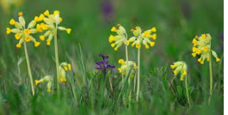
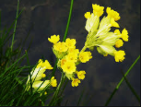

Cowslips

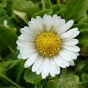
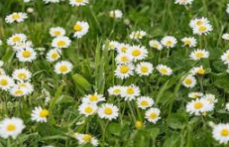

Daisies
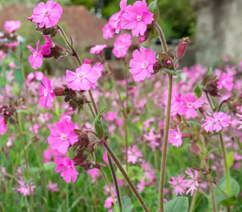
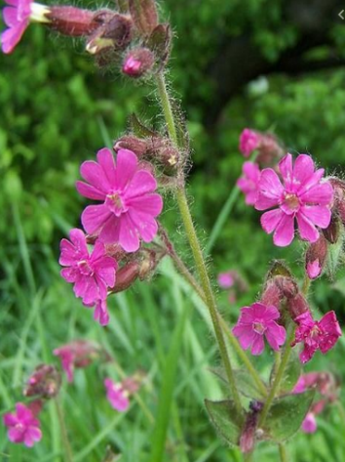

Red campion

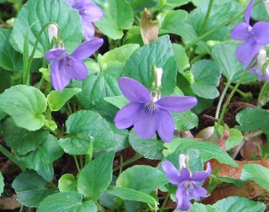
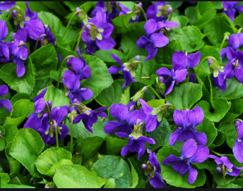

Wild violets
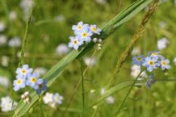
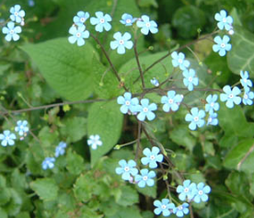

Forget me nots

Watch the videos in the links below and/or look at the powerpoint.
https://www.youtube.com/watch?v=zy3r1zlC_IU
Watch this funny animation about flower, pollen and bees.
https://www.youtube.com/watch?v=3bqwcky-01M

Can you answer these questions?
Why do bees land on flowers? ________________
______________________________________________________________________________
Why do flowers need bees?___________________
______________________________________________________________________________
How do flowers attract bees?_________________
______________________________________________________________________________

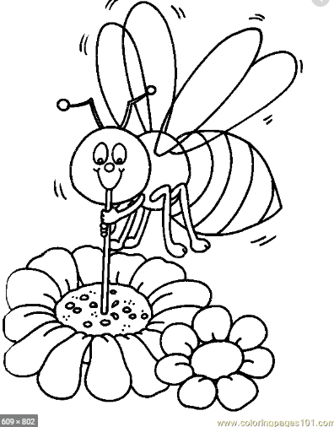

Colour the picture above.

Additional tasks Make your own pressed leaves and flowers! Then use them to make artwork and cards
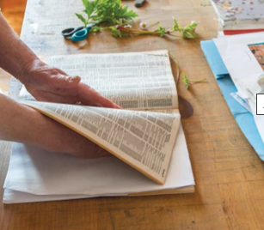
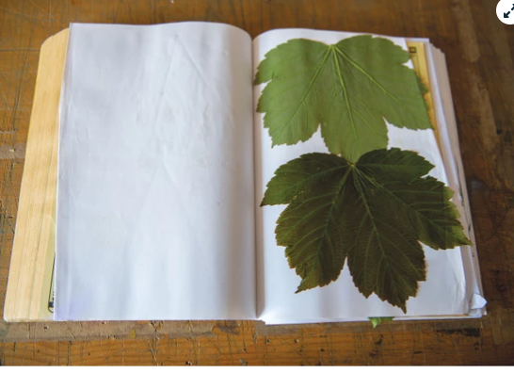
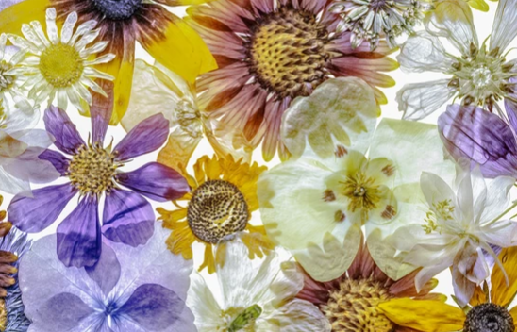

1. The easiest way to press flowers in a jiffy is to simply use two heavy books. Encylopedias and hardback books work well. Arrange your flowers between two pieces of parchment paper or cardboard and pop a few books on top. Leave for ten days, or until the flowers look dry and paper.
2. Can’t wait for your floral creations? You can use an iron to instantly press flowers. Flatten the flowers first between two pieces of paper, and then use an iron on low without any water to press down on the paper for ten seconds at a time, letting the paper cool in between, until your flowers feel paper-like and dry.
3. You can even microwave flowers! Pop them between parchment sheets into a book that doesn’t have any metal elements, then heat on low for a minute. You’ll still need to leave the flowers to dry in the book for a few days, but it should speed things up a bit.
Try making your own
Beehouse. Make sure you
Check with an adult first.
