Learn an African dance.
This video in the link below teaches a simple dance AND reinforces knowledge of a clockface!
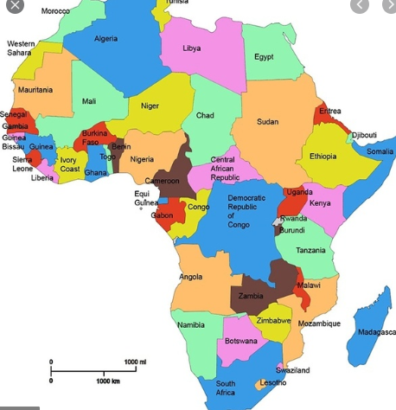
https://www.youtube.com/watch?v=eBoyh1BEF_o

Can you count and find out how many countries there are in the continent of Africa? ________________
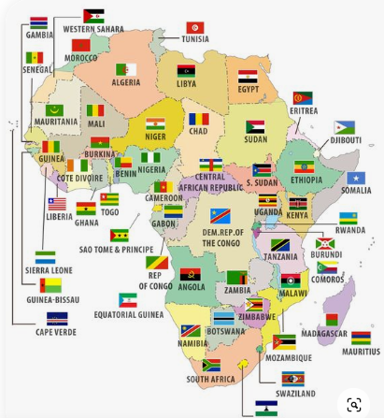
Choose a flag to copy or colour one over page.:

https://www.inkjets.com/printablelearning/flags-of-africa/
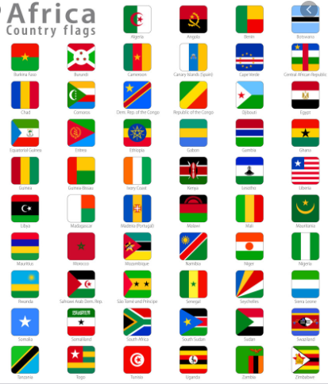
At the above link you can download and print an African flag colouring book free, by entering your email address. This includes information about each country and a flag and country quiz.

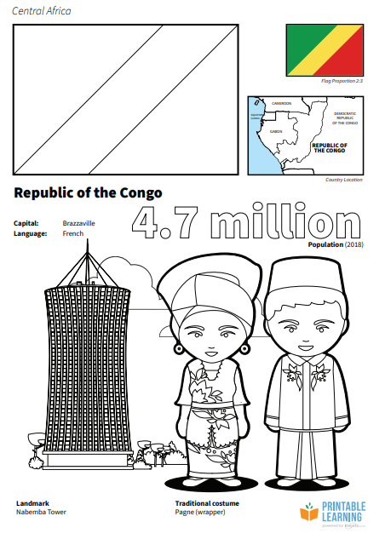
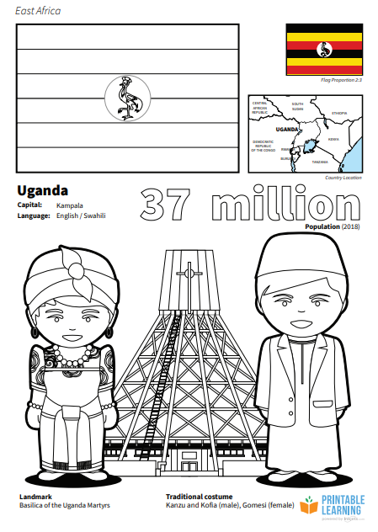
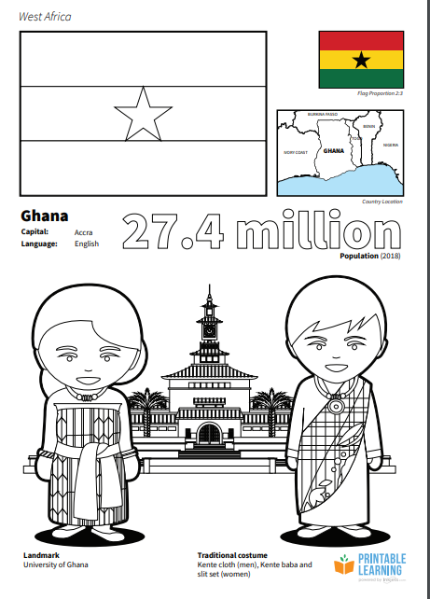
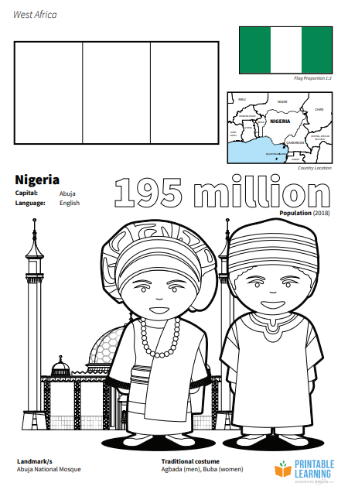
Tasks: Did you enjoy learning the dance? Did you learn any others?
Challenge: Can you write some facts about Africa?
How many countries are there in Africa? _________
Name some fruit or vegetable which grows in Africa? __________________________________
Which country is the biggest in Africa? _______________________________________
In which country in Africa are the most people living? ( highest population) _______________________ Can you draw and colour a flag from an African country?

