Learning Objectives: Children should learn:
- In which parts of the year key holidays take place;
- To recall information from their past to answer questions about holidays;
- To place key holidays in chronological order
Class Objectives: to learn about the holidays that we have today.
Talk about some of the holidays and events we have throughout the year. For example, Christmas, Easter, Summer, Halloween, then place them on the timeline over page.
In which month do we celebrate Christmas? ________________
What happens at Christmas? _____________________
______________________________________
At what time of year do we celebrate Easter? ______________
What happens at Easter?______________________________
Can you think of any other holidays that we have? ___________
In what months of the year do we have our summer holidays?
_________________________________________________
What happens during the summer holiday?_________________
_________________________________________________
When might it be better to have a seaside holiday? In the summer or winter? Why? ______________________________
_________________________________________________

Turn this page to side and order dates along to make your Holiday Timeline

Cut and stick /paste the months along the timeline and then stick the holidays –
Christmas, Halloween, Easter and Summer holiday where you think they go.
April
June
July
September
December

February
October
August
March

November

May
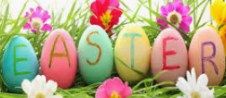
January

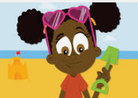
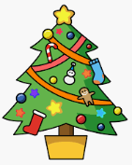
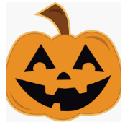

If this is too challenging do the easier timeline.

