Week 7 (summer 2 week 2) Science
To identify and classify leaves as deciduous or evergreen.
https://youtu.be/RJx2xQKIgXU song and video to learn about deciduous trees. Read through the powerpoint and try to identify the trees on the worksheet as deciduous or evergreen.
Leaf printing Gather some leaves when you’re out for a walk. Try leaf printing by painting the leaves and pressing paper onto the top. Can you find some spiky evergreen leaves to make prints with. Otherwise, make some more leaf rubbings, or collect some fallen leaves from the ground. Are there any seed heads? Has the tree dropped some seeds to disperse?
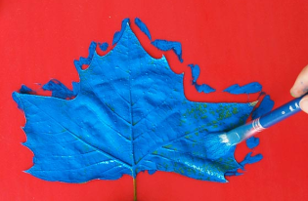
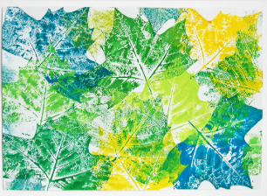
1 2 3

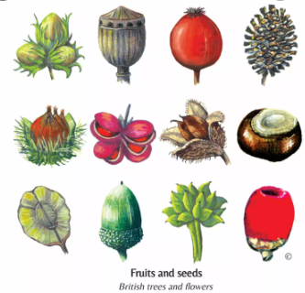

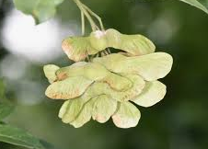
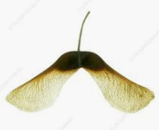

What else did you find? Draw it and see if you can find out what tree it is from and if it is a leaf, seed or something else.
I found _____________________________________________

My leaf prints, drawings or paintings.

https://www.youtube.com/brainysongs?sub_confirmation=1
(food chain, lifecycle links with animals including humans).

Literacy – The Day the Crayons Quit followed by the Day the Crayons came home (postcards and seasides)
Meerkat Mail (links to habitats and postcards)
Snail and the Whale ocean animals (oceans and animals inc humans)
Mrs Armitage at the Beach? On wheels
Sharing the Shell

